**16-09: K8S Introduction:**

* K8s, or KuberneteS, is an open-source container orchestration platform designed to automate the deployment, scaling, and management of containerized applications.
* It was originally developed by Google and is now maintained by the Cloud Native Computing Foundation (CNCF). Kubernetes provides a powerful and flexible framework for managing containerized workloads in a consistent and efficient manner.

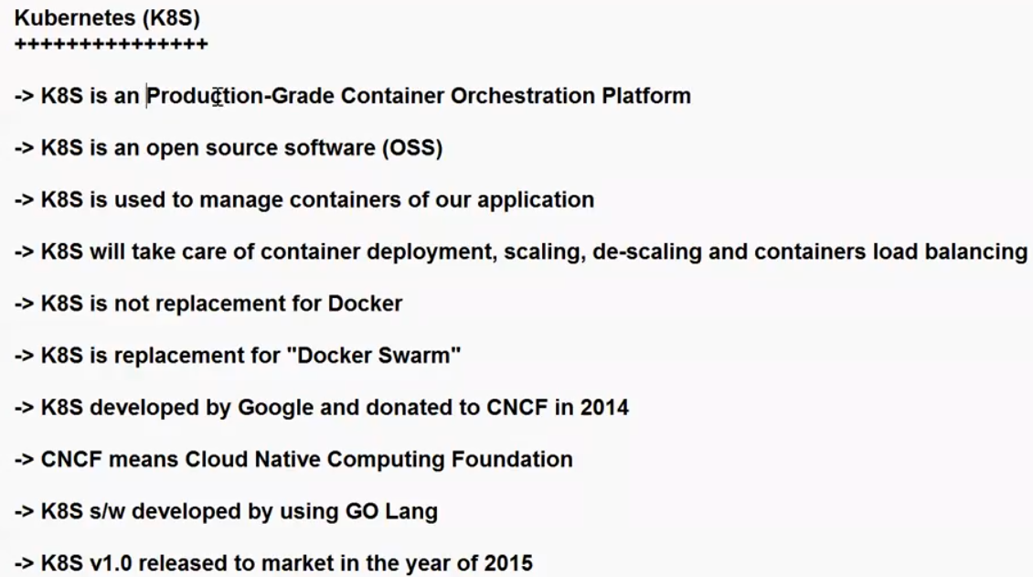

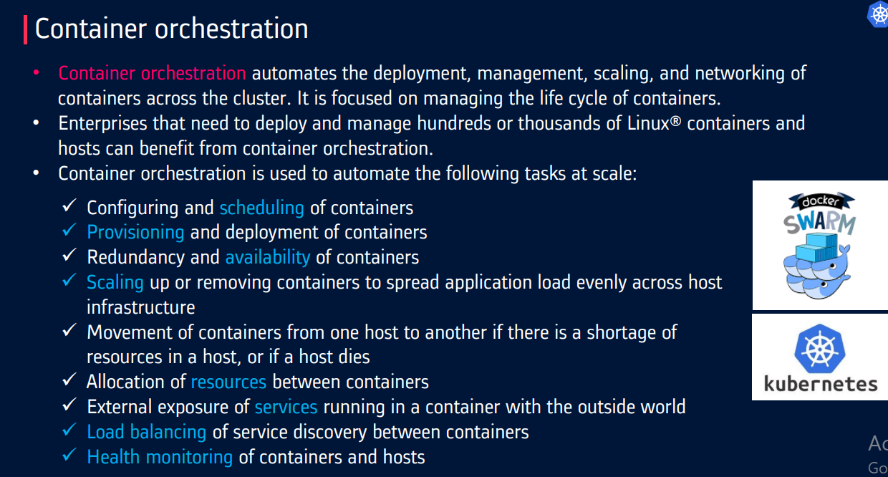

Docker is containerized platform, K8S is orchestration platform.

**Difference Between K8S and Docker Swarm:**

* Kubernetes (often abbreviated as K8s) and Docker Swarm are both container orchestration platforms, but they have some significant differences in terms of their architecture, features, and use cases.

1. **Origin and Ecosystem:**

* Kubernetes: Kubernetes was originally developed by Google and is now maintained by the Cloud Native Computing Foundation (CNCF). It has a large and active open-source community, as well as a wide ecosystem of tools and services built around it.
* Docker Swarm: Docker Swarm is part of the Docker ecosystem and is primarily focused on providing container orchestration capabilities for Docker containers. While it is user-friendly and easy to set up, its ecosystem is smaller compared to Kubernetes.

1. **Architecture:**

Kubernetes: Kubernetes follows a more complex, highly modular architecture. It consists of multiple components like the Master (control plane) and Nodes (worker nodes). It uses a declarative approach to define the desired state of applications and services.

Docker Swarm: Docker Swarm has a simpler architecture with fewer components. It typically has one manager node and multiple worker nodes. Docker Swarm uses a declarative approach as well but is generally considered easier to set up and manage compared to Kubernetes.

1. **Scaling and Load Balancing:**

Kubernetes: Kubernetes provides more advanced scaling and load balancing features, such as Horizontal Pod Autoscaling (HPA) and more advanced load balancing options. It's well-suited for complex, highly scalable applications.

Docker Swarm: Docker Swarm offers basic scaling and load balancing capabilities but is generally considered less powerful in this regard compared to Kubernetes.

1. **Service Discovery:**

Kubernetes: Kubernetes has built-in service discovery and DNS-based service naming, making it easier to manage and communicate between services.

Docker Swarm: Docker Swarm also provides service discovery, but it may not be as feature-rich or flexible as Kubernetes.

1. **Rolling Updates and Rollbacks:**

Kubernetes: Kubernetes offers advanced rolling updates and rollbacks with fine-grained control over the update process.

Docker Swarm: Docker Swarm provides rolling updates and rollbacks but with fewer customization options compared to Kubernetes.

1. **Community and Ecosystem:**

Kubernetes: Kubernetes has a larger and more active community, which means more third-party integrations, plugins, and a broader pool of knowledge and resources.

Docker Swarm: Docker Swarm has a smaller community and ecosystem compared to Kubernetes, which may limit the availability of third-party tools and solutions.

1. **Complexity and Learning Curve:**

Kubernetes: Kubernetes is known for its steeper learning curve due to its rich feature set and complex architecture. It is often a better choice for large and complex containerized applications.

Docker Swarm: Docker Swarm is generally easier to get started with and is considered a good choice for smaller applications or teams with limited container orchestration experience.

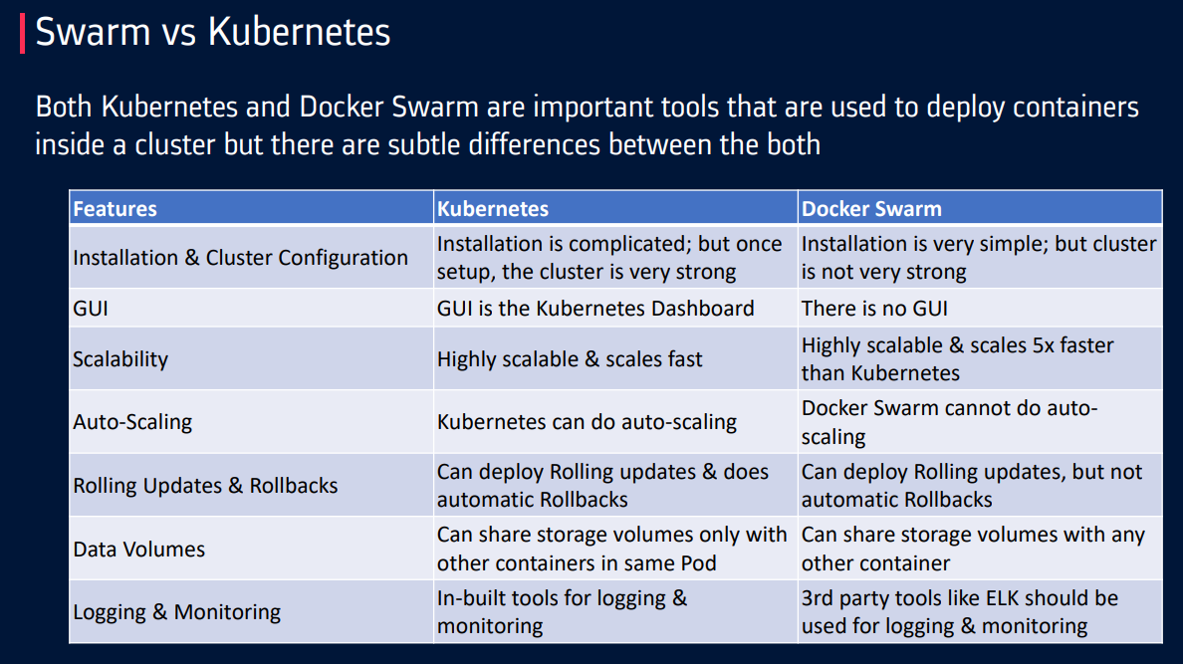

* K8S Official Website: <https://kubernetes.io/>

**K8s Key features:**

1. Automated rollouts and rollbacks.
2. Container-orchestration
3. Service discovery and load balancing.
4. Storage orchestration.
5. Self-healing.
6. Secret and configuration management.
7. Automatic bin packing.
8. Batch execution.
9. Horizontal scaling.
10. IPv4/IPv6 dual-stack.
11. Designed for extensibility.
12. Automated Scheduling.
13. Multi-Environment and Multi-Cloud Support:
14. **Automated rollouts and rollbacks:**

* Kubernetes progressively rolls out changes to your application or its configuration, while monitoring application health to ensure it doesn't kill all your instances at the same time.
* If something goes wrong, Kubernetes will rollback the change for you. Take advantage of a growing ecosystem of deployment solutions.

1. **Service discovery and load balancing:**

* No need to modify your application to use an unfamiliar service discovery mechanism. Kubernetes gives Pods their own IP addresses and a single DNS name for a set of Pods, and can load-balance across them.

1. **Storage orchestration:**

Automatically mount the storage system of your choice, whether from local storage, a public cloud provider, or a network storage system such as iSCSI or NFS.

1. **Self Healing:**
2. Restarts containers that fail, replaces and reschedules containers when nodes die, kills containers that don't respond to your user-defined health check, and doesn't advertise them to clients until they are ready to serve. (Simply if any node is die, k8s will kill that node and not give that node to users).
3. **Secret and configuration management:**
4. Deploy and update secrets and application configuration without rebuilding your image and without exposing secrets in your stack configuration.
5. **Automatic bin packing:**

* Automatically places containers based on their resource requirements and other constraints, while not sacrificing availability. Mix critical and best-effort workloads in order to drive up utilization and save even more resources.

1. **Batch execution:**

* In addition to services, Kubernetes can manage your batch and CI workloads, replacing containers that fail, if desired.

1. **Horizontal scaling:**

* Scale your application up and down with a simple command, with a UI, or automatically based on CPU usage.

1. **IPv4/IPv6 dual-stack:**

* Allocation of IPv4 and IPv6 addresses to Pods and Services

1. **Designed for extensibility:**

* Add features to your Kubernetes cluster without changing upstream source code.

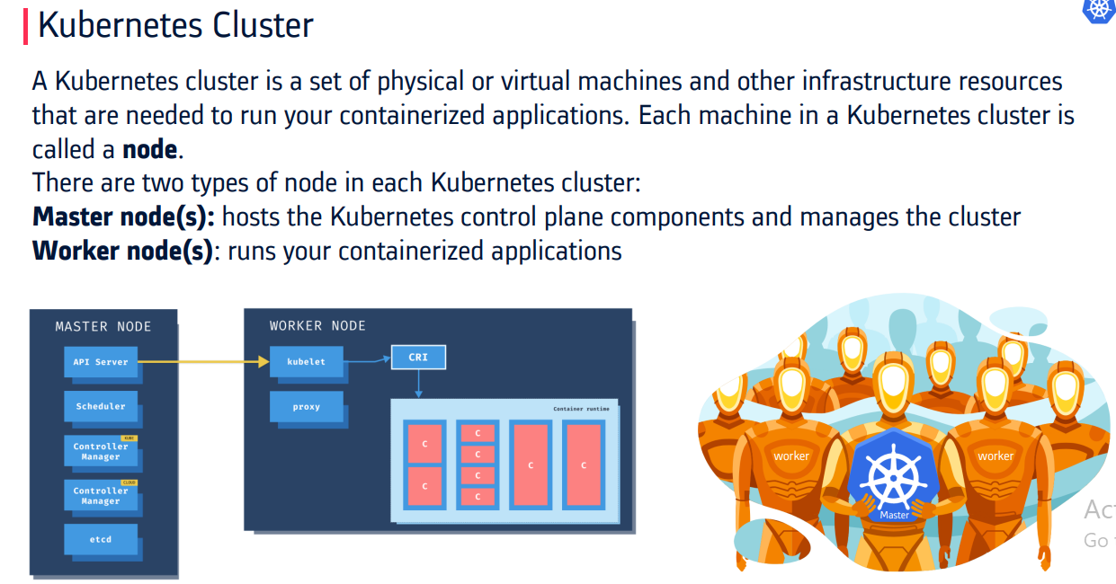

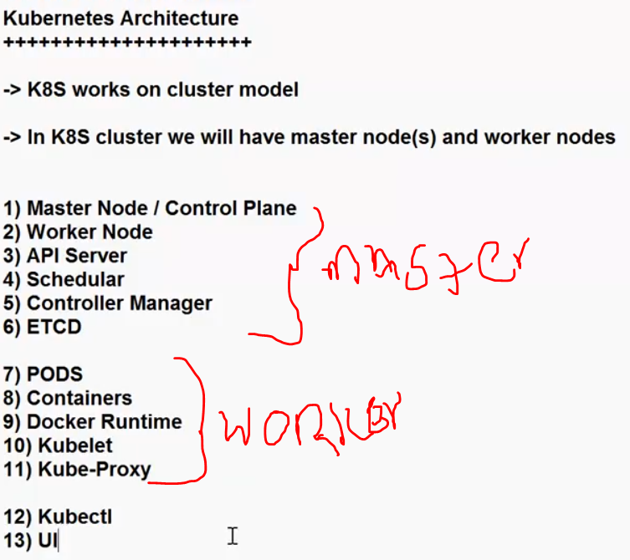

**19-09:**

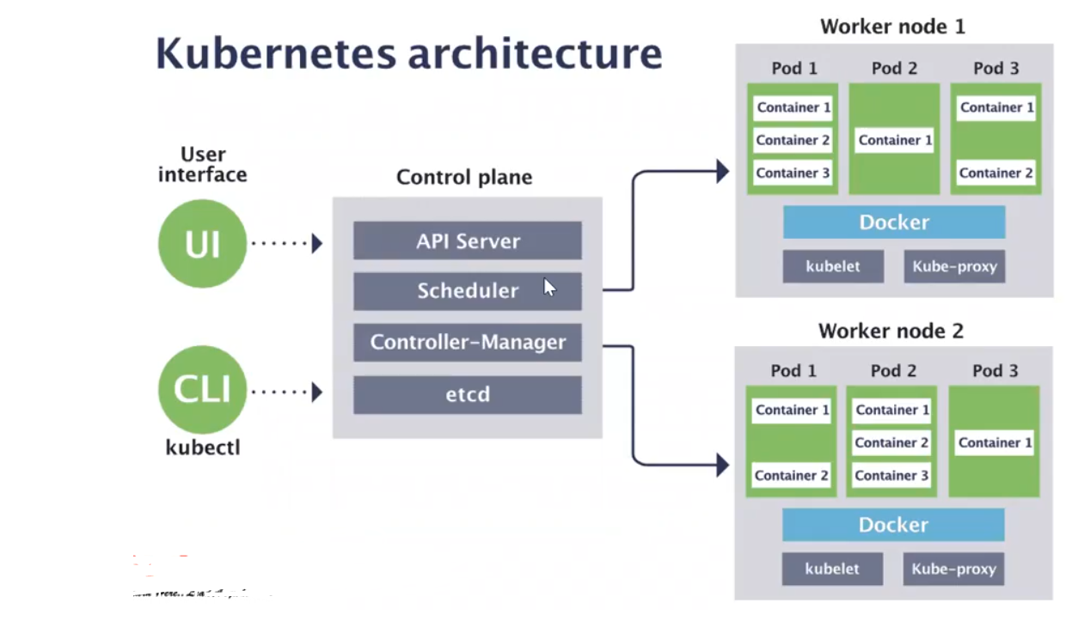

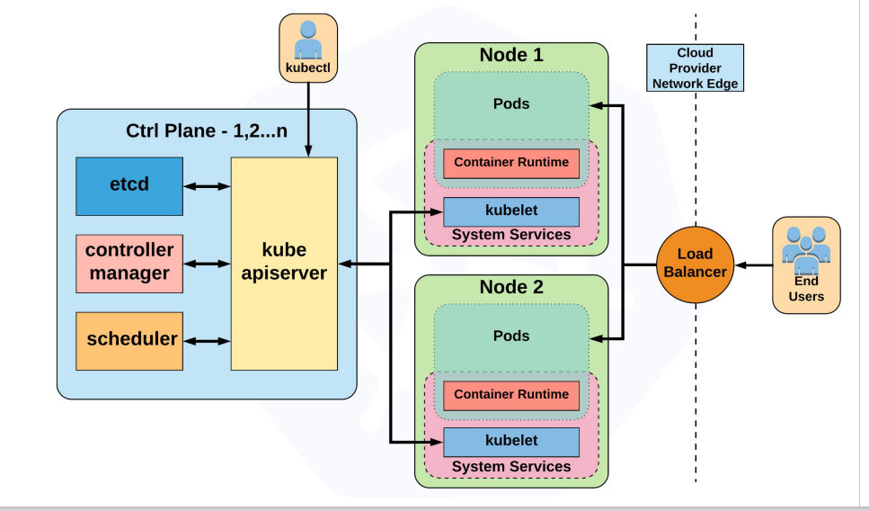

* When you deploy Kubernetes, you get a cluster.
* A Kubernetes cluster consists of a set of worker machines, called [nodes](https://kubernetes.io/docs/concepts/architecture/nodes/), that run containerized applications. Every cluster has at least one worker node.
* The worker node(s) host the [Pods](https://kubernetes.io/docs/concepts/workloads/pods/) that are the components of the application workload.
* The [control plane](https://kubernetes.io/docs/reference/glossary/?all=true#term-control-plane) manages the worker nodes and the Pods in the cluster.
* In production environments, the control plane usually runs across multiple computers and a cluster usually runs multiple nodes, providing fault-tolerance and high availability.
* Its architecture is designed to provide a highly available, scalable, and resilient(able to withstand or recover quickly from difficult conditions) platform for running containers. Here's an overview of the key components and concepts in Kubernetes architecture:

## Control Plane Components:

* The control plane's components make global decisions about the cluster (for example, scheduling), as well as detecting and responding to cluster events (for example, starting up a new [pod](https://kubernetes.io/docs/concepts/workloads/pods/) when a deployment's replicas field is unsatisfied).
* Control plane components can be run on any machine in the cluster. However, for simplicity, set up scripts typically start all control plane components on the same machine, and do not run user containers on this machine.

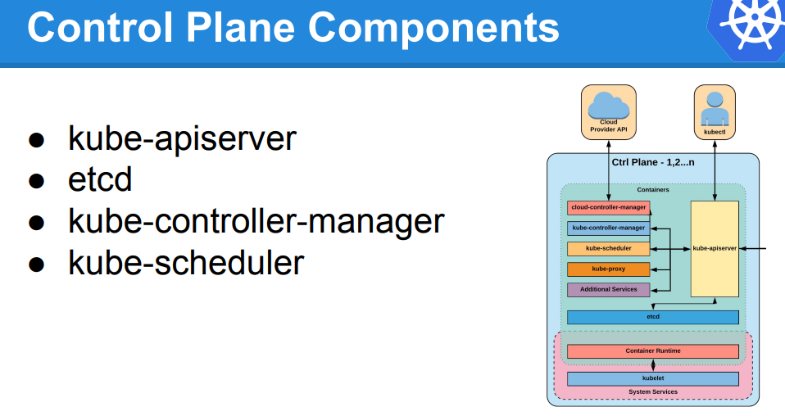

**Control plane:** The control plane node is responsible for the overall control and management of the Kubernetes cluster. It consists of several key components:

1. **API Server:** The API Server is responsible for exposing the Kubernetes API and serving as the entry point for managing the cluster. It plays a pivotal role in the communication and co-ordination of all other components within the cluster.

Here are some key aspects and functions of the API Server:

1. **Exposes Kubernetes API:** The API Server provides a RESTful HTTP API that allows users, administrators, and external systems to interact with the Kubernetes cluster.

This API is the primary means of communication for performing actions like creating and updating resources (e.g., pods, services, deployments), querying cluster state, and managing the cluster's configuration.

1. **Authentication and Authorization:** The API Server handles authentication and authorization for incoming API requests. It verifies the identity of users or processes making requests and enforces access control policies to ensure that only authorized actions are allowed.
2. **Validation and Admission Control:** The API Server performs validation checks on incoming requests to ensure they conform to Kubernetes resource schemas and policies. Admission controllers can be configured to enforce additional rules and policies before resources are created or updated in the cluster.
3. **Synchronization with etcd:** The API Server interacts with the etcd key-value store, which serves as the cluster's data store. It stores and retrieves information about the cluster's desired state and actual state. When an API request is made to change the cluster's state.
4. **Proxy and Load Balancing:** In multi-node clusters, multiple API Servers may be deployed for high availability and load distribution. The API Server instances are typically fronted by a load balancer or proxy to distribute incoming requests evenly across them.
5. **Resource Endpoints:** The API Server exposes endpoints for various Kubernetes resources, such as pods, services, config maps, secrets, and more. Users interact with these endpoints to create, update, or query the state of these resources.
6. **Event Handling:** The API Server generates events to communicate changes and updates within the cluster. Users can subscribe to these events to monitor the cluster's state and respond to changes as needed.

**In summary, the API Server in Kubernetes serves as the primary interface for users and automation tools to interact with the cluster. It enforces authentication, authorization, and validation rules, maintains cluster state, and plays a crucial role in maintaining the desired configuration and orchestrating changes within the cluster.**



1. **What is ETCD:**

* In Kubernetes, etcd is a distributed key-value store that serves as the primary source of truth and the backend data store for the entire cluster.
* It is a critical component of the control plane, and it stores the configuration data, state information, and metadata about all resources and objects in the cluster.

Here are key aspects and functions of etcd in the Kubernetes control plane:

1. Consistent and Highly Available Data Store:

* etcd is designed to be highly available and consistent. It uses the Raft consensus algorithm to ensure that data stored across the cluster remains consistent, even in the presence of node failures or network partitions.
* This consistency is crucial for maintaining the integrity of the cluster's configuration and state.

1. Cluster Configuration:

* etcd stores information about the cluster's configuration, including details about nodes (both worker nodes and master nodes), network configuration, API server endpoints, and cluster-wide settings.

1. Resource State:

* All resource and object state information in Kubernetes is stored in etcd. This includes information about pods, services, nodes, deployments, replica sets, and more. Whenever a resource is created, updated, or deleted, the corresponding changes are reflected in etcd.

1. Configuration Data:

* etcd can store configuration data that is critical for the functioning of various Kubernetes components. This includes configuration information for the API server, controller manager, scheduler, and other components.]

1. Performance and Scalability:

* etcd is designed to be highly performant and can handle a large number of read and write operations per second.
* Its performance and scalability are crucial for the smooth operation of Kubernetes clusters, especially in large-scale deployments.
* In summary, etcd in the Kubernetes control plane is a distributed, consistent, and highly available key-value store that stores configuration data and resource state information.
* It plays a central role in maintaining the desired state of the cluster and enabling the various Kubernetes components to coordinate and communicate effectively.
* Etcd's reliability and performance are critical to the overall stability and functionality of Kubernetes clusters.

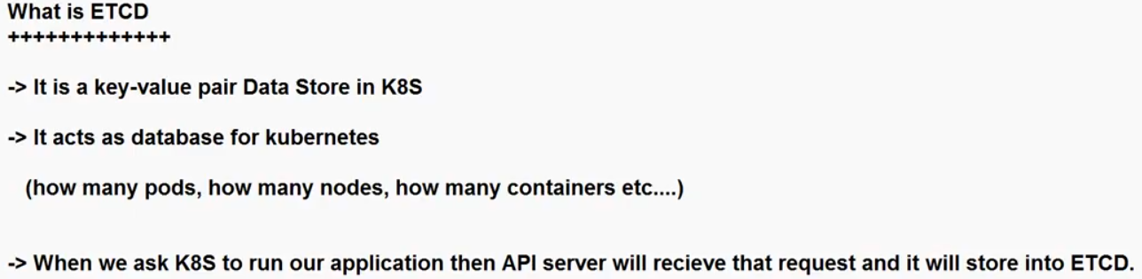

1. **Schedular:**

* In Kubernetes (K8s), the Scheduler is a critical component of the control plane responsible for making decisions about where and when to place newly created pods onto available worker nodes in the cluster.
* Its primary role is to ensure that workloads are distributed efficiently across the cluster.

Here's an overview of the Scheduler and its role in Kubernetes:

1. Scheduling Decisions:

* When a user or controller creates a new pod specification, it does not specify which node in the cluster the pod should run on.
* Instead, the pod's scheduling requirements, such as CPU and memory requests, node affinity, and other constraints, are defined in its configuration.
* The Scheduler's job is to determine the best node for each pod based on these requirements.

1. Node Selection:

* The Scheduler evaluates the suitability of each node in the cluster by considering factors like available resources (CPU, memory), node capacity, and the already running pods on each node.
* It then selects the node that best meets the pod's requirements.

1. Prioritization:

* The Scheduler assigns each node a score, and nodes with higher scores are considered better fits for the pod.
* The scoring system allows administrators to implement custom policies and prioritize certain nodes over others, based on application requirements.

In summary, the Scheduler in Kubernetes is responsible for making intelligent decisions about where to place pods in the cluster to optimize resource utilization, maintain high availability, and satisfy scheduling constraints. It plays a crucial role in automating the deployment of workloads in a Kubernetes cluster and ensures that pods are distributed efficiently and effectively across the available nodes.

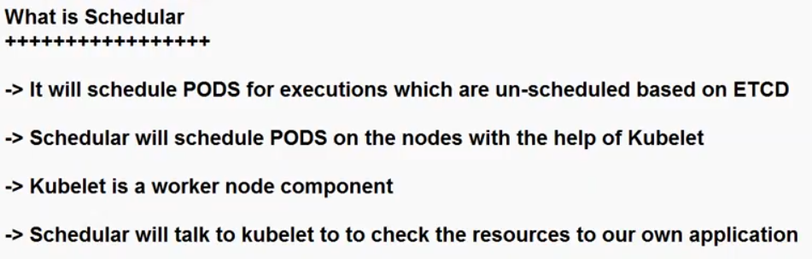

1. **Controller –Manager:**

* In Kubernetes (K8s), the Controller Manager responsible for managing various controllers that regulate the state of the cluster.
* Each controller focuses on ensuring that a specific desired state is maintained for resources and objects in the cluster. Here's an explanation of the Controller Manager and its role:

1. Controller:

* In Kubernetes, a controller is a control loop that continuously watches the desired state of a resource and takes corrective actions to make the current state match the desired state.
* Controllers are responsible for managing the lifecycle of various resources, such as pods, replica sets, deployments, services, and more.

1. Controller Manager:

* The Controller Manager is a Kubernetes control plane component that houses and manages multiple controllers.
* Each controller is responsible for one or more resource types, and they ensure that the desired configuration for those resources is maintained.

The key controllers managed by the Controller Manager include:

1. Replication Controller: Ensures that the desired number of pod replicas are running at all times. It automatically scales the number of replicas up or down to match the desired state.
2. Deployment Controller: Manages Deployments, which allow declarative updates to applications. It ensures that the specified number of replica sets are created and maintained as the application is updated or rolled back.
3. StatefulSet Controller: Manages StatefulSets, which are used for state full applications. It ensures ordered pod creation, scaling, and deletion while maintaining stable network identities and persistent storage.

stateful applications: Managing stateful applications can be more challenging than stateless ones due to the complexity of maintaining data integrity, ensuring high availability, and managing data backups and recovery. However, they are essential for many use cases where data persistence and consistency are critical

1. Job and CronJob Controllers: Manages Job and CronJob resources, which are used for batch processing and scheduled tasks, respectively.
2. Service Controller: Manages Kubernetes Services, which provide network access to a set of pods. It ensures that services are properly configured and that endpoints are updated as pods are created or destroyed.

**Worker Node**:

1. **Kubelet:**

* A node is a physical or virtual machine in the Kubernetes cluster where containers are deployed. Each node runs a container runtime (such as Docker) and a kubelet, which is an agent responsible for managing containers on that node.
* kubelet is a critical component of the cluster responsible for managing and maintaining individual nodes (also known as worker nodes or minions).
* It plays a key role in ensuring that containers are running as expected on each node.

Here's an overview of the kubelet and its responsibilities:

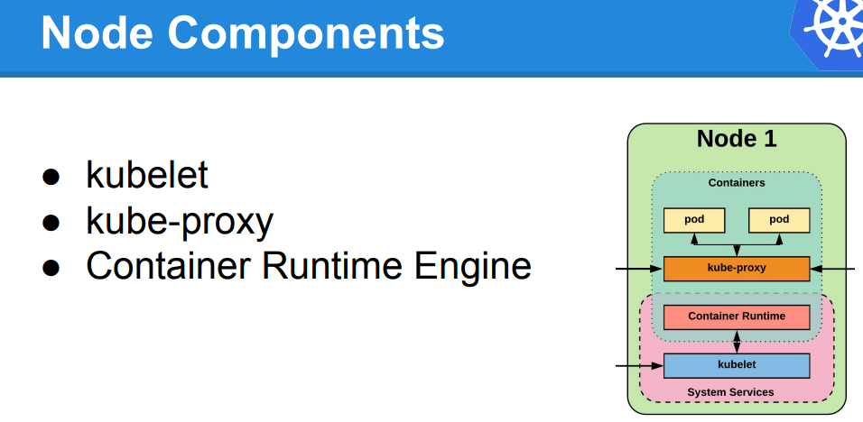

* Kubernetes creates a Node object internally (the representation). Kubernetes checks that a kubelet has registered to the API server that matches the metadata.name field of the Node. If the node is healthy (i.e. all necessary services are running), then it is eligible to run a Pod. Otherwise, that node is ignored for any cluster activity until it becomes healthy.
* Kubernetes keeps the object for the invalid Node and continues checking to see whether it becomes healthy.

1. Container Management:

* The kubelet is responsible for managing containers on its assigned node.
* It ensures that containers specified in Kubernetes Pod manifests are started, stopped, and maintained in the desired state.
* It communicates with the container runtime (e.g., Docker, containerd, or CRI-O) on the node to start and stop containers.

1. Pod Lifecycle Management:

* Pods are the smallest deployable units in Kubernetes, and each node can run multiple pods. The kubelet is responsible for ensuring the lifecycle of pods on its node.
* It monitors the pod's status, reports it to the Kubernetes control plane, and takes actions to recover pods if they fail.

1. Resource Monitoring and Reporting:

* The kubelet collects resource usage and performance data from containers running on its node, such as CPU and memory usage.
* This information is exposed via the Kubernetes API and can be used for monitoring, scaling, and resource allocation decisions.

1. Node Status Updates:

* The kubelet regularly reports the status of its node (e.g., node conditions, available resources, and capacity) to the Kubernetes control plane, allowing the scheduler to make informed decisions about where to place pods.

1. Image Management:

* It ensures that the required container images are pulled from container registries and available for use when starting pods that reference those images.

1. Health Checks:

* The kubelet performs periodic health checks on containers to detect and respond to any failures. If a container becomes unhealthy, the kubelet can restart or recreate the pod as needed.

1. Pod Eviction:

* In cases of resource constraints or node failures, the kubelet can evict (remove) pods from the node to free up resources or to ensure that critical pods are rescheduled onto healthy nodes.

1. Pod Security Policies:

* The kubelet enforces certain security policies at the node level, such as ensuring that containers run with specified security contexts or within specific namespaces.
* How can use kubectl to view a Node's status and other details:

#kubectl describe node <insert-node-name-here>

What is the NameSpace: Namespace is a logical, virtual cluster within a physical Kubernetes cluster. It is a way to divide and isolate resources and objects in a Kubernetes cluster, allowing multiple users or teams to share the same cluster while maintaining resource and access separation. Namespaces provide a scope for the resources created within them, preventing naming collisions and helping with resource organization and management.

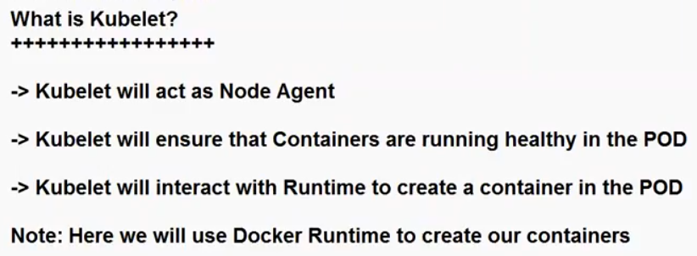

1. **Kube-proxy:**

* In Kubernetes (K8s), kube-proxy is a one of the component that runs on every worker node in the cluster. Its primary responsibility is to maintain network connectivity and provide basic load balancing for services within the cluster.
* kube-proxy ensures that network traffic is properly routed to the appropriate pods or endpoints.

Here are the key functions and roles of kube-proxy on a K8s worker node

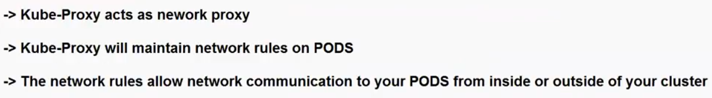

1. Service Abstraction:

Kube-proxy is responsible for implementing this service abstraction and ensuring that traffic to services is correctly load-balanced to the appropriate pods.

1. Network Routing:
2. Load Balancing:

When a service is exposed with type "LoadBalancer" or "NodePort," kube-proxy manages the load balancing of incoming traffic to the service.

* Kube-proxy plays a crucial role in ensuring that services within a Kubernetes cluster are accessible and that network traffic is correctly directed to the appropriate pods.
* It abstracts the complexities of networking in a distributed container environment, making it easier for users and applications to communicate with services running in the cluster.

**POD:**

* In Kubernetes (K8s), a Pod is the smallest deployable unit and the fundamental building block for running containers.
* A Pod can contain one or more tightly coupled containerized applications that share the same network namespace, IP address, and storage volumes.
* Pods are used to deploy, manage, and scale applications in a K8s cluster.

Here are some key points to understand about Pods:

1. Atomic Unit: A Pod represents the smallest deployable entity in Kubernetes. It is often used to encapsulate a single container, but it can also host multiple containers that are tightly coupled and need to share resources.
2. Shared Network Namespace: All containers within the same Pod share the same network namespace, meaning they can communicate with each other using localhost. This makes it easy for containers in the same Pod to work together.
3. Shared Storage Volumes: Containers in a Pod can share storage volumes, allowing them to read and write data to the same filesystem. This facilitates data sharing and communication between containers.
4. Single IP Address: A Pod is assigned a single IP address within the cluster. This IP address is reachable from other Pods in the same cluster but is not directly reachable from outside the cluster without additional network configurations.
5. Pod Lifecycle: Pods have their own lifecycle. They can be created, started, stopped, and deleted. When a Pod is deleted, all the containers within it are also terminated.
6. Immutable: Pods are considered immutable. When changes are required, such as updating container images or configuration, a new Pod is created with the desired changes, and the old one is terminated.

The immutable objects are objects whose value can not be changed after initialization. We can not change anything once the object is created.

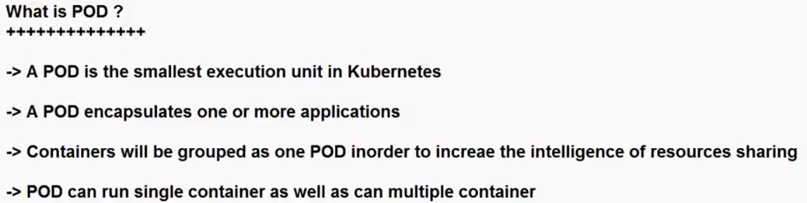

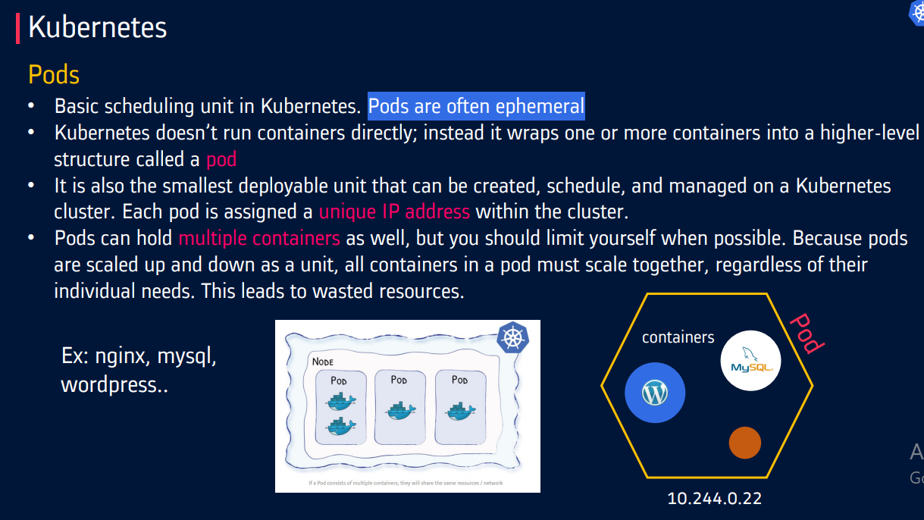

**Kubernetes Cluster Set-up:**

Setting up a Kubernetes cluster can be done in several ways, depending on your requirements and infrastructure. Here are some common methods for setting up a Kubernetes cluster:

1.Local Development Cluster: You can set up a local development cluster on your machine for testing and development purposes. Tools like Minikube, KinD (Kubernetes in Docker), and K3d (K3s in Docker) allow you to run a single-node or multi-node Kubernetes cluster on your local system.

2. Hosted Kubernetes Services: Many cloud providers offer managed Kubernetes services that make it easy to set up and manage a Kubernetes cluster. Examples include Google Kubernetes Engine (GKE), Amazon Elastic Kubernetes Service (EKS), Microsoft Azure Kubernetes Service (AKS), and IBM Kubernetes Service.

3.Kubeadm: Kubeadm is a tool for bootstrapping a minimal, production-ready Kubernetes cluster. It's often used for setting up clusters on bare-metal servers, virtual machines, or cloud instances. Kubeadm automates many of the manual steps required to initialize a cluster.

4.Kops (Kubernetes Operations): Kops is a tool for creating, upgrading, and managing Kubernetes clusters on AWS (Amazon Web Services). It simplifies the process of deploying Kubernetes on AWS infrastructure.

5.RKE (Rancher Kubernetes Engine): RKE is a tool for deploying, managing, and scaling Kubernetes clusters. It's commonly used in conjunction with Rancher, a container management platform, and can be used on various infrastructure providers.

6.Custom Installation: For advanced users, it's possible to manually set up a Kubernetes cluster by installing and configuring all the necessary components, including the control plane components (API server, etcd, etc.) and worker nodes.

7.Managed Kubernetes Distributions: Some companies offer their distributions of Kubernetes, which are preconfigured and optimized for specific use cases. Examples include OpenShift by Red Hat and Tanzu Kubernetes Grid by VMware.

8.Multi-Cluster Management Tools: There are tools like Crossplane and ArgoCD that help manage and deploy multiple Kubernetes clusters across different environments, enabling cluster lifecycle management and GitOps workflows.

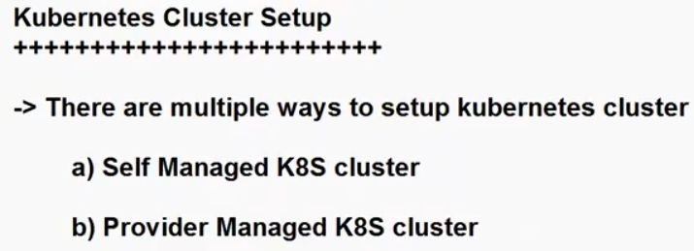

1. **Self Managed K8S Cluster:**

* A self-managed Kubernetes (K8s) cluster, also known as a DIY (Do-It-Yourself) Kubernetes cluster, refers to a Kubernetes cluster that you set up, configure, and manage entirely on your own, typically without the assistance of a managed Kubernetes service provided by a cloud provider or a Kubernetes distribution.

Key characteristics and considerations of a self-managed Kubernetes cluster include:

Manual Setup:

* You are responsible for provisioning the infrastructure (physical servers, virtual machines, or cloud instances), installing the necessary software components (container runtime, Kubernetes control plane, and worker node components), and configuring networking and security settings.

1. Complete Control:

* With a self-managed cluster, you have full control over every aspect of the Kubernetes environment. This level of control allows you to customize the cluster to your specific requirements and integrate it with your existing infrastructure and tools.

1. Complexity:

* Setting up and managing a self-managed Kubernetes cluster can be complex and time-consuming, especially for production environments. It requires expertise in Kubernetes, infrastructure management, networking, and security.

1. Flexibility:

* Self-managed clusters offer flexibility in terms of the choice of container runtimes, networking solutions, and storage options. You can tailor the cluster to meet your organization's unique needs.

1. Maintenance:

* You are responsible for routine maintenance tasks such as upgrading Kubernetes versions, applying security patches, monitoring cluster health, and ensuring high availability. These tasks can be resource-intensive.

1. Scalability:

* You can scale a self-managed Kubernetes cluster by adding or removing nodes as needed to handle
* increased workloads. This scalability is under your direct control.

1. Backup and Disaster Recovery:

* Implementing backup and disaster recovery solutions is crucial to ensure data and application availability in case of failures or data loss.

1. Resource Management:

* Managing resources like CPU, memory, and storage for applications and pods running in the cluster is your responsibility. You may need to implement resource quotas and limits to prevent resource contention.

1. Monitoring and Logging:

* You'll need to set up monitoring and logging tools to gain insights into the cluster's performance and troubleshoot issues effectively.

1. Security:

* Ensuring the security of your self-managed cluster is paramount. You must configure network policies, implement access controls, and regularly apply security best practices.

Note: 

In the Self-Managed cluster we have a two types:

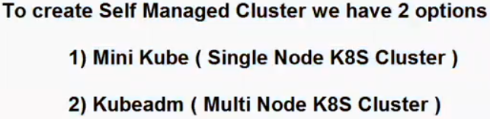  
Both Minikube and kubeadm are tools used to set up Kubernetes clusters, but they serve different purposes and are designed for different use cases.

1. **Minikube:**

* Minikube is a lightweight tool that is primarily used for local development and testing of Kubernetes applications. It is intended to run a single-node Kubernetes cluster on your local machine. Key points about Minikube include:
* **Local Development:** Minikube is ideal for developers who want to test their Kubernetes applications or learn how Kubernetes works without needing access to a full-scale cluster.
* **Single-Node Cluster:** It sets up a single-node Kubernetes cluster in a virtual machine on your local system. This cluster includes the control plane and worker node components, all running on a single VM.
* **Easy to Use:** Minikube is designed to be user-friendly and is often used for quick experimentation. It's a good choice for getting started with Kubernetes without the complexity of setting up a multi-node cluster.
* **Limited for Production:** While Minikube is excellent for local development and learning, it's not suitable for production deployments due to its single-node nature and lack of high availability.

1. **kubeadm:**

* **Multi-Node Clusters:** kubeadm is used to initialize and join nodes to a Kubernetes cluster. It's suitable for creating multi-node clusters with separate control plane and worker nodes.
* **Production Ready:** It's often used in production environments where you need a reliable, scalable Kubernetes cluster.
* **Customization:** kubeadm provides more flexibility for customizing your Kubernetes cluster configuration. You can choose the container runtime, networking solution, and other components.
* **Configuration Files:** You can define the cluster's configuration in YAML files, making it easier to version and manage your cluster configuration.

In summary, Minikube is a tool designed for local development and testing, whereas kubeadm is used for setting up more complex and scalable Kubernetes clusters, whether for development, testing, or production. The choice between the two depends on your use case.

**2.Provider Managed K8S Cluster:**

* A provider-managed Kubernetes cluster, also known as a managed Kubernetes service, is a Kubernetes cluster that is fully hosted, operated, and managed by a cloud provider or a third-party Kubernetes distribution vendor.
* In this model, the provider takes care of many of the operational tasks, allowing users to focus more on deploying and managing their applications rather than the underlying infrastructure and Kubernetes control plane.

Here are some key characteristics of provider-managed Kubernetes clusters:

1. Infrastructure Management:

* The cloud provider or vendor handles all aspects of infrastructure provisioning, including the management of virtual machines (VMs), networking, and storage.
* Users don't need to worry about server maintenance, hardware failures, or scaling the underlying infrastructure.

1. Control Plane Management:

* The provider is responsible for managing the Kubernetes control plane, which includes components like the API server, etcd, and controllers. This ensures high availability and reliability of the control plane.

1. Kubernetes Upgrades: Provider-managed Kubernetes services often offer automated or simplified Kubernetes version upgrades. Users can easily upgrade to newer versions without extensive manual intervention.
2. Security Updates: The provider applies security patches and updates to the Kubernetes control plane to protect against vulnerabilities. Users benefit from the provider's security expertise.

5.Monitoring and Logging: Managed Kubernetes services typically include integrated monitoring and logging solutions, making it easier to track the health and performance of the cluster and applications.

1. Load Balancing: Load balancing and traffic routing to services within the cluster are often handled automatically by the provider. This simplifies service exposure to the internet and internal traffic management.
2. Scalability: Users can scale their clusters up or down to meet changing workloads and resource requirements. Scaling is usually straightforward through the provider's interface.
3. Backup and Recovery: Managed Kubernetes services often provide backup and disaster recovery features, helping users protect their data and configurations.
4. Integration with Ecosystem Services: These services may be tightly integrated with other cloud provider services, allowing seamless use of additional resources such as databases, storage, and identity management.
5. Cost Management: Users are billed based on their cluster's resource usage, and costs are typically predictable. Providers may offer tools for cost optimization.

Popular examples of provider-managed Kubernetes services include:

Amazon Elastic Kubernetes Service (EKS) on AWS.

Google Kubernetes Engine (GKE) on Google Cloud.

Azure Kubernetes Service (AKS) on Microsoft Azure.

DigitalOcean Kubernetes (DOKS) on DigitalOcean.

IBM Cloud Kubernetes Service on IBM Cloud.

Note: These managed Kubernetes services are suitable for organizations that want to leverage Kubernetes without the operational overhead of managing the underlying infrastructure and control plane. Users can focus on application development, deployment, and scaling while the provider ensures the reliability, security, and performance of the Kubernetes cluster.

**LAB:**

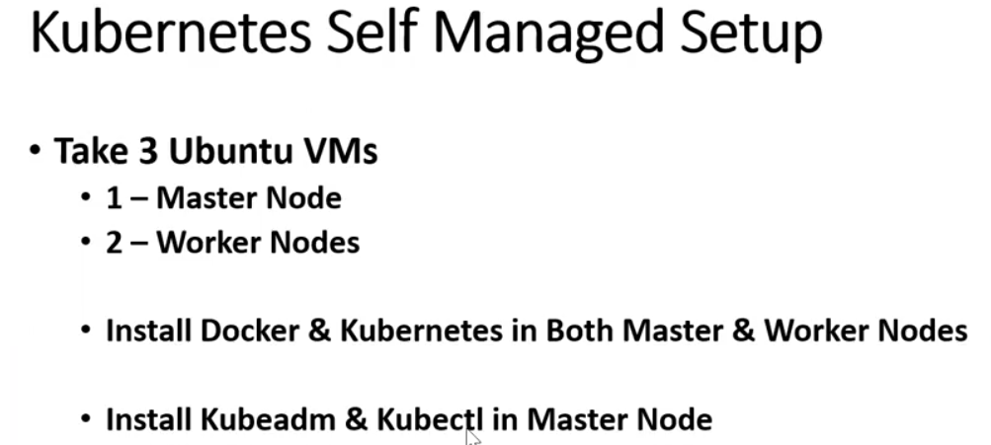

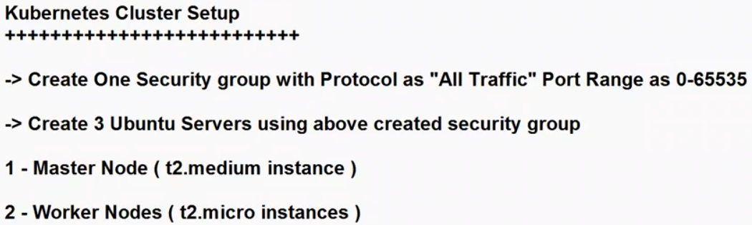

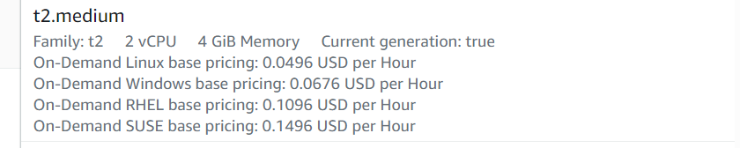

NOTE: if you take t2.micro will get this error, For Master node,

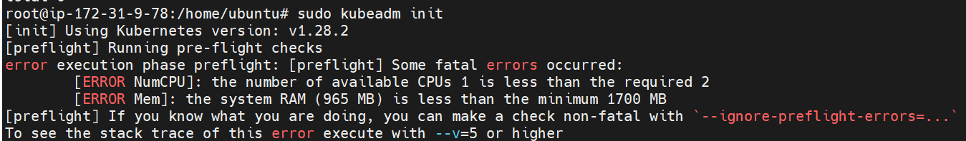

**NOTE: You should have to run all the command in ROOT user only.**

**$sudo –I (before going to execute the command , switch into root user)**

Need to launch 3 EC2 servers, one for Master and 2 for workers.

You have to execute these all commands in all the servers(Master & workers)

|  |
| --- |
| **sudo apt-get update**  **sudo apt-get install docker.io -y**  **sudo docker --version**  **sudo docker info**  **sudo usermod -aG docker $USER**  **sudo systemctl start docker**  **sudo systemctl enable docker**  **sudo apt install curl -y**  **curl -s https://packages.cloud.google.com/apt/doc/apt-key.gpg |sudo apt-key add -**  **sudo apt-add-repository "deb http://apt.kubernetes.io/ kubernetes-xenial main"**  **sudo apt-get install kubeadm kubelet kubectl kubernetes-cni**  **sudo apt-mark hold kubeadm kubelet kubectl kubernetes-cni**  **NOTE: kubectl not required to install in worker nodes.**  **sudo kubectl apply -f https://docs.projectcalico.org/manifests/calico.yaml**  $kubectl apply -f https://raw.githubusercontent.com/coreos/flannel/master/Documentation/kube-flannel.yml  **NOTE: if you are not execute this above command , node’s status will NOT READY**  **In the SG don’t open port:8080 or 80**  **kubeadm version**  **sudo swapoff -a**  **sudo systemctl daemon-reload**  **sudo systemctl start kubelet**  **sudo systemctl enable kubelet.service** |

**Step 1: Install docker all the servers:**

**Need to update your server before going to install docker:**

Login to master server: # apt-get update

1. Then Install docker:

# apt-get install docker.io –y

1. Verify the Docker version:

#docker –version OR docker info

1. sudo usermod -aG docker $USER

The command you've provided is used to add the current user to the "docker" group. Adding a user to the "docker" group allows that user to run Docker commands without needing to use sudo for each Docker command, which can be more convenient for development and administration tasks.

usermod: This is a command for modifying user account properties.

-aG docker: These options are used to add the user to the "docker" group.

$USER: This variable represents the currently logged-in user's username

1. Start the docker service:

#sudo systemctl start docker

1. Enable the docker service:

sudo systemctl enable docker

The command sudo systemctl enable docker is used to enable the Docker service to start automatically at boot time on a system that uses systemd for managing services. When you enable a service, it means that the service will be started automatically during system boot.

1. Install curl package:

sudo apt install curl

Verify curl version: #curl --version

The sudo apt install curl command is used to install the curl package on an Ubuntu system using the apt package manager. curl is a command-line tool that allows you to transfer data to or from a server using various protocols, including HTTP, HTTPS, FTP, and more. It's commonly used for tasks like downloading files, making HTTP requests, and testing network connectivity.

1. Now add GPG key to our system’s list of trusted keys:

curl -s https://packages.cloud.google.com/apt/doc/apt-key.gpg | sudo apt-key add -

1. Now add kubernetes repository to you’re system repository.

sudo apt-add-repository "deb http://apt.kubernetes.io/ kubernetes-xenial main"

The command you've provided is used to add the Kubernetes APT repository to your system's list of package sources. This allows you to install Kubernetes-related packages using the apt-get or apt package manager on Ubuntu.

1. Now you can install Kubernetes-related packages.

sudo apt-get update

sudo apt-get install kubeadm kubelet kubectl kubernetes-cni

NOTE: kubectl not required to install worker nodes.

1. The sudo swapoff -a command is used to disable all swap partitions and swap files on your Linux system. Swap is a space on your hard drive that is used as virtual memory when your physical RAM (Random Access Memory) is exhausted.

#sudo swapoff –a

1. To check the version of kubeadm installed on your system.

#kubeadm version

1. The systemctl daemon-reload command is used to reload the systemd manager configuration. systemd is a system and service manager for Linux systems, and it uses unit files to manage system services, including their configurations.

When you make changes to unit files (e.g., service unit files) or other systemd-related configuration files, you often need to inform systemd to reload its configuration to apply the changes. This is where systemctl daemon-reload comes into play.

#systemctl daemon-reload

This command is typically used when you've made changes to service unit files (located in /etc/systemd/system or /lib/systemd/system) or when you've made changes to systemd configuration files (e.g., /etc/systemd/system.conf or /etc/systemd/user.conf) that affect the system's behavior.

1. The systemctl start kubelet command is used to manually start the Kubernetes Kubelet service on a Linux system.

#sudo systemctl start kubelet

Status verify: #sudo systemctl status kubelet

1. The systemctl enable kubelet.service command is used to enable the Kubernetes Kubelet service to start automatically at boot time on a Linux system that uses systemd for managing services. When you enable a service, it ensures that the service starts automatically whenever your system boots up or is restarted.

#sudo systemctl enable kubelet.service

$kubectl apply -f <https://raw.githubusercontent.com/coreos/flannel/master/Documentation/kube-flannel.yml>

NOTE: If have to face any issue in cluster set-up will run below command as well.

#iptables -F && iptables -t nat -F && iptables -t mangle -F && iptables –X

* By running this corrected command, you are effectively resetting all the rules in your iptables configuration, including the default filter table, NAT table, and any user-defined chains.
* This can be useful when you want to start with a clean slate for your firewall rules. Be sure to reconfigure your firewall rules as needed after running this command to maintain the security and functionality of your server.

**Overall steps still what we did.**

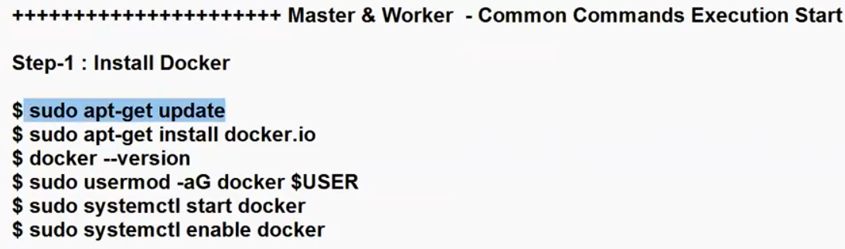

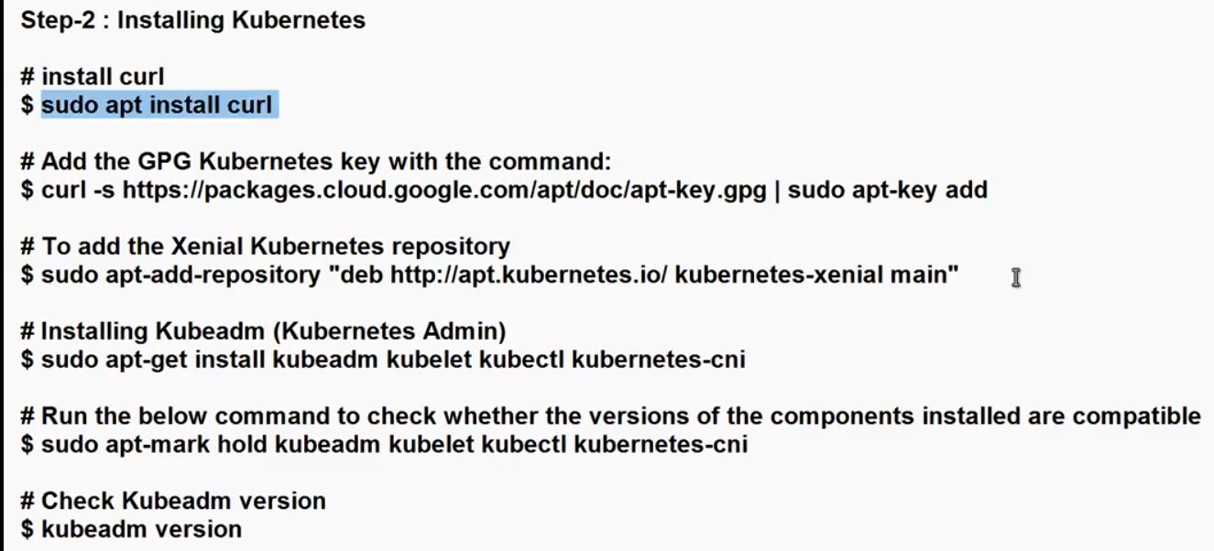

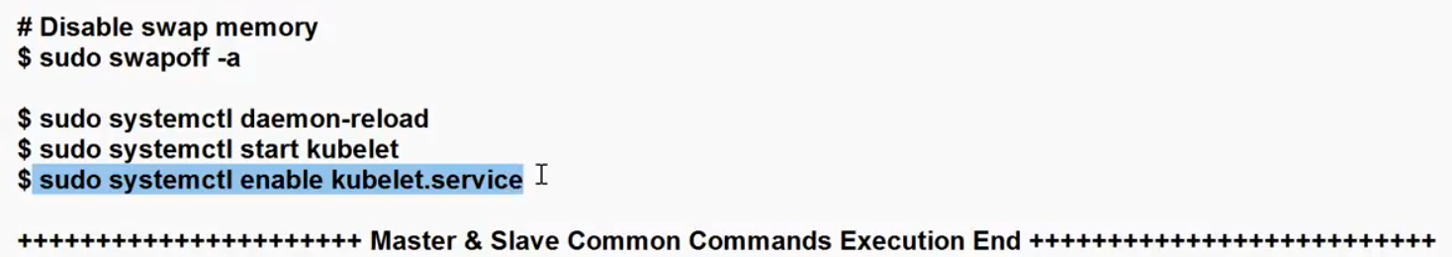

**Now master node(control-plane) common execution commands:**

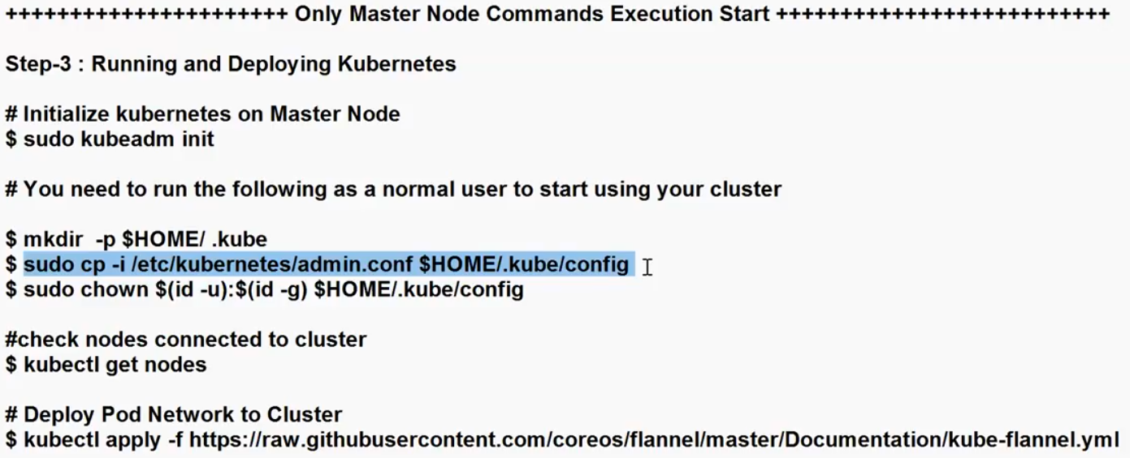

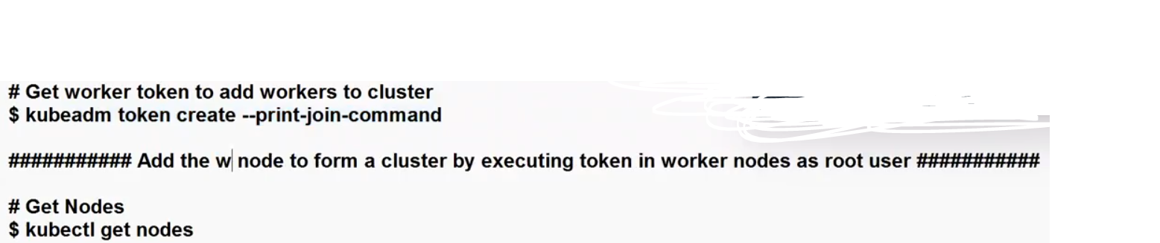

**Steps to follow In master node above steps:**

1. **$sudo kubeadm init**

* The command "sudo kubeadm init" is used to initialize a Kubernetes control plane on a Linux machine using the kubeadm tool.
* This command is typically run on the master node of a Kubernetes cluster to set up the control plane components, including the API server, etcd, controller manager, and scheduler.
* When you run "sudo kubeadm init," it will perform several tasks, including:
* Checking the prerequisites on the system.
* Initializing the etcd key-value store, which stores cluster configuration data.
* Generating cryptographic keys for securing communication within the cluster.
* Setting up the control plane components like the API server, controller manager, and scheduler.
* Printing out a command for joining worker nodes to the cluster.
* After running this command, you will typically see a message that provides a "kubeadm join" command, which you should run on your worker nodes to join them to the newly created Kubernetes cluster.

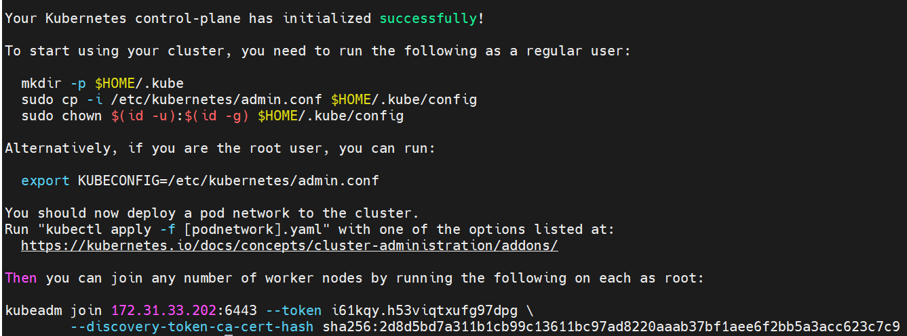

1. **To start using your cluster, you need to run the following as a regular user:**

**$mkdir -p $HOME/.kube**

* when you run "mkdir -p $HOME/.kube," it ensures that the ".kube" directory exists in your home directory.
* The ".kube" directory is often used in Kubernetes configurations to store the kubeconfig file, which contains information about how to connect to a Kubernetes cluster.
* This is where Kubernetes clients like kubectl look for configuration files by default.
* After running this command, you can typically proceed to configure your Kubernetes cluster by placing the kubeconfig file in the ".kube" directory

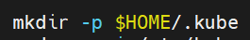

1. **Now copy the kubeconfig file in the ".kube" directory**

**$sudo cp -i /etc/kubernetes/admin.conf $HOME/.kube/config**

* /etc/kubernetes/admin.conf: This is the source file path. It is typically the location of the Kubernetes configuration file for the admin user on the control plane node.
* This configuration file contains details about how to connect to the Kubernetes cluster, including the API server address, client certificates, and authentication tokens.
* $HOME/.kube/config: This is the destination file path. It specifies that the copied configuration file should be placed in the ".kube" directory within the user's home directory and named "config."
* By copying the configuration file to the user's home directory, you make it accessible to the user without requiring root privileges. This allows the user to interact with the Kubernetes cluster using tools like kubectl without needing to use sudo for every Kubernetes-related command.



1. **Now change the file owner permission to kubeconfig file:**

**$sudo chown $(id -u):$(id -g) $HOME/.kube/config**

* The command "sudo chown $(id -u):$(id -g) $HOME/.kube/config" is used to change the ownership of the Kubernetes configuration file located at "$HOME/.kube/config" to the user who executed the command.
* This is often done to ensure that the user has proper permissions to access and modify the configuration file without requiring superuser privileges.

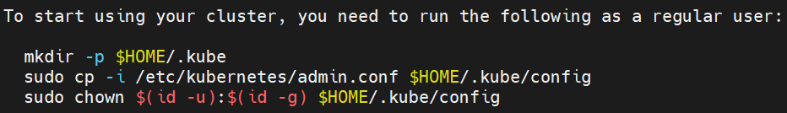

1. **Now run the join token in worker nodes for cluser setup.**

Then you can join any number of worker nodes by running the following on each as root:

$sudo kubeadm join 172.31.33.202:6443 --token i61kqy.h53viqtxufg97dpg \

--discovery-token-ca-cert-hash sha256:2d8d5bd7a311b1cb99c13611bc97ad8220aaab37bf1aee6f2bb5a3acc623c7c9



This command will download the kube-flannel.yml file from the GitHub repository and apply the Flannel configuration to your Kubernetes cluster. Make sure your cluster is properly set up and running before applying this configuration.

NOTE : Otherwise nodes status will show NOT READY (Execute in master node0

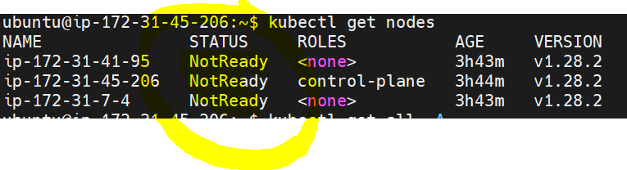

$kubectl apply -f <https://raw.githubusercontent.com/coreos/flannel/master/Documentation/kube-flannel.yml>

sudo kubectl apply -f <https://raw.githubusercontent.com/kubernetes/ingress-nginx/controller-v0.49.0/deploy/static/provider/baremetal/deploy.yaml>

Install calico n/w in the servers if servers are not Ready:

Install calico n/w:

kubectl apply -f https://docs.projectcalico.org/manifests/calico.yaml

**How to reset my cluster:**

sudo kubeadm reset –f

* The kubeadm reset command is used to revert a node that was previously initialized with kubeadm init back to its original state.
* The -f flag is used to force the reset without asking for confirmation. This command will undo all the changes made by kubeadm init and remove the Kubernetes control plane components and any other changes made to the node.
* Make sure to run this command with superuser privileges (usually with sudo) because it involves making changes to the system.

**After running kubeadm reset, you should expect the following to happen:**

* The Kubernetes control plane components (API server, controller-manager, and scheduler) will be stopped and removed.
* Any kubeconfig files for the control plane will be deleted.
* The kubelet service will be restarted and any containers created by the control plane will be stopped and removed.
* Any changes to iptables rules made during the initialization will be reverted.
* The node will no longer be part of the Kubernetes cluster.

ubuntu@ip-172-31-10-5:~$ mkdir -p $HOME/.kube

ubuntu@ip-172-31-10-5:~$ sudo cp -i /etc/kubernetes/admin.conf $HOME/.kube/config

ubuntu@ip-172-31-10-5:~$ sudo chown $(id -u):$(id -g) $HOME/.kube/config

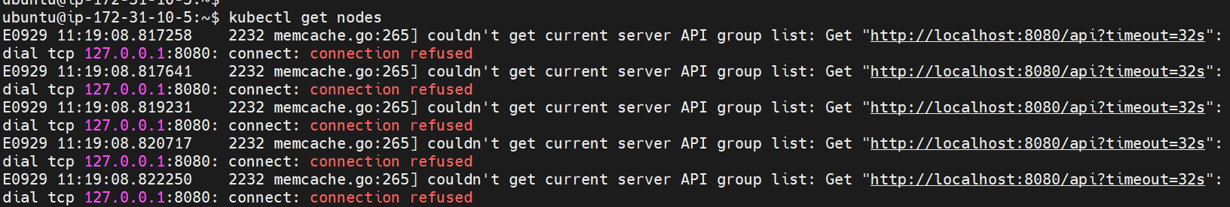

**How to get token later as well:**

$kubeadm token create --print-join-command



After execute the join token in worker node will get below message:

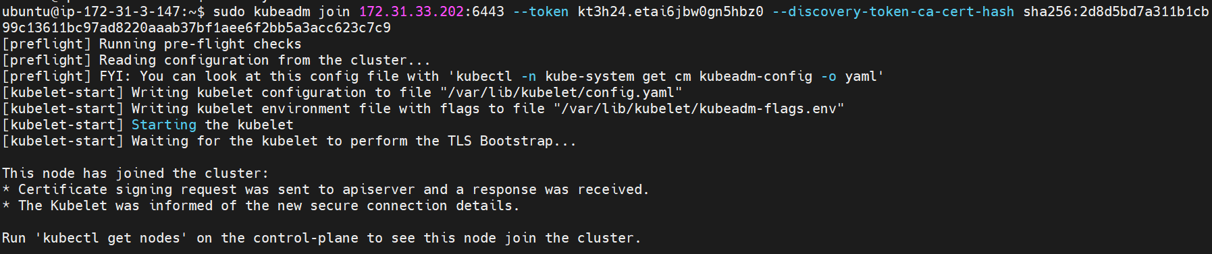

**Then verify the cluster nodes using below command:**

$ kubectl get nodes

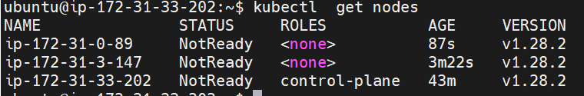

**Self-created K8S cluster is ready, we used Kubeadm (multi Node K8S Cluster)**



**How to use Kubectl Remote server in real-time:**

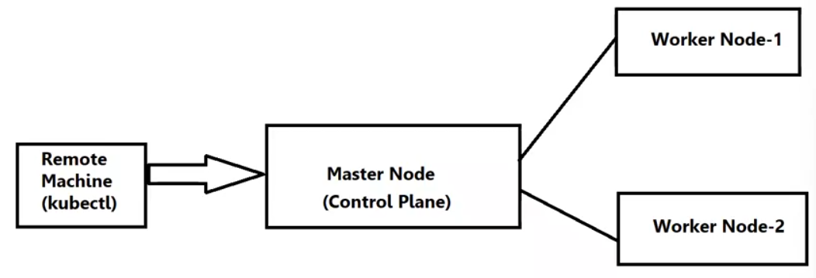

* In the Real-time, they didn’t share any details about master node to execute commands .
* So that will launch one more new server for install kubectl to communicate with master node.
* Here we are not disturbing the K8S cluster.

**How to Install Kubectl in Remote server:**

To install kubectl, the command-line tool for interacting with Kubernetes clusters, on an Ubuntu server, you can follow these steps:

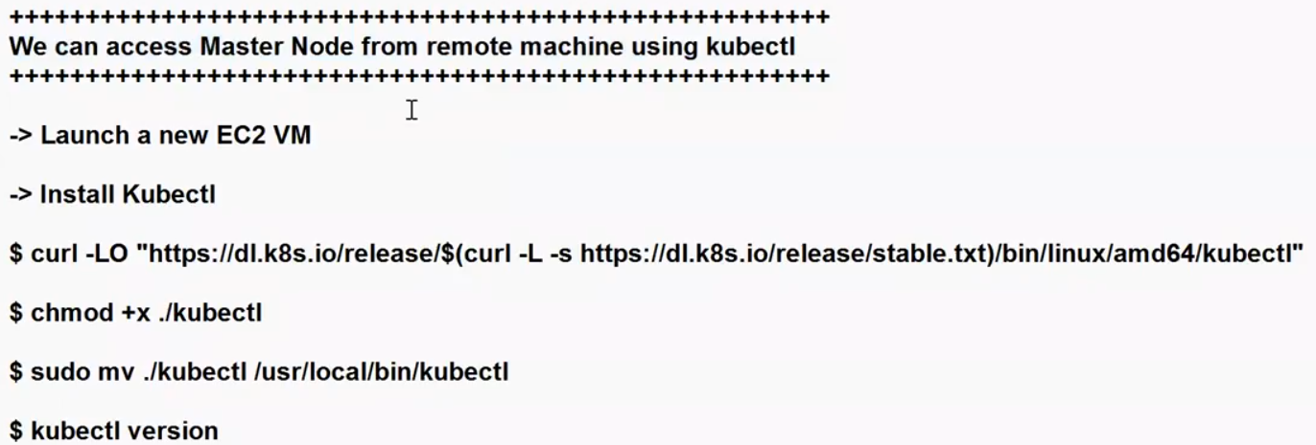

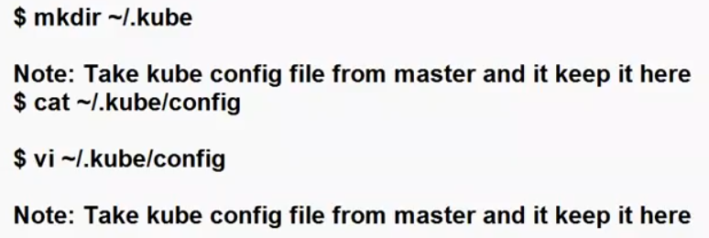

1. sudo apt update
2. Install kubectl: sudo apt-get install -y apt-transport-https ca-certificates curl
3. Download the kubectl binary:

sudo curl -LO [https://dl.k8s.io/release/$(curl -L -s https://dl.k8s.io/release/stable.txt)/bin/linux/amd64/kubectl](https://dl.k8s.io/release/$(curl%20-L%20-s%20https://dl.k8s.io/release/stable.txt)/bin/linux/amd64/kubectl)

1. Make the kubectl binary executable:

sudo chmod +x kubectl

1. Move kubectl to a directory in your PATH:

sudo mv kubectl /usr/local/bin/

1. Verify the Installation:

kubectl version –client

1. Create directory for kube-config file

Go to master node and will get kube-config file

$ cat ~/ .kube/config

1. Then go to kubectl server and directory for kube file.

Mkdir ~/.kube

1. vi ~/.kube/config

here you will copy the file.

* A kubeconfig file is a configuration file used by the Kubernetes command-line tool kubectl to specify how it should interact with a Kubernetes cluster.
* It contains several pieces of information and settings necessary for kubectl to communicate with a specific Kubernetes cluster. Here are the key elements typically found in a kubeconfig file:

Cluster Configuration:

* Cluster Name: A user-defined name for the cluster.
* Cluster Server: The URL of the Kubernetes API server for the cluster.
* Certificate Authority Data: The certificate authority (CA) that signs the server certificate, usually in PEM-encoded format. It's used to verify the server's certificate when making secure API requests.

User Configuration:

* User Name: A user-defined name for the user context.
* Client Certificate Data: The client certificate for authentication, often in PEM-encoded format.
* Client Key Data: The private key associated with the client certificate, also in PEM-encoded format.
* Token: An authentication token used instead of client certificates and keys.
* Username and Password: Alternative authentication options for username and password-based authentication.

Context Configuration:

* Context Name: A user-defined name for the context.
* Cluster: The cluster to use for this context.
* User: The user to use for this context.
* Namespace: The default namespace for kubectl commands when using this context.
* Current Context: Specifies which context should be used by default when running kubectl commands. Typically, you can switch between contexts to interact with different clusters or namespaces.

Then verify with cat command.

1. Then get the cluster info

$

1. Verify the nodes

$kubectl get nodes ( verify in master and kubectl nodes)

NOTE: if you are get any error like below, will restart the kubelet service in master node.

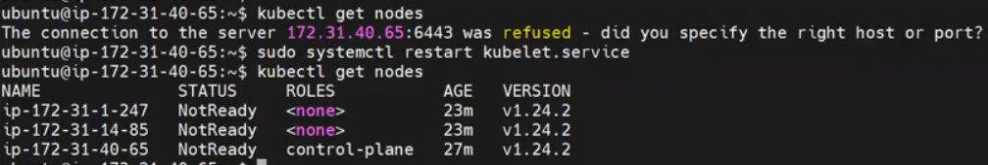

$sudo systemctl restart kubelet.service

1. Now execute in kubectl node

$kubectl get nodes

NOTE: once you will copy/paste the kubeconfig file from master node to kubectl node over write.

Cat > ~/.kube/config

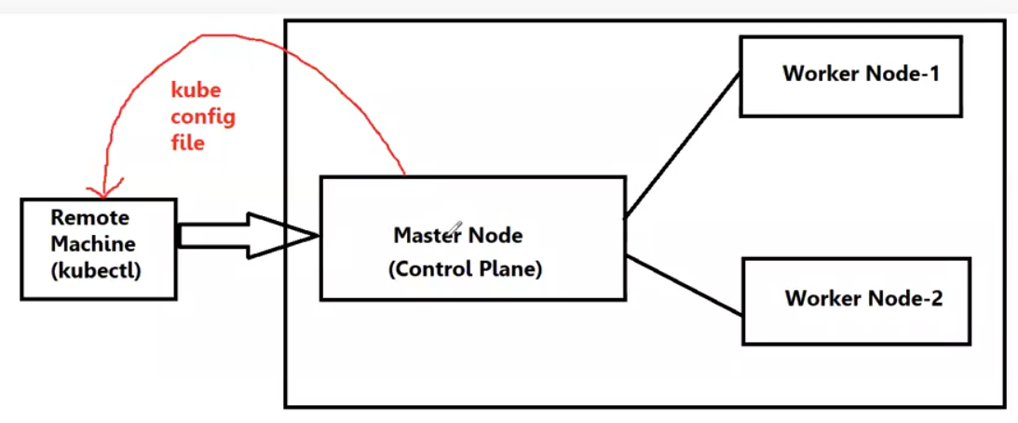

Here will copy the kube config file from master node to kubectl node.

Now verify the cluster info in kubectl server:

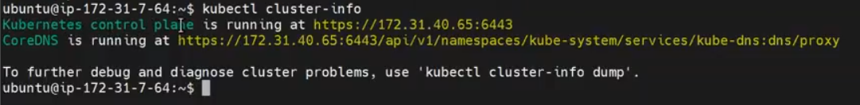

In kubectl node: $kubectl cluster-info

$kubectl get nodes (in master and kubectl node)

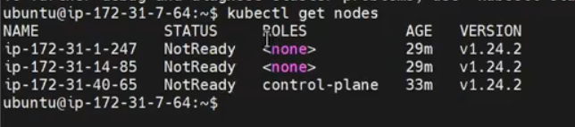

++++++++++++++++++++++++++++++++++++++++++++++++++++++++++++++++++++++

**Kubernetes core components:**

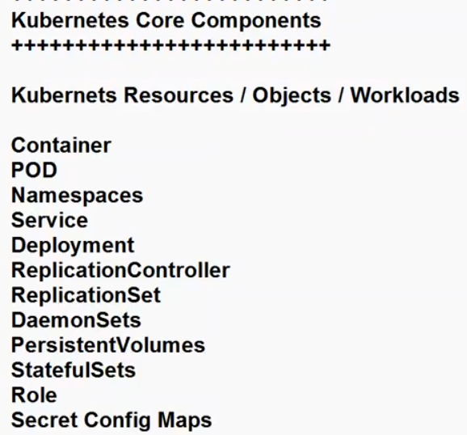

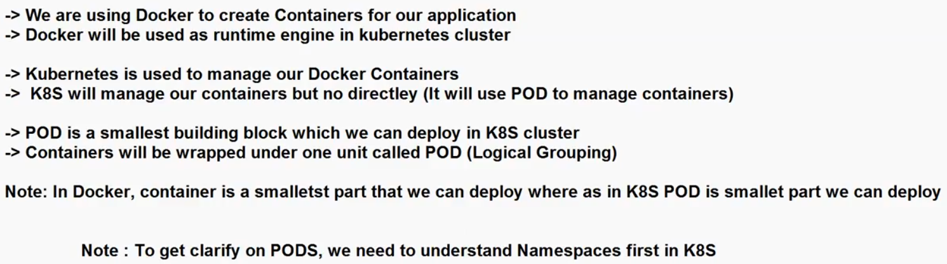

What is a Namespace in K8S:

* In Kubernetes (K8s), a namespace is a virtual cluster or a logical partition within a K8s cluster that is used to isolate and separate resources, applications, and objects.
* Namespaces are a way to organize and manage resources and workloads, providing a level of isolation and resource segmentation.

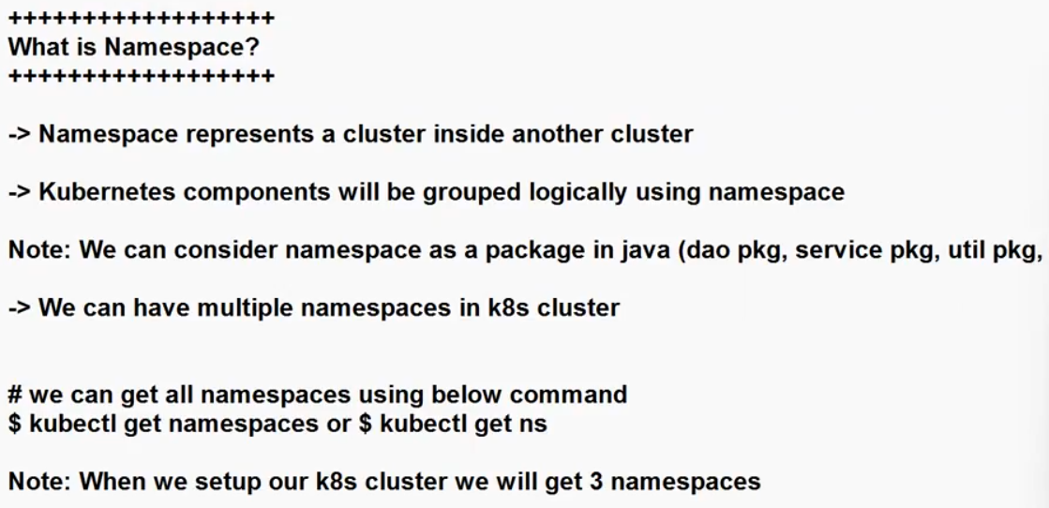

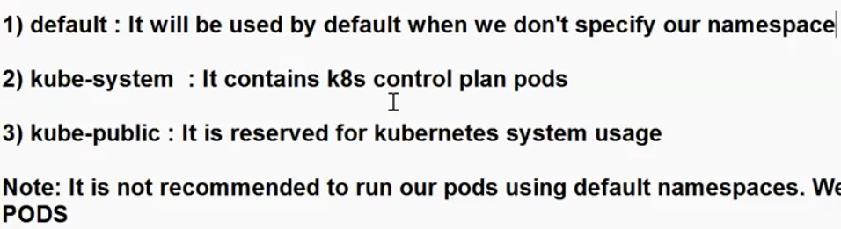

NOTE: It’s not recommended to run our POD’s using default namespaces. We have to create our own namespace to run our POD’s.

In a Kubernetes (K8s) cluster, there are several built-in namespaces, each serving a specific purpose:

1. default:

* The "default" namespace is the namespace where resources are placed if no namespace is specified during resource creation.
* It's often used for small deployments, testing, or when you haven't created additional namespaces for specific projects or teams.
* Resources in this namespace are typically not isolated from each other.

1. kube-system:

* The "kube-system" namespace is used to house Kubernetes system-level components and infrastructure services that are required for the cluster to function correctly.
* These include components like the API server, controller manager, scheduler, and add-ons like DNS and monitoring agents.
* Resources in this namespace are essential for the operation of the cluster and should not be deleted or modified without a thorough understanding of their purpose.

1. kube-public:

* The "kube-public" namespace is a special namespace that contains resources that should be made publicly accessible to all users (authenticated and unauthenticated) of the cluster.
* It is typically used to host a ConfigMap that is accessible to all pods in the cluster. For example, it may store a cluster-wide configuration or welcome message.

NOTE: It’s not recommended to run our POD’s using default namespaces. We have to create our own namespace to run our POD’s.

**How to get the all namespaces:**

$kubectl get namespaces

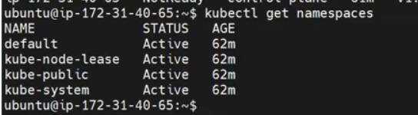

**How to create a custom namespace in K8S:**

Creating a custom namespace in Kubernetes on an Ubuntu server involves using the kubectl command-line

Syntax: kubectl create namespace <namespace-name>

Ex: $ kubectl create namespace my-namespace

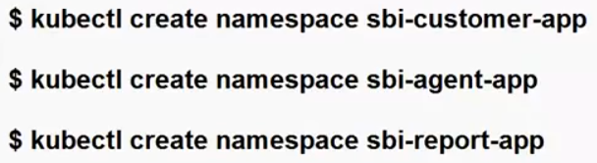

How to run a POD in custom namespace:

* You can run a pod in a custom namespace in Kubernetes (K8s) using kubectl by specifying the namespace in the kubectl create or kubectl apply command.

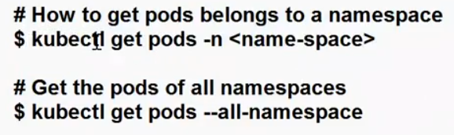

$kubectl get pods -n <your-custom-namespace>

$kubectl get pods –all-namespace

How to get all the POD’s are running in kube-system:

$kubectl get pods -n kube-system

* The command kubectl get pods -n kube-system is used to list all the pods that are running in the kube-system namespace of your Kubernetes cluster. The output will display information about the pods in that namespace, including their names, statuses, and more.

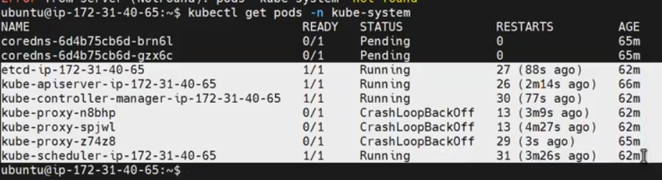

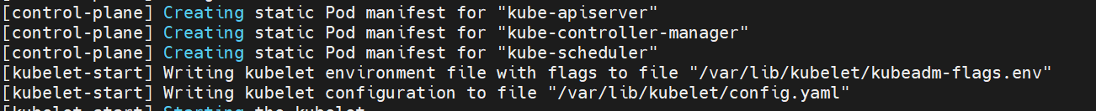

Here will observe kube-apiserver, kube-controller, kube-schedular, kube-etcd all the control plane components (POD’s)are running in one namespace ie: kube-system

* The kube-system namespace in Kubernetes (K8s) contains system-level components and infrastructure services that are critical for the functioning of the Kubernetes cluster itself.
* These components are essential for cluster management, monitoring, and networking.

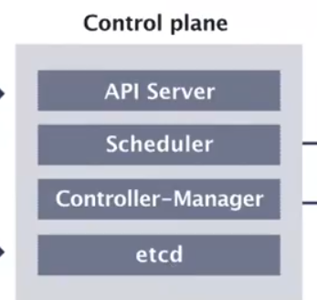

These all pods are running in one namespace, kube-system

Verify with kube-public default namespace as well:

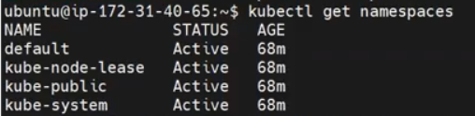

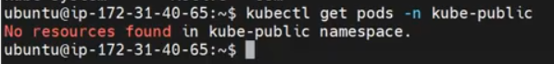

$kubectl get pods –n kube-public

NO resources found.

**How to delete custom namespace:**

To delete a namespace in Kubernetes (K8s), you can use the kubectl delete command.

Syntax: kubectl delete namespace <namespace-name>

Ex: $kubectl delete namespace my-namespace

Verify: $kubectl get namespaces

NOTE:

* Termination of All Resources: All resources (pods, services, deployments, config maps, secrets, etc.) that belong to the deleted namespace are terminated and deleted. This includes both user-created resources and system-level resources associated with the namespace.
* Pod Termination: Pods running in the deleted namespace are terminated gracefully
* Services Deletion: Any services defined within the namespace are deleted. These services are no longer accessible from other namespaces or externally.
* Garbage Collection: Kubernetes has a garbage collection mechanism that ensures the cleanup of resources associated with the deleted namespace, even if their owner references the namespace.
* It's important to note that deleting a namespace is a potentially destructive operation. You should exercise caution and ensure that you intend to delete the namespace and its resources.
* Always take backups or follow disaster recovery procedures if the data within the namespace is critical.
* Please be extremely cautious when deleting namespaces, as it will delete all resources within the namespace, and the data may be irrecoverable.
* Always double-check your command and ensure you intend to delete the namespace before confirming the deletion.

As of now we did these all the concepts:

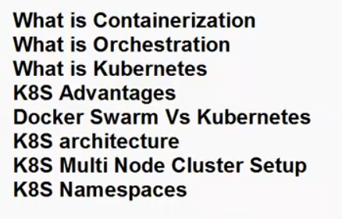

**What is a POD?**

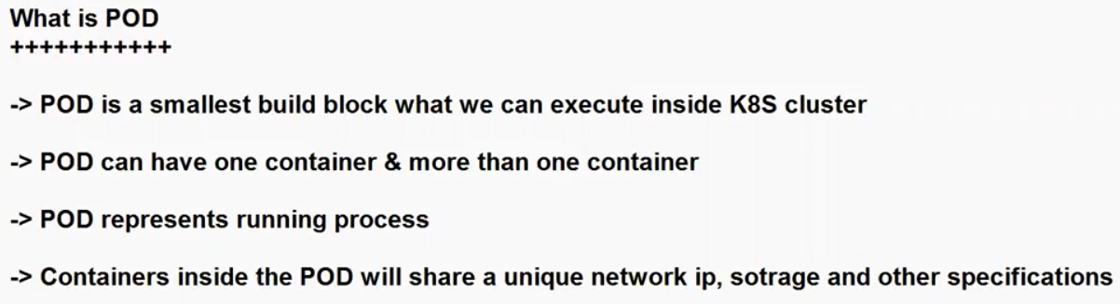

* In Kubernetes (often abbreviated as K8s), a "Pod" is the smallest deployable unit. It represents a single instance of a running process in a cluster.
* Containers within the same Pod are typically tightly coupled and share resources and configuration.
* Pods are a fundamental building block in Kubernetes, and they are used to deploy applications and services.

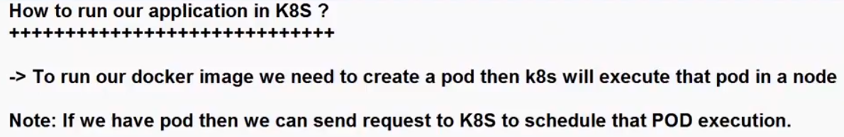

How to create a POD?

We can create a Pod in Kubernetes using two common methods: imperative(Interactive) and declarative.

1. Imperative Method /interact(using kubectl commands)
2. Declarative Method (using YAML configuration files)

**Imperative Method (using kubectl commands):**

1. Using kubectl run:

* The kubectl run command allows you to create a Pod in an imperative manner, specifying various parameters directly on the command line. This method is handy for quick testing and debugging.

Syntax: kubectl run my-pod --image=my-image

This command creates a Pod named "my-pod" using the specified Docker image "my-image" and exposes port 80.

1. Using kubectl create:

* You can also create a Pod by providing a YAML configuration directly via the kubectl create command. This method is useful when you have a pre-defined Pod configuration in a YAML file.

Syntax: Kubectl create –f <YAML-FILE>

EX: kubectl create -f pod-definition.yaml

Here, "pod-definition.yaml" is a YAML file containing the Pod definition.

**Declarative Method (using YAML configuration files):**

Create a YAML File:

* First, create a YAML file that defines your Pod. Here's an example YAML for a simple Pod:
* To create a Pod using a YAML file in Kubernetes, you need to define the Pod's configuration in a YAML file and then use the kubectl apply command to apply that configuration to your cluster. Here are the steps:

Create a YAML File: Create a YAML file with the configuration for your Pod. The following is a minimal example of a Pod YAML file:

apiVersion: v1

kind: Pod

metadata:

name: my-pod

spec:

containers:

- name: my-container

image: nginx:latest

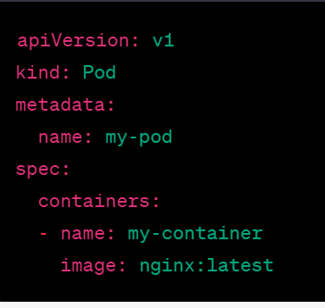

In this example:

* apiVersion specifies the Kubernetes API version for the Pod resource (in this case, "v1").
* kind specifies the type of resource (in this case, "Pod").
* metadata contains metadata about the Pod, including its name.
* spec defines the specification for the Pod, including the containers it should run. In this case, there is one container named "my-container" that runs the "nginx" image.

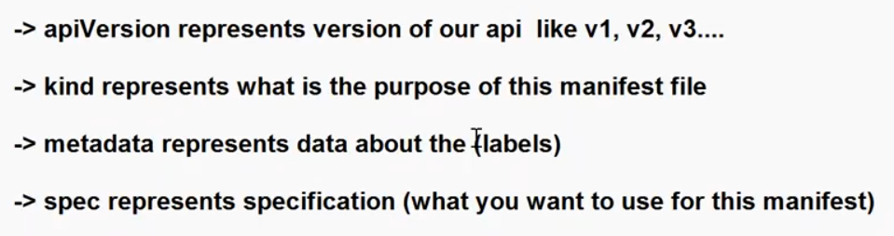

Save the YAML File: Save the YAML file with a descriptive name (e.g., my-pod.yaml).

Apply the YAML File: Use the kubectl apply command to create the Pod based on the YAML configuration:

$kubectl apply -f my-pod.yaml

Verify the Pod Creation:

You can verify that the Pod has been created by running:

$kubectl get pods

* This command will list all the Pods in your cluster, and you should see your newly created Pod in the list.
* You've created a Pod in Kubernetes using a YAML file. You can modify the YAML file to include additional configuration options such as environment variables, resource limits, volumes, and more, depending on your application's requirements.

**28-09:**

**How to create a POD?**

We will create a POD using Declarative method(manifest file).

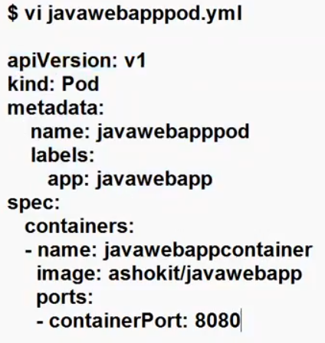

How to create a POD using manifest file and how to get the existing POD’s:

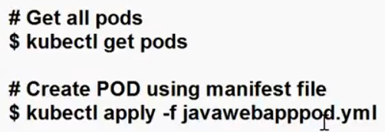

**How to verify control plane components status:**

**# ku get componentstatuses**

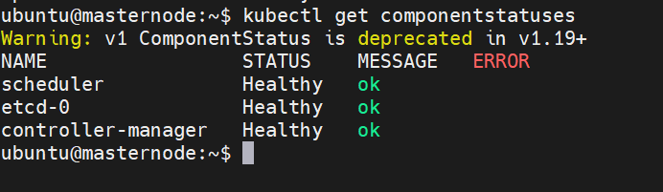

ubuntu@ip-172-31-45-206:~$ kubectl get componentstatuses

**LAB**:

Verify have any existing pod’s ?

$kubectl get pods



* In the worker node , where the POD’s will be created ?
* where the pod is created? Under which ns? If we are not given any custom NS, when pod creation time.

ubuntu@ip-172-31-45-206:~$ kubectl get ns

#NOTE: don’t launch 22.04 ubuntu version , use 20.04 version only.

How to create a manifest file:

For better understand go with VStudio.

$vi javawebapppod.yml

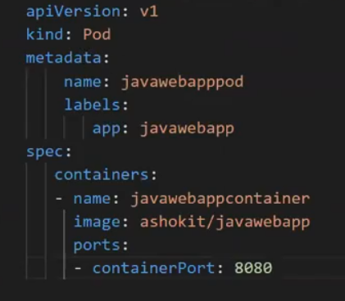

* Need to verify the manifest file, using cat command.

$Cat javawebapppod.yml

* Now I have a manifest file, which method I will use to create a POD?
* Will go with Declarative method.

$kubectl apply –f <manifest file>

$kubectl apply –f javawebappppod.yml



If my pod is not running(containercreating) execute this command

kubectl taint nodes ip-172-31-10-5 node-role.kubernetes.io/control-plane-

NOTE: when I execute this above command in cluster what’s going on inside the cluster?

1. When I send the request through kubectl , the request receive a control plane.
2. In the API server will receive the request.
3. API server will store the request meta data in etcd(etcd all ways sink with API server)
4. Then scheduler takes the request meata data from etcd.
5. Scheduler will talk with kubelet
6. Then schedule using by the controller-manager.

Verify the POD’s:

$kubectl get pods

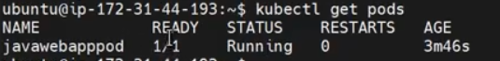

**How can I know my pod complete details?**

Now let’s describe the pod: It will show’s all the details about pod(like postmortem)

Syntax: $kubectl describe pod <pod-name>

Ex: $kubectl describe pod javawebapppod

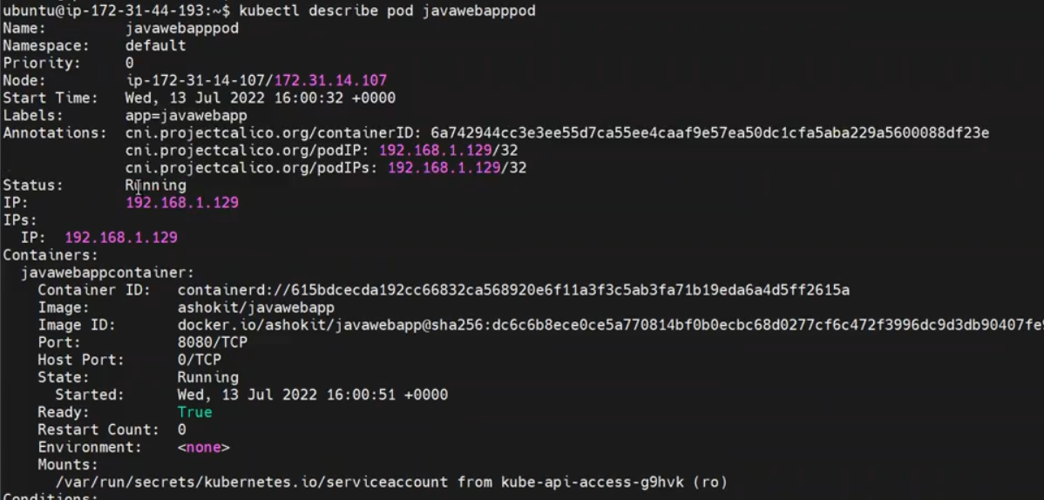

In the above pic , we will see complete information about pod.

**How can I know where the pod is running? Which node?**

Syntax: $kubectl get pods –o wide



NOTE: If my pod status is not running execute below command:

$kubectl taint nodes ip-172-31-10-5 node-role.kubernetes.io/control-plane-

In the above pic, we will see the pod details.

**POD NAME**

**READY**

**STATUS**

**RESTARTS**

**AGE**

**IP (this is pod ip OR worker node IP?)**

**NODE (node IP, pod is running this worker node)**

K8S cluster assign on unique Ip to pods.

**How to get the response from pod:**

$curl <pod ip>:<port> (where we execute this command in control plane or worker node?)

Ex: $curl 192.168.1.1:8080

Open service port in SG ( contrl plane)

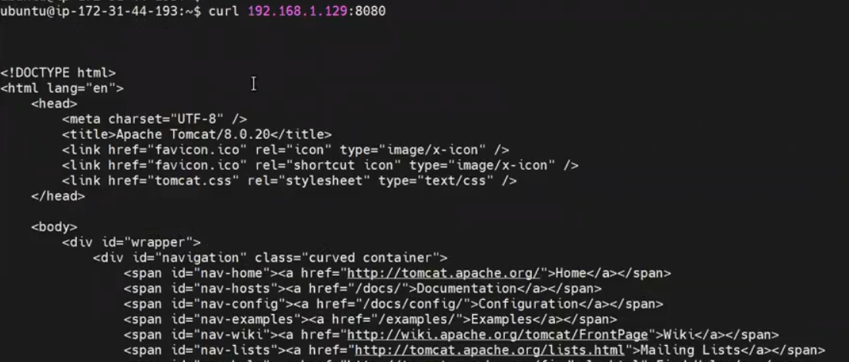

**Qns: actually where the pod is runngin?**

Can I get the pod response from worker nodes as well? Yes will get it.

Will execute the curl command in worker nodes as well , get the pod response.

**Re-collect all what we have discussed:**

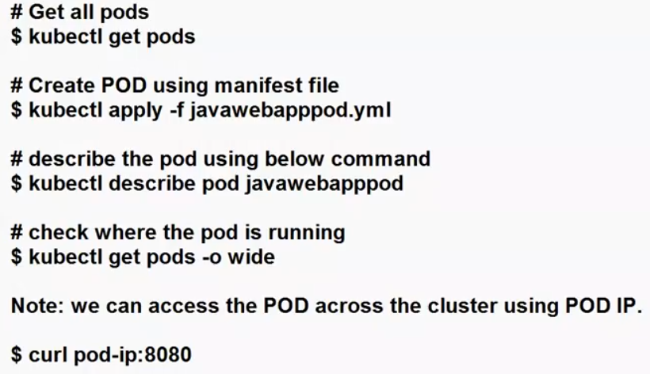

**Qns: can we access the POD, outside of the cluster?**

Go to browser 🡪 podip: port (try with node ip as well)

We cannot access? Pod will be access with in the cluster only.



**Qns: Can you please explain POD life cycle in K8S cluster using below architecture.**

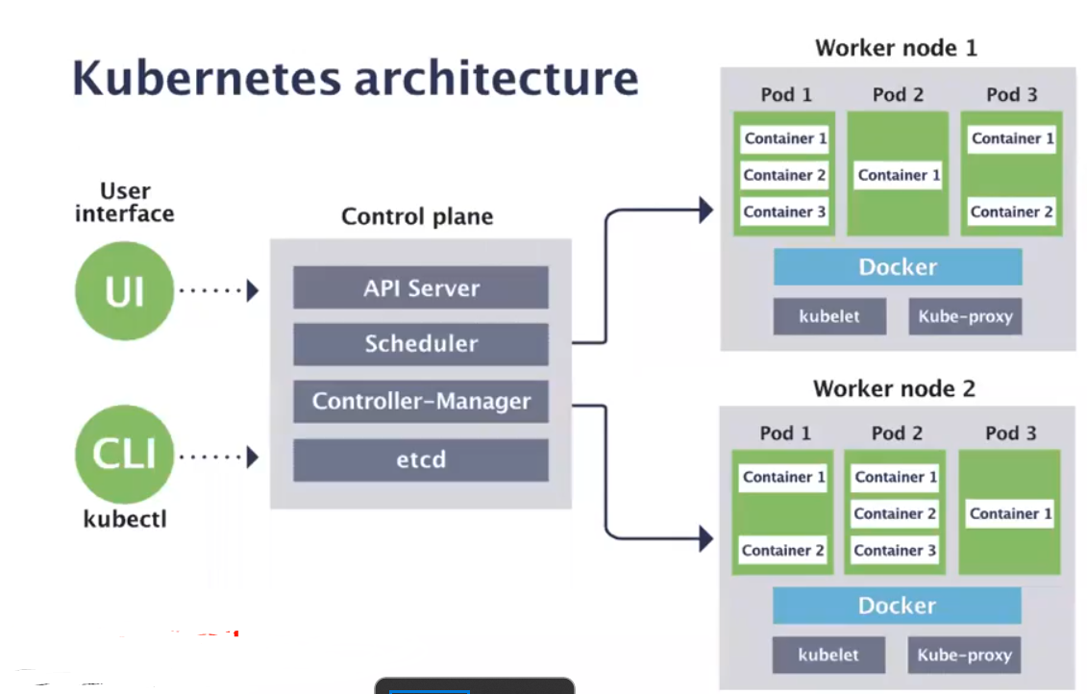

POD Life Cycle:

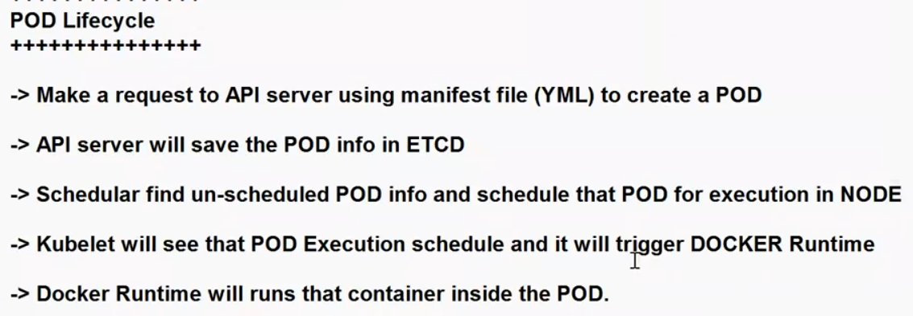

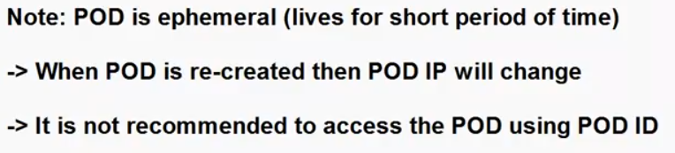

NOTE: when I modified my manifest file, the POD will be recreate, means kill the existing pod and recreate one new pod based on new manifest file.

When the new pod is created IP will be changed.

This is the reason, we are not recommend access the POD using pod ip address.

**Qns: In my pod running 3 containers, if I changed my manifest file, what’s going on?**

In Kubernetes, whether your Pod is recreated when you update the manifest file depends on how you apply the changes to the Pod and what type of changes you make.

1. **Immutable Containers:** If you make changes to the Pod's manifest file that only affect non-essential properties of the containers (e.g., environment variables, command, resources, labels), the existing containers are not recreated. These changes are typically applied without disrupting the running containers.

**What is the Mutable & Immutable?**

The terms "mutable" and "immutable" describe whether an object or data structure can be changed after it is created. These terms are commonly used in computer science, programming, and software engineering to describe how data behaves.

**Mutable:**

Changeable: Mutable objects or data structures can be modified or altered after their creation.

**Immutable:**

Unchangeable: Immutable objects or data structures cannot be modified once they are created.

1. **Image Updates:** If you update the image version for one or more containers within the Pod's manifest file, Kubernetes will recreate those containers with the new image. However, other containers in the same Pod that were not affected by the change will continue to run without interruption.
2. **PodSpec Changes:** If you make changes to the Pod's specification that are not compatible with an in-place update (e.g., changing the container's name or ports), Kubernetes will recreate the entire Pod to apply the changes. This can lead to downtime if you have only a single replica of the Pod.

* To apply changes to your Pod's manifest file, you typically use the kubectl apply command or other methods such as kubectl replace or kubectl edit. The behavior of whether the Pod is recreated or not depends on the specific changes you are making.



**What is kubeadm command in K8S cluster:**

* kubeadm is a command-line utility used to bootstrap and manage Kubernetes (K8s) clusters. It is part of the Kubernetes project and is designed to simplify the process of setting up and configuring the control plane nodes (master nodes) and worker nodes in a Kubernetes cluster. kubeadm

**29-09**

**NOTE: give alias name to kubectl => $alias k=kubectl ( only for that session only)**

**What is Kubernetes Service:**

* In a Kubernetes (K8s) cluster, services are a fundamental concept that enables network communication to and between the pods running within the cluster.
* Kubernetes services allow you to abstract away the details of how individual pods are networked and provide a consistent way to access them, even as pods are created, terminated, or scaled up and down.
* There are several types of services in a Kubernetes cluster:

1. **ClusterIP**
2. **NodePort**
3. **LoadBalancer**

**4.ExternalName**

**5.HeadLess**

**6.Ingress**

**ClusterIP:**

* This is the default service type.
* It exposes the service on an internal cluster IP address, making it accessible only from **within the cluster.**
* It's suitable for services that should only be accessed from other pods within the same cluster.

**NodePort:**

* This service type exposes the service on a static port on each node's IP address.
* It allows external traffic to reach the service by connecting to any node in the cluster on the specified port.
* NodePort is typically used when you need to expose a service to external clients.

**LoadBalancer:**

* This service type provisions an external load balancer (like a cloud load balancer) and assigns it a public IP address.
* The load balancer then routes traffic to one of the cluster nodes and, subsequently, to the service.
* This is useful for distributing external traffic across a set of pods

**Ingress:**

* Ingress is not a service type, but it's often used in conjunction with services. Ingress resources define rules for routing external HTTP and HTTPS traffic to services within the cluster.
* It acts as a layer of HTTP routing and load balancing.
* These service types provide flexibility in how you expose and manage network communication to your applications within a Kubernetes cluster.
* The choice of service type depends on your specific use case and requirements, such as whether the service needs to be accessed externally, how traffic should be load-balanced, and whether you want to use DNS for service discovery.

**How to get list of existing K8S services:**

Use the following kubectl command to list all services in the currently configured Kubernetes cluster:

Syntax: kubectl get services

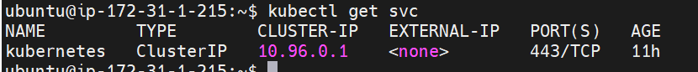

**How to get a list of services from all namespaces in the cluster**

$kubectl get services --all-namespaces

* If you only want to list services in a specific namespace, you can specify the namespace using the -n or --namespace flag.

$kubectl get services –n <NS>

**Qns: how to know my K8S cluster name?**

$kubectl config current-context

**How to see my cluster config file?**

$cat ~/.kube/config

Note: sudo cp -i /etc/kubernetes/admin.conf $HOME/.kube/config

**How to write a ClusterIP Service manifest file:**

To create a ClusterIP service in Kubernetes, you can write a YAML manifest file that describes the service's properties. Here's an example of how to write a ClusterIP service YAML file:

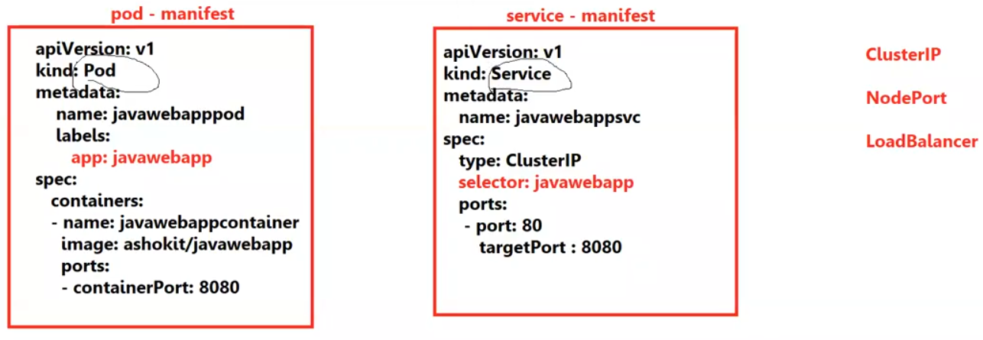

* **apiVersion**: specifies the Kubernetes API version being used (v1 in this case).
* **kind** : specifies that we're creating a Service.
* **Metadata**: contains metadata about the service, including its name (my-clusterip-service in this case).
* **spec** : contains the service's specification.
* **Type**: which type of cluster
* **Selector**: specifies which pods the service should target. In this example, it selects pods with the label app: my-app. Make sure the pods you want to expose have this label.
* **Ports**: defines the ports to open on the service. Here, we expose port 80 on the service, and it forwards traffic to pods on port 8080.

To apply this YAML file to your Kubernetes cluster and create the ClusterIP service, you can use the kubectl apply command.

**How to create a K8S Cluster-IP service using manifest file:**

Syntax: $kubectl apply -f <service-manifestfile>

Ex: kubectl apply -f my-clusterip-service.yaml

Note: Replace my-clusterip-service.yaml with the actual filename of your YAML file.

* After applying the YAML file, you can verify that the service was created successfully using:

$kubectl get svc < service-manifestfile>

Ex: kubectl get svc my-clusterip-service

* This command will show you information about the ClusterIP service, including its ClusterIP address, ports, and more.
* The service will be accessible within the cluster at the specified ClusterIP address and port, and it will route traffic to the pods matching the selector labels specified in the YAML file.

**How to access a ClusterIP service in a Kubernetes cluster:**

* Identify the ClusterIP Service: First, ensure you know the name of the ClusterIP service you want to access. You can list all services in your cluster using the following command.

$kubectl get services

Look for the service you want to access and note its name.

* **Access from within the Cluster:** ClusterIP services are designed for communication within the cluster. Pods running within the same Kubernetes cluster can access the service using its ClusterIP and port.
* For example, if your ClusterIP service is named my-clusterip-service and it listens on port 80, a pod within the same cluster can access it using my-clusterip-service and port 80.

**$ curl my-clusterip-service:80**

**Testing Connectivity:** You can test connectivity from within a pod using the kubectl exec command.

For example:

$ kubectl exec -it your-pod-name -- curl my-clusterip-service:80

Here Replace your-pod-name with the name of the pod from which you want to test connectivity.

**How to get my pods: $kubectl get pods**

NOTE: Access from Outside the Cluster (Optional): If you need to access the ClusterIP service from outside the cluster, you have a few options:

**Port Forwarding:** You can use kubectl port-forward to forward a local port to the ClusterIP service.

For example.

$kubectl port-forward svc/my-clusterip-service 8080:80

NOTE: Remember that ClusterIP services are primarily intended for internal communication within the cluster. If you need to expose a service to the external world, consider using NodePort or LoadBalancer service types, or set up an Ingress controller for more advanced routing and external access.

**How to write a NodePort Service in K8S :**

Same as above, here we have to change the type: NodePort

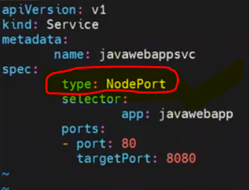

To apply this YAML file to your Kubernetes cluster and create the NodePort service, you can use the kubectl apply command:

**$ kubectl apply -f my-nodeport-service.yaml**

Replace my-nodeport-service.yaml with the actual filename of your YAML file.

After applying the YAML file, you can verify that the service was created successfully using:

**$kubectl get svc**

This command will show you information about the NodePort service, including its NodePort number, ports, and more.

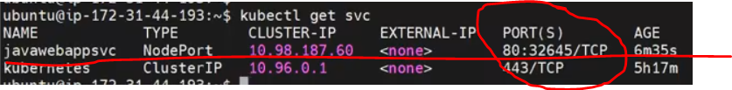

NOTE: you should have to open Nodeport port number in the Security Group.(what we have to assign the security group in the cluster nodes)

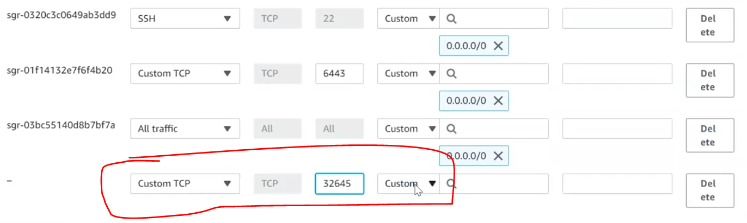

The service will be accessible externally from outside the cluster using any node's IP address and the NodePort number.

For example, if the NodePort is 30000, you can access the service using <http://node-ip:30000>.

Ex: http://<master-node-ip: 30000 OR http://<workernode-ip:30000>

If you want access inside the cluster: $curl <cluster-ip>:nodeport

Here cluster-ip is : 10.98.187.60:32645



Here cluster-ip is : 10.98.187.60:32645

Please note that NodePort services are exposed on every node in the cluster, and the NodePort number is typically in a range defined by Kubernetes (e.g., 30000-32767).

Go to browser 🡪 node-ip(master or worker): clusterPORT

EX: $curl 13.233.133.11: 30184 (inside cluster)

<http://master-ip/worker-ip>: cluster-ip (same above example)

url : [13.233.133.11:30184/java-web-app/](http://13.233.133.11:30184/java-web-app/)

Recollect all the Points:

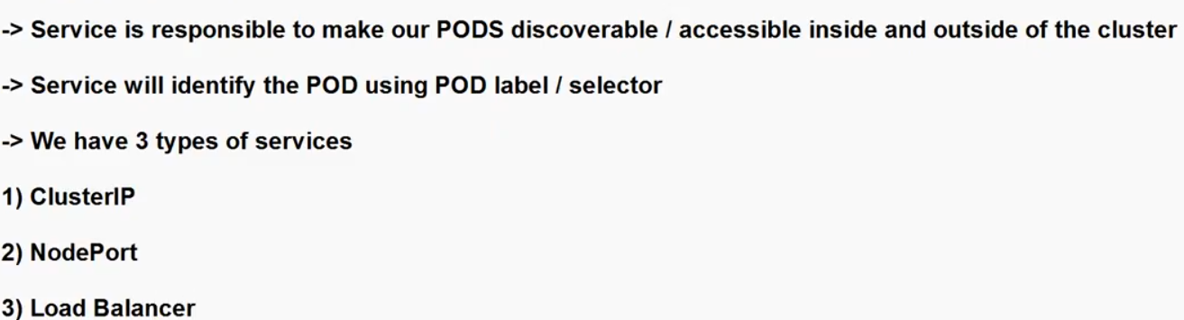

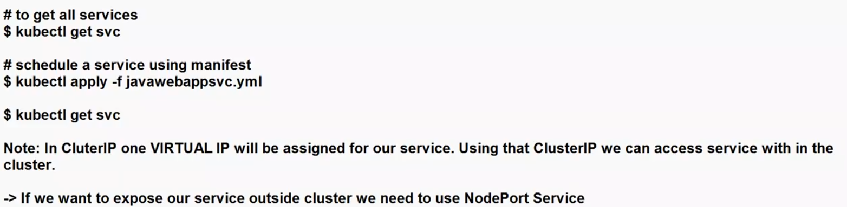

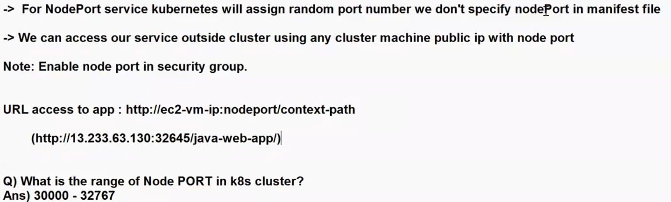

**Load Balancer Service:**

* In Kubernetes (K8s), a LoadBalancer service is a type of service that provides external network access to services running inside a cluster.
* It is particularly useful when you have a Kubernetes cluster running in a cloud environment or with a load balancer provider that can provision external load balancers dynamically.

**External Load Balancer Integration:**

* A LoadBalancer service is designed to work with cloud providers that support load balancers (e.g., AWS, GCP, Azure).
* When you create a LoadBalancer service, Kubernetes communicates with the cloud provider's API to provision an external load balancer to distribute traffic to the pods in your service.

**Automatic IP Assignment:**

* LoadBalancer services typically get an externally accessible IP address (e.g., a public IP) automatically assigned by the cloud provider.
* This IP address is associated with the external load balancer, and traffic directed to this IP is forwarded to the pods that belong to the service.

**Service Load Distribution:**

* The external load balancer distributes incoming traffic to the pods in the service using various load-balancing algorithms (e.g., round-robin, least connections)

**Health Checks:**

* Load balancers often perform health checks on the backend pods to determine their availability. If a pod becomes unhealthy, the load balancer may stop sending traffic to it until it recovers.

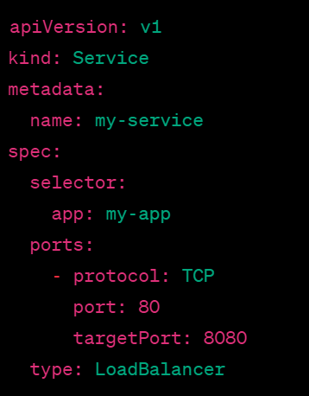

* In above service, who is created the POD, it’s crated manually.
* If I delete the POD, can I access my application?

$kubectl delete pod <pod-name>

Qns: If I delete the POD, application will access OR application will not access?

When I deleted the pod Service is running, but inside the service pod is not existed.

Qns: Here when I deleted the pod, K8S will recreate the POD or will not recreate?

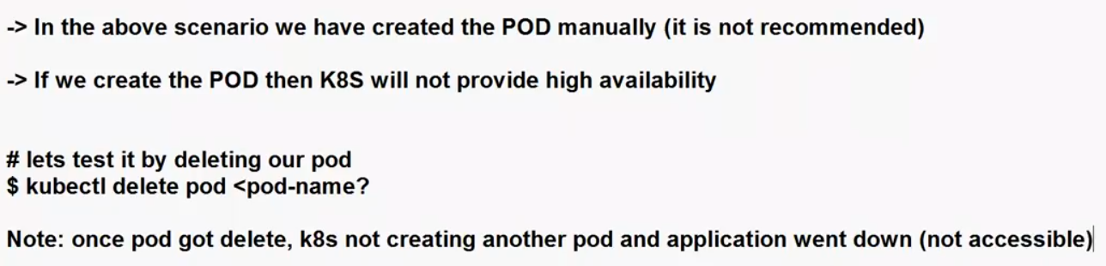

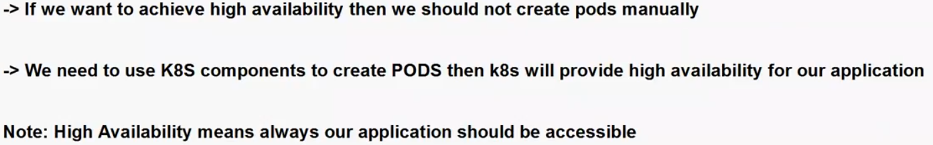

**01/10/23**

**Cluster high availability:**

NOTE: Recommended don’t create pod’s manually, if you create the pod’s manually when you deleted the pod the application will goes down.

SO that recommends using k8s components to create a pod. Below are the components for POD’s high availability.

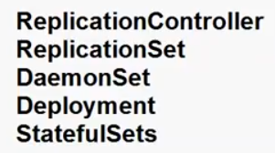

**What is the Replication Controller?**

* A Replication Controller in Kubernetes (K8s) is used for managing the desired number of pod replicas and ensuring their availability and stability within a cluster.
* While it has been largely replaced by Deployments and Replica Sets in recent Kubernetes versions, it's still important to understand what a Replication Controller is because it lays the foundation for these newer abstractions.

Here are the key characteristics and functions of a Replication Controller:

1. Desired Replicas: A Replication Controller specifies the desired number of replicas (identical copies) of a pod that should be running at any given time. You define this desired count in the controller's configuration.
2. Pod Template: The Replication Controller uses a pod template to create new pods. The template includes information like the container image, ports, labels, and other specifications.
3. Automatic Scaling: If the actual number of replicas diverges from the desired count, the Replication Controller takes corrective action. It can create new pods if there are too few replicas or terminate excess pods if there are too many. This automatic scaling ensures that the specified number of pods are maintained.
4. Selectors: Replication Controllers use label selectors to identify which pods belong to their controlled set. Pods that match the selector are considered part of the controller's replication target.
5. Imperative Updates: Replication Controllers are updated imperatively. If you want to change the pod template or desired count, you must update the controller's configuration directly. This approach is different from Deployments, which use a declarative approach.

Overall re-collect about RC:

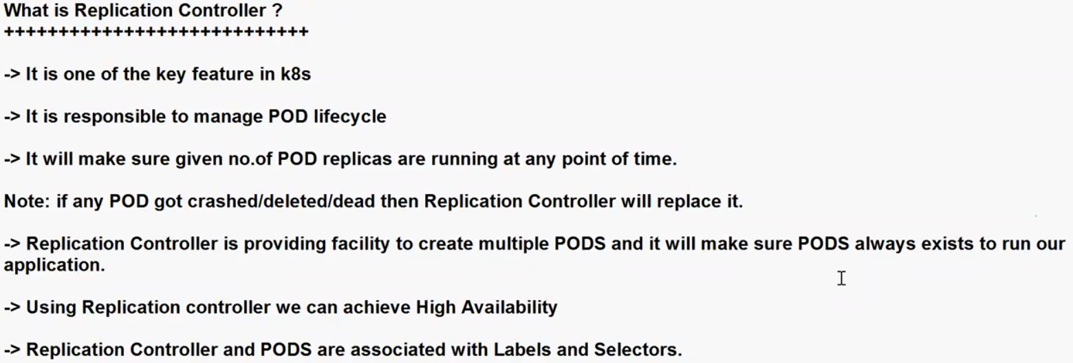

How to write a manifest file for replication controller:

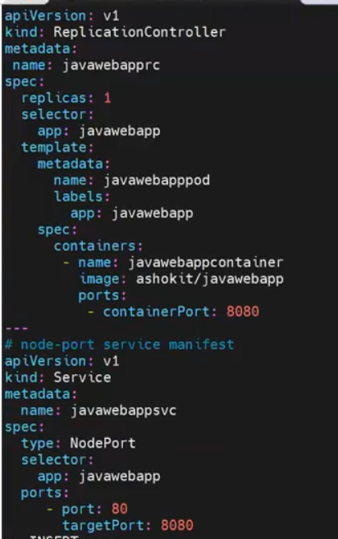

Then execute the command to create the pod with replication controller and node-port service.

ports: Specifies the ports that the Service will listen on and forward traffic to. The port is the port on which the Service will be accessible externally, and targetPort is the port on which the pods are listening.

$kubectl apply –f <manifest file>

How to verify my pods and service:

$kubectl get pods

$kubectl describe pod pod-name

$kubeclt get pods –o wide

**How to get my RC-Services:**

$kubeclt get rc (here will verify Replication controller service only)

Now verify Replication controller:

If we delete the pod , the replication controller will recreate the pod , automatically.

How to delete thepod: $kubectl delete pod <pod-name>

Then verify pods, existing pod is deleted and RC created one new pod.

$kubectl get pods.

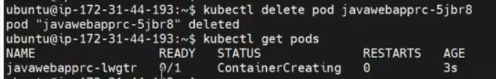

Note: When deleted the pod, will take couple of seconds’ re-creating the pod, that is the application down time(observe above dig)

RC is the Self-healing capability in k8s

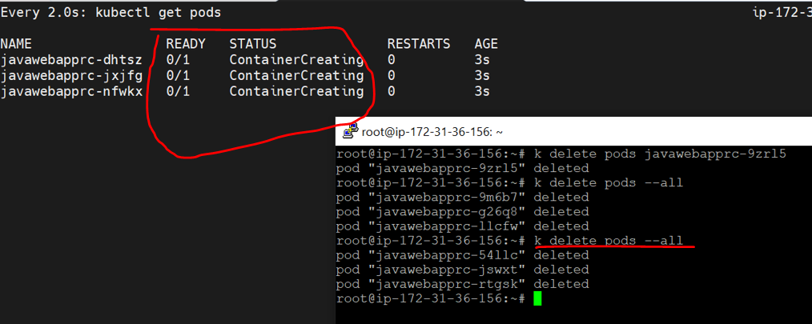

NOTE: Not Recommended create the pod’s using replication controller.

Ho to verify : open putty 🡪 #watch kubectl get pods

Second terminal🡪 # ku delete pods –all

Here will observe the pods deleting and creating.

**How to scale my application:**

* Running the application in multiple containers is scaling.
* Currently application is running in one pod.
* Now scale-up the application.

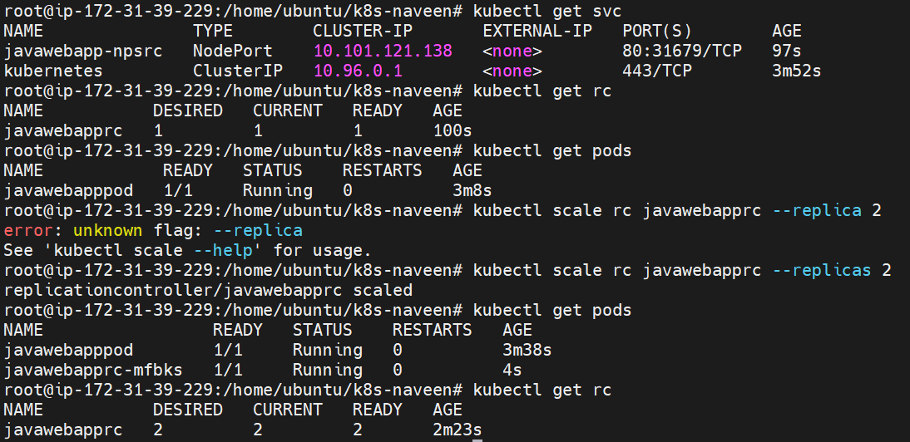

$kubectl scale rc <replication-controller-name> --replicas 3

Ex: $kubectl scale rc javawebapprc --replicas 3

**NOTE:When I change the replicas 3 to 5 It will crate 2 new pods.. already 3 existed and it’s create 2 new pods.**

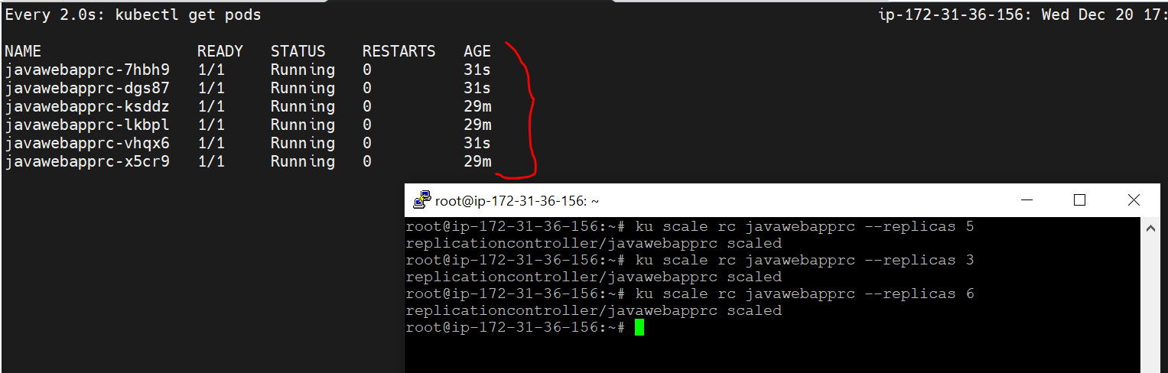

Then verify the pods: $kubectl get pods

This is the high availably.

Verify High availability : delete the pod: $kubectl delete pod <podname>

Note: Immediately replace the another pod(this is self-healing, high –availability)

* To determine how many pods are running in your Replication Controller (commonly referred to as ReplicaSet in modern Kubernetes)

#kubectl get rc



NOTE: try to scale down here

++++++++++++++++++++++++++++++++++++++++++++++++++++++++++++++++++++++++++++++++++++++

**2.What is Replica-Set:**

Replica set is a next generation of replica-controller

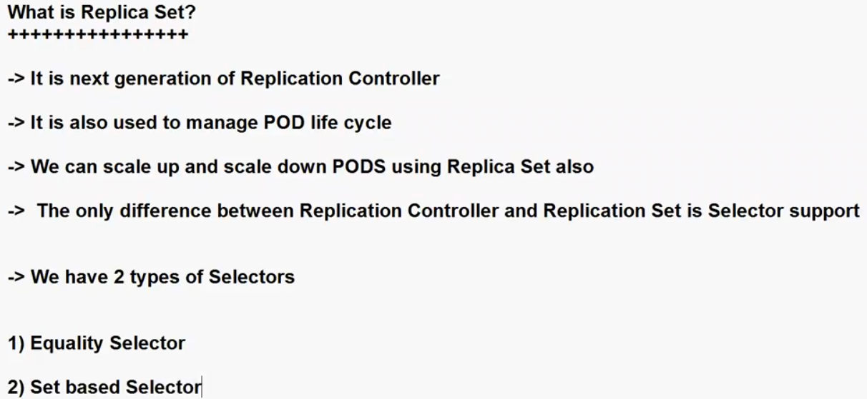

* When a ReplicaSet needs to create new Pods, it uses its Pod template.
* All Pods acquired by a ReplicaSet have their owning ReplicaSet's identifying information within their ownerReferences field.
* A ReplicaSet identifies new Pods to acquire by using its selector.

**Difference Between Replication Controller and Replica Set:**

* In Kubernetes, both ReplicationControllers and ReplicaSets are used to manage the number of replica Pods running in a cluster, but they have some key differences:

1. API Version and Kind:

ReplicationController: Uses the API version v1 and has the kind ReplicationController.

ReplicaSet: Uses the API version apps/v1 and has the kind ReplicaSet.

1. Selector Matching:

ReplicationController: Uses the equality-based selector. It only supports simple equality-based selectors.

ReplicaSet: Uses set-based selectors. It supports more powerful set-based selectors, allowing for more complex and flexible filtering of Pods.

3.Updates Triggered by Changes:

ReplicationController: Typically updates Pods based on changes in the replicas field of the controller's manifest. If you update the replicas field, it will trigger a scaling action.

ReplicaSet: Uses a **rolling update strategy** based on changes in the template specification. When you change the template, it triggers a rolling update, which allows for more controlled and fine-grained updates.

* What is Rolling Up-dates:

Rolling updates in Kubernetes (K8s) refer to a strategy for updating or upgrading applications deployed within a Kubernetes cluster without causing downtime or service interruptions. This strategy is commonly used to ensure that your applications remain available and responsive to users while you make changes, such as deploying a new version of your application or updating its configuration.

4.Label Selector Syntax:

Replication-Controller: Uses equality-based label selectors like app=my-app.

ReplicaSet: Supports both equality-based and set-based label selectors, allowing for more complex selection criteria.

5.Scaling Behavior:

Replication-Controller: When you scale a Replication Controller, you explicitly set the desired number of replicas in the replicas field, and it attempts to maintain that number.

Replica-Set: Supports auto-scaling based on metrics (Horizontal Pod Auto scaler - HPA) more naturally, although this feature can be used with both Replication-Controllers and Replica-Sets.

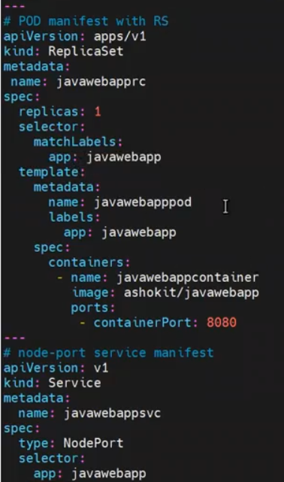

**How to create a replicas using manifest file:**

$kubectl apply –f replicaset.yml

Then verify the Pods: $kubectl get pods

How to get my replica-set count:

#kubectl get replicaset



How to scale my pods :

$kubectl scale rs javawebapprs –replicas 2

Verify: $kubectl get pods

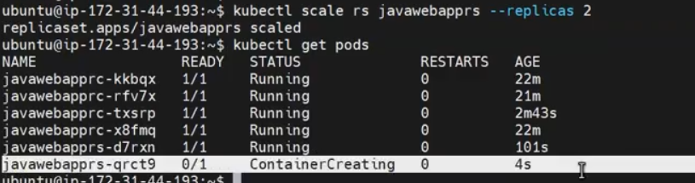

Observe container is creating.

The below command will give the metadata of the of the pod.

$kubectl describe pods frontend-b2zdv -o yamlS

Qns: when I execute the command to create the pod, who will decide the pod will create which node?

As of now control plane is decide.

Qns: I have 5 worker node cluster is existed, when I created a pod it will create one of the worker node in the cluster, but now I want create a pod in all the worker nodes by default? How?

NOTE: In replica-controller and replica-set both scenarios, if we want more replicas will increase the pods manually through scale command.

The below dig , shows my current pods in my worker nodes.

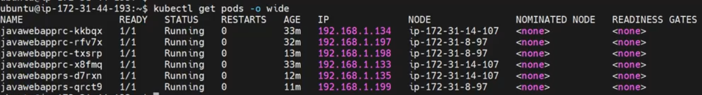

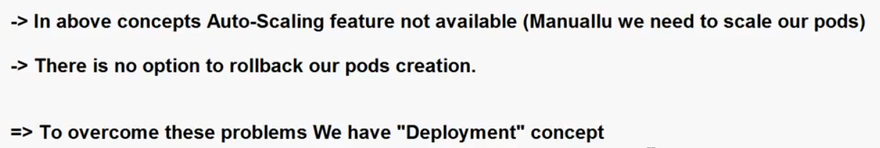

QNS: why we are using K8s, in place of docker swarm?

**3.Daemonset:**

* A Daemon Set ensures that all (or some) Nodes run a copy of a Pod. As nodes are added to the cluster, Pods are added to them.
* As nodes are removed from the cluster, those Pods are garbage collected. Deleting a Daemon-Set will clean up the Pods it created.

Some typical uses of a DaemonSet are:

* running a cluster storage daemon on every node
* running a logs collection daemon on every node
* running a node monitoring daemon on every node

How to delete all pods and services with single command?

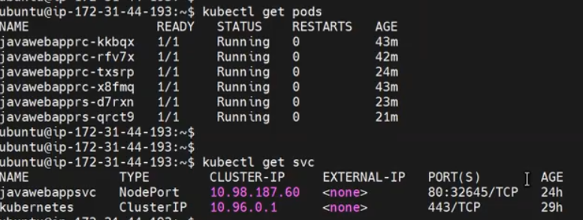

Now delete all the resources at a single command: $kubectl delete all –all

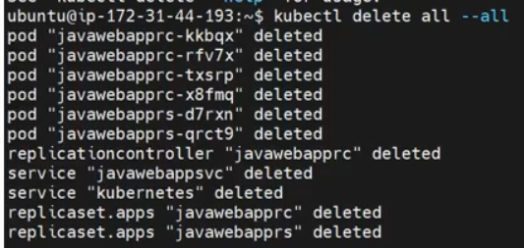

**Before going to execute the Daemon-set manifest file verify existing pods and services.**

$kubectl get pods

$kubectl get svc

How to create a manifest file for DaemonSet:

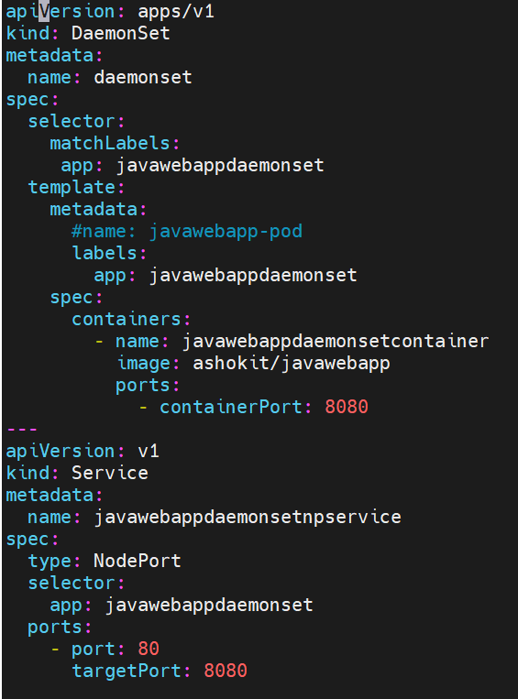

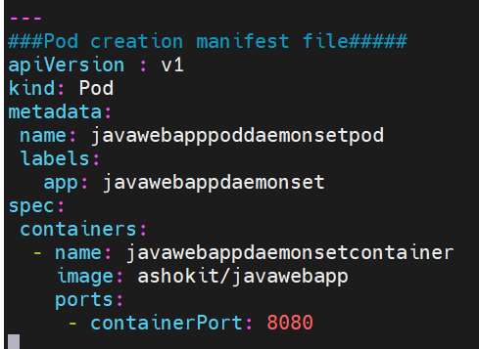

**How to get running pods list:**

#kubectl get pods

**How to get my list of services:**

# kubectl get svc



**How to know how many pods running in my daemon-set service:**

#kubectl get daemonset



NOTE: Replicas not applicable for Daemon-set.

If you have 5 nodes, will run only 5 pods.

Recollect: As of now we have discussed, how much way to create a pod?

1. Interactive(Imparative)
2. Kubectl run name –image=nginx
3. Kubectl create –f <yaml-file>
4. Declarative method (here we will use manifest file for create the pods)

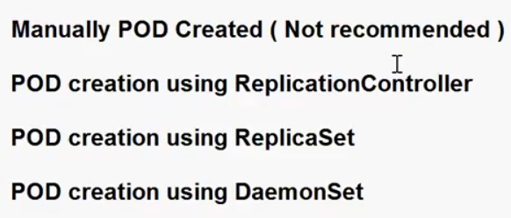

**What are the differences between replication controller replication set and daemon set in k8s:**

**Replication Controller (RC):**

In Kubernetes (K8s), replication controllers, replica sets, and daemon sets are three different mechanisms for managing and ensuring the desired number of pod replicas are running in a cluster. Each of them has distinct use cases and characteristics:

**Replication Controller (RC):**

* Replication controllers are one of the earlier controllers used in Kubernetes for managing replica sets of pods.
* They ensure that a specified number of replicas of a pod are running at all times. If a pod fails or is deleted, the replication controller creates a new pod to replace it.
* Replication controllers are typically used when you need to maintain a fixed number of replicas and do not need to scale pods based on labels or other criteria.
* However, replication controllers have limitations and have largely been replaced by replica sets and deployments in modern Kubernetes.

**Replica Set (RS):**

* Replica sets are the evolution of replication controllers and are a more flexible and powerful way to manage pod replicas.
* Similar to replication controllers, replica sets ensure that a specified number of pod replicas are running, but they offer more advanced selectors for targeting pods.
* Replica sets are often used in conjunction with deployments, which provide declarative updates to applications, rolling updates, and rollbacks.
* They allow you to define scaling behaviors, **such as scaling the number of pods up or down,** and can be combined with various update strategies.

**Daemon Set (DS):**

* Daemon sets are designed for ensuring that exactly one pod of a specific type runs on each node in the cluster.
* They are commonly used for cluster-level tasks or running system-level agents and daemons on every node, such as log collectors, monitoring agents, or networking components.
* Daemon sets are useful when you need to run a pod on every node to provide node-specific services or configurations.
* Unlike replication controllers or replica sets, daemon sets do not allow you to specify a desired replica count; they run one pod per node by design.

Now we will see important way to create a pod, it’s recommended in real-time.

+++++++++++++++++++++++++++++++++++++++++++++++++++++++++++++++++++++++++++++++++++++

**\*\*\*\*\*\*\*Deployment (it’s very Important topic in K8S)\*\*\*\*\*\*\*\*\***

**In the K8S core components the most important component is Deployment.**

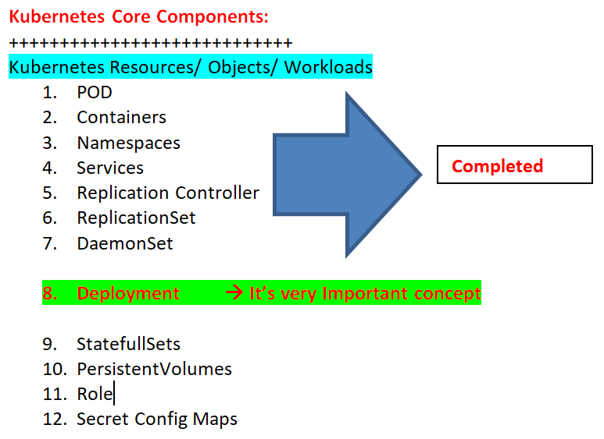

**\*\*\*\*\*\*\*\*\*\*\*\*\*\*Deployments: \*\*\*\*\*\*\*\*\*\*\*\***

In the real-time industries follows Deployment strategy to deploy the application.

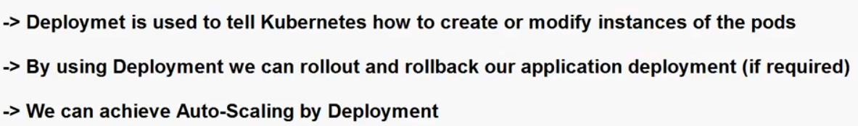

* In Kubernetes (K8s), a Deployment is a higher-level resource that provides declarative updates to applications.
* Deployments are a more powerful and flexible way to manage application scaling and updates compared to the older Replication Controllers and Replica Sets.
* **Desired Replica Count:**
* A Deployment allows you to specify the desired number of replicas (identical copies) of a pod that should be running at any given time.
* You define this desired count in the Deployment's configuration.
* **Pod Template:**
* Just like ReplicaSets and Replication Controllers, a Deployment uses a pod template to create and manage pods.
* The template includes information such as the container image, ports, labels, and other specifications.
* **Automatic Scaling:**
* If the actual number of replicas deviates from the desired count (due to scaling events, updates, or failures), the Deployment automatically takes corrective action.
* It can create new pods if there are too few replicas or terminate excess pods if there are too many.
* **Declarative Updates:**
* Deployments are declarative, meaning you specify the desired state in the configuration, and Kubernetes ensures that the actual state matches it.
* This simplifies application updates, as you only need to update the Deployment's configuration to a new version of your application, and Kubernetes handles the rest.
* **Rolling Updates:**
* Deployments facilitate rolling updates with minimal downtime. When you update the pod template (e.g., by changing the container image), Kubernetes gradually replaces old pods with new ones, ensuring that the application remains available throughout the update process.
* **Revision History:**
* Deployments maintain a revision history, allowing you to roll back to a previous version if a new version has issues.
* You can specify the desired revision to roll back to.
* **Pausing and Rollback:** Deployments provide the ability to pause and resume updates and perform rollbacks to previous versions easily.

**NOTE:** Deployments are the recommended way to manage applications in Kubernetes when you need automatic scaling, updates, and rollback capabilities.

**Deployment Strategy:**

* In Kubernetes (K8s), deploying applications using a Deployment resource provides flexibility in choosing a deployment strategy.
* Deployment strategies define how pods are replaced during updates, scaling, and rollbacks. Some common deployment strategies in K8s are:

1. **Rolling Updates (Default):**
2. **Recreate:**
3. **Blue-Green Deployment:**
4. **Canary Deployment:**
5. **Recreate:**

* Description: The recreate deployment strategy involves terminating all existing pods before creating new ones. This results in a brief period of downtime during the update.
* How It Works: When a new version is deployed, K8s scales down the replicas to zero, effectively terminating all pods. **Then, it scales up to the desired replica count** with the new version of the application.
* Use Case: Use the recreate strategy when you can tolerate a brief downtime during updates and when you want to ensure that old pods are completely removed before introducing new ones.

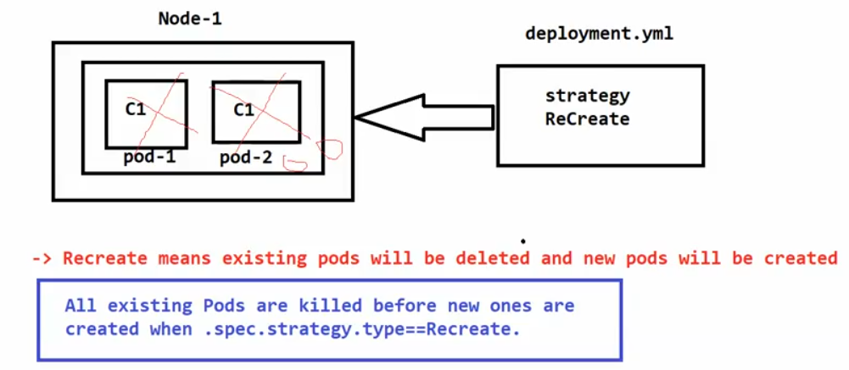

How to write a Deployment manifest-file (Pod manifest + Service Manifest)

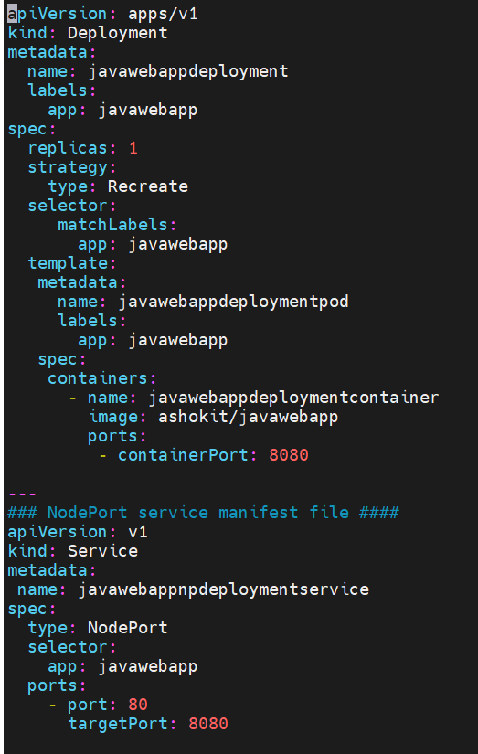

**NOTE: here no need to write he pod manifest file, If we write a pod manifest file, it will create one more new pod(except replicas)with what we have to give pod name in pod manifest file.**

* Before going to setup delete all existing services for you’re better understand.
* Once verify existing pods and services then delete:

Verify the pods: $kubectl get pods

Verify the services: $kubectl get svc (here one default service will be available)

Verify deployments: #kubectl get deployments

Now deploy our application using manifest file.

$kubectl apply –f <manifest-file>

Then verify the pods, services, deployments.

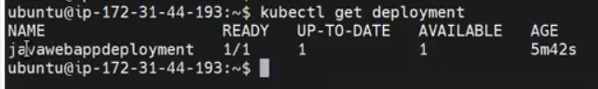

Verify the services: $kubectl get svc (here one default service will be available)

Verify deployments: #kubectl get deployments

When you inspect the Deployments in your cluster, the following fields are displayed:

NAME: lists the names of the Deployments in the namespace.

READY: displays how many replicas of the application are available to your users. It follows the pattern ready/desired.

UP-TO-DATE :displays the number of replicas that have been updated to achieve the desired state.

AVAILABLE: displays how many replicas of the application are available to your users.

AGE: displays the amount of time that the application has been running.

* To see the labels automatically generated for each Pod:

# kubectl get pods --show-labels



Get details of your Deployment:

#kubectl describe deployments

Verify: #kubectl get deploy

**How to scale deployment:**

Syntax: kubectl scale deployment <deployment-name> --replicas <desired-replicas-count>

# kubectl scale deployment javawebappdeployment --replicas 3

**Updating a Deployment:**

Note: A Deployment's rollout is triggered if and only if the Deployment's Pod template (that is, .spec.template) is changed, for example if the labels or container images of the template are updated. Other updates, such as scaling the Deployment, do not trigger a rollout.

What is rollout: In Kubernetes (K8s), a rollout refers to the process of updating a Deployment, ReplicaSet, or StatefulSet with a new desired state, typically a new version of your application or a configuration change.

Syntax: kubectl set image deployment <deployment-name> nginx=nginx:1.16.1

OR

We will edit manifest file. Same we will do in Rolling Back a Deployment

# kubectl edit deployment mydepl

**Rolling Back to a Previous Revision:**

# kubectl rollout undo deployment <deployment-name>

**To see the rollout status, run:**

#kubectl rollout status deployment <deployment-name>

**Get details of your Deployment:**

#kubectl describe deployments

**Checking Rollout History of a Deployment:**

#kubectl rollout history deployment <deployment-name>

**Scaling a Deployment:**

# kubectl scale deployment <deployment-name>--replicas=10

# kubectl get deploy

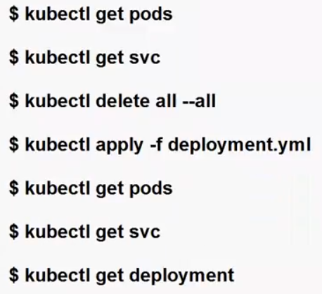

### Failed Deployment:

Your Deployment may get stuck trying to deploy its newest ReplicaSet without ever completing. This can occur due to some of the following factors:

* Insufficient quota
* Readiness probe failures
* Image pull errors
* Insufficient permissions
* Limit ranges
* Application runtime misconfiguration

**How to delete deployment:**

$kubectl delete deployment <deployment-name>



Qns: If I delete my deployment, can I access my pods?

Note: My service is available, but pod is not available.

Then delete: $kubectl delete all –all (it will be deleting all the services)

Conclusion Recreate Deployment:

All existing Pods are killed before new ones are created when .spec.strategy.type==Recreate.

-----------------------------------------------------------------------------------------------------------------------------------------------

1. **Rolling Updates (Default):**

* Description: Rolling updates are the default deployment strategy for Deployments. This strategy gradually replaces old pods with new ones, ensuring a smooth transition without downtime.
* How It Works: When a new version of the application is deployed, K8s starts by creating pods for the new version while maintaining the desired replica count.
* As new pods become ready, old pods are gradually terminated. This process continues until all pods are updated
* Use Case: Rolling updates are suitable for most applications as they ensure high availability and minimal disruption during updates.

**Performing a Rolling Update:**

Updating an application:

* Users expect applications to be available all the time and developers are expected to deploy new versions of them several times a day.
* In Kubernetes this is done with rolling updates. Rolling updates allow Deployments' update to take place with zero downtime by incrementally updating Pods instances with new ones.
* If a Deployment is exposed publicly, the Service will load-balance the traffic only to available Pods during the update. An available Pod is an instance that is available to the users of the application.

Rolling updates allow the following actions:

* Promote an application from one environment to another (via container image updates)
* Rollback to previous versions
* Continuous Integration and Continuous Delivery of applications with zero downtime.

**What are the differences between rolling updates, recreate:**

Rolling updates, Recreate deployments are different strategies for updating and managing applications in a Kubernetes (K8s) cluster.

**Rolling Updates:**

Characteristics:

In a rolling update, you gradually replace old pods with new ones, one at a time, until all pods are updated. This approach is designed to minimize downtime and ensure high availability during the update process.

**How it works:** New pods are created with the updated version of your application, and they are gradually scaled up while old pods are scaled down. This process continues until all old pods are replaced.

Use Cases: Rolling updates are suitable for applications where you want to minimize disruption and can tolerate some temporary coexistence of old and new versions. It's the default update strategy for Deployments in Kubernetes.

**Recreate Deployments:**

Characteristics: In a recreate deployment, all existing pods are terminated simultaneously, and new pods are then created with the updated application version. This approach can result in a brief period of downtime during the update.

How it works: All old pods are deleted, and new pods are created to replace them. This means that there is a momentary interruption in service while the old pods are terminated and new pods are started.

Use Cases: Recreate deployments are suitable for applications where a brief downtime is acceptable, or you want to ensure that all instances of the application are consistently updated at the same time.

**Conclusion:**

Rolling Updates are used to update applications gradually, minimizing downtime and ensuring high availability during the update process.

Recreate Deployments involve updating all pods simultaneously, resulting in a brief downtime but ensuring consistency.

**What is a Blue Green Deployment: (It’s very Important concept) Its’ called A &B Deployment .**

NOTE: Blue Green is the approach, how to route the traffic.

Rolling update is strategy in deployment, how you want to create the pods.

* Blue-green deployment is a deployment strategy used in Kubernetes (K8s) to release and update applications with minimal downtime and risk.
* It involves creating two separate environments, the "blue" environment (the current live version) and the "green" environment (the new version).
* You switch traffic from the blue environment to the green environment when you are confident that the new version is stable and ready for production.

Here's how you can implement a blue-green deployment in Kubernetes:

1. **Set Up Two Identical Environments:**

* Create two Kubernetes Deployments or ReplicaSets with identical configurations, except for the version of your application code or container image.
* One represents the current live version (blue), and the other represents the new version (green).

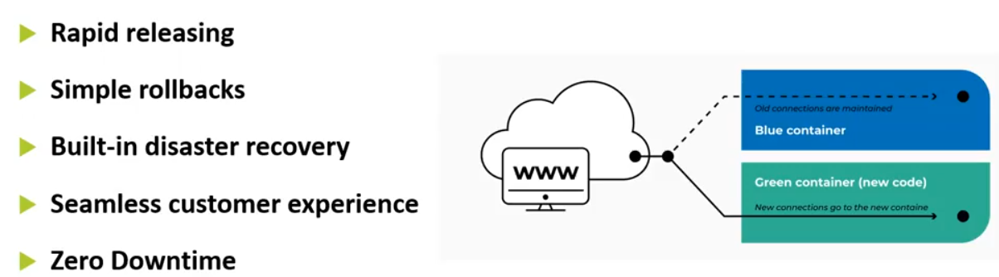

1. **Deploy the New Version (Green):**

* Deploy the new version of your application (the green environment) into Kubernetes. Ensure that the desired number of replicas for the green environment is up and running, but don't expose it to external traffic yet.

1. **Test the Green Environment:**

* Perform extensive testing, including functional, performance, and integration testing, in the green environment. Make sure it meets your quality standards and is ready for production traffic.

1. **Route Traffic to the Green Environment:**

* To gradually shift traffic from the blue environment to the green environment, you can use Kubernetes Services and Ingress controllers.
* Update the Service or Ingress configuration to direct a portion of the incoming traffic to the green environment.
* You can use a weight-based routing strategy to control the traffic split (e.g., 90% blue, 10% green initially).

1. **Monitor and Validate:**

* Continuously monitor the green environment to ensure that it's handling the traffic properly and without issues.
* Use Kubernetes metrics, logs, and application monitoring tools to track the health and performance of the green environment.

1. **Rollback (if necessary):**

* If issues are detected in the green environment, you can quickly switch traffic back to the blue environment by adjusting the Service or Ingress configurations.
* This provides a safe and fast rollback mechanism.

1. **Complete the Deployment:**

* Once you are confident that the green environment is stable and performing well, you can gradually increase the traffic to it until it receives 100% of the traffic.
* At this point, the green environment becomes the new live version, and you can scale down and eventually

delete the blue environment.

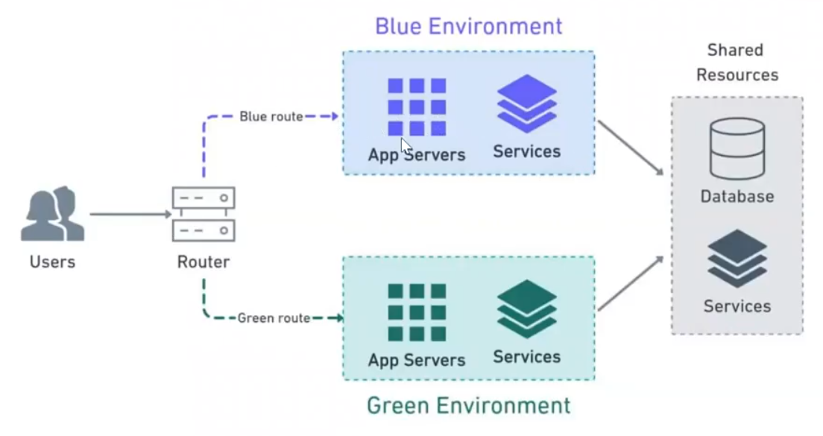

1. **Clean Up:**

* After the deployment is complete, you can remove any resources associated with the blue environment, such as the old ReplicaSet or Deployment.

Note: By following these steps, you can achieve a blue-green deployment in Kubernetes, which allows you to release new versions of your application with minimal risk and downtime, and the ability to quickly roll back in case of issues.

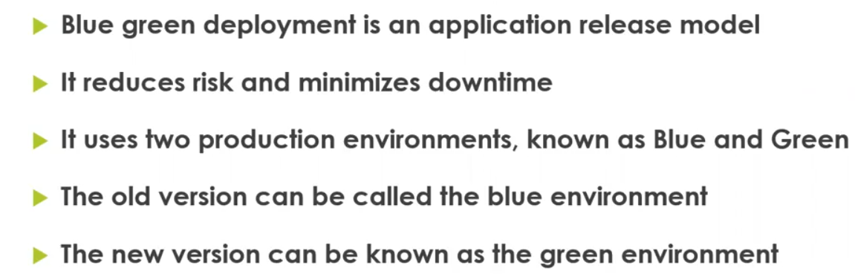

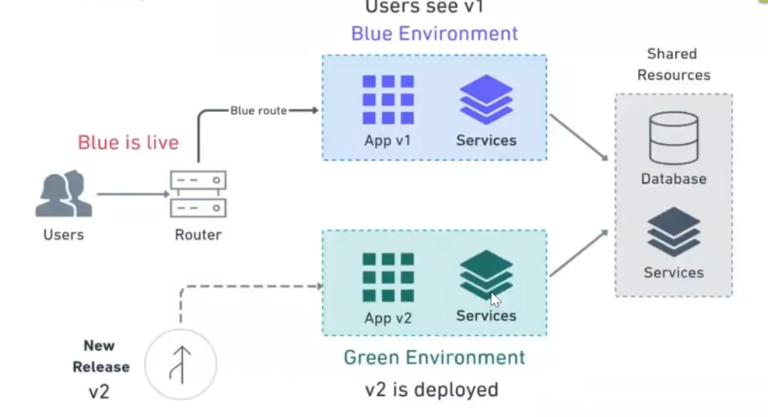

* Here Users try to access the application, the request came to Router, and then router will talk with Blue (live) Environment.
* Once Green deployment is ready, the traffic will route to Green deployment.

**Blue Green Deployment Advantages:**

Blue-green deployment offers several advantages that make it a popular choice for releasing and updating applications in a production environment:

1. **Minimal Downtime:**

* Blue-green deployment minimizes downtime because you have two separate environments. You can switch traffic from the old (blue) environment to the new (green) one instantly, reducing or eliminating service interruptions for end-users.

1. **Rapid Rollback:**

* In case of issues with the new version, you can quickly roll back by directing traffic back to the old environment.
* This rollback process is almost instantaneous and reduces the risk associated with deployments.

1. **Safety and Risk Mitigation:**

* Blue-green deployment allows for comprehensive testing of the new version in an isolated environment.
* This helps identify and fix issues before they impact production users, reducing the risk of deploying a flawed version.

1. **Increased Confidence:**

* The ability to run extensive testing in the green environment before switching production traffic provides greater confidence that the new version will perform well in the live environment.

1. **Easy Validation:**

* Monitoring and validating the new version is straightforward because it's separated from the old one.
* You can closely monitor metrics, logs, and user behavior in the green environment without impacting production.

1. **Consistency:**

* Since both environments are identical (except for the version), there are fewer chances of environmental differences causing issues in the new version.

1. **Efficient Rollout:**

* You can gradually increase the traffic to the green environment, allowing you to observe its behavior under different loads and gradually scale up resources as needed.

1. **Rolling Updates:**

* Blue-green deployment can be part of a rolling update strategy, allowing you to update multiple parts of your application infrastructure (e.g., databases, cache) in a coordinated manner.

1. **Enhanced Disaster Recovery:**

* Having two separate environments means you have built-in redundancy. If there's a critical failure in one environment, you can quickly switch to the other as part of your disaster recovery plan.

1. **Automated Deployment:**

* Blue-green deployments can be automated using deployment tools and scripts, making the process more repeatable and less error-prone.

1. **Simplified Rollback Planning:**

* The rollback process is well-defined and straightforward, making it easier to plan and execute in case of issues.

1. **Continuous Delivery:**

* Blue-green deployment fits well into a continuous delivery pipeline, allowing for rapid and frequent releases while maintaining high levels of confidence and control.

Note: Overall, blue-green deployment is a robust strategy that combines the benefits of minimal downtime, risk mitigation, and efficient validation to help organizations release and update software with confidence and reliability.

Qns: If we are not follow this approach, what happen into the deployment?

* We will stop the service (Application), deploy new application it will take some time, can we give this much down time to users?

**Now we have to go through LAB:**

Before going to Lab clear all the existed things for your better understand.

#kubectl delete all –all

Verify: kubectl get pods/svc/rc/rs/

**Step1: Create manifest file for POD:**

NOTE: Blue Green is the approach, how to route the traffic.

Rolling update is strategy in deployment, how you want to create the pods.

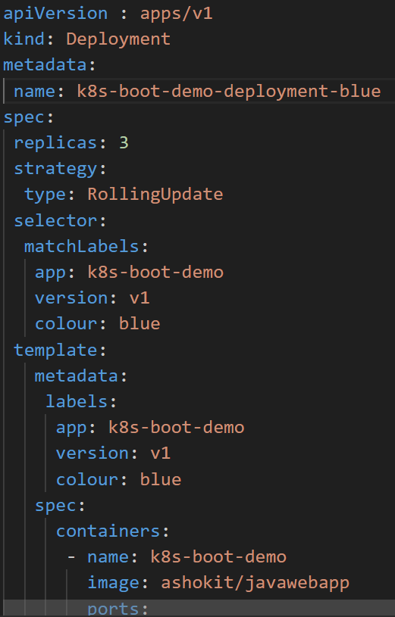

**Now execute this blue deployment yaml file.**

#kubectl apply –f yaml-file

Verify the Pods: #kubectl get pods

Verify the Service: #kubectl get svc (here what is the purpose of Service manifest file)

Wide : kubectl get pods –o wide

Verify the deployment:

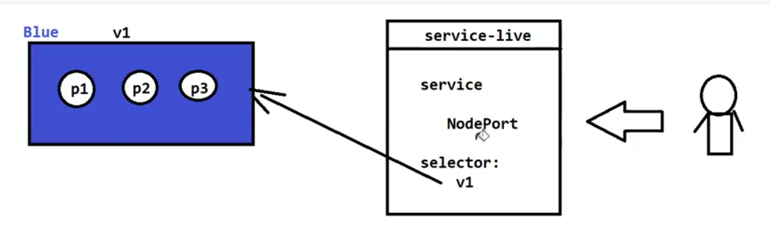

Here live service going to V1 selector, v1 selector configure to V1 environment we called blue environment.

Means the traffic routing to V1 environment (blue).

Now there are some code changes in application, now I want to create new pods for the latest code.

Create one new green manifest file for new code.

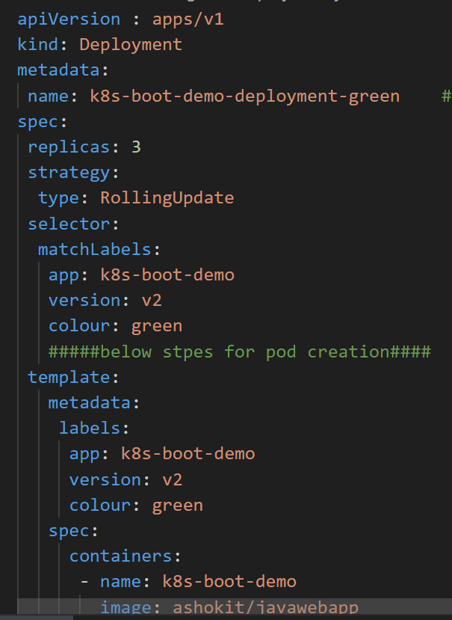

Create pods: #kubectl apply –f green.yml

Verify: #kubectl get pods

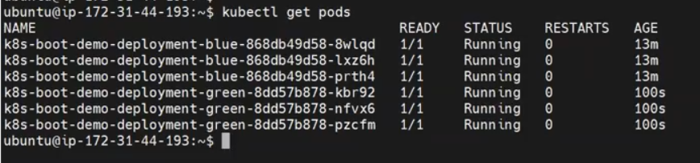

Here have 6 pods 3 are the old code and 3 are the new code.

As of now the incoming traffic routing to old pods(blue env), as of live service is blue only. But the latest code is available in green environment.

So before give to give live this env, need to test the applications with testers.

Before going to live (green) need to test , so need to create a service NodePort.

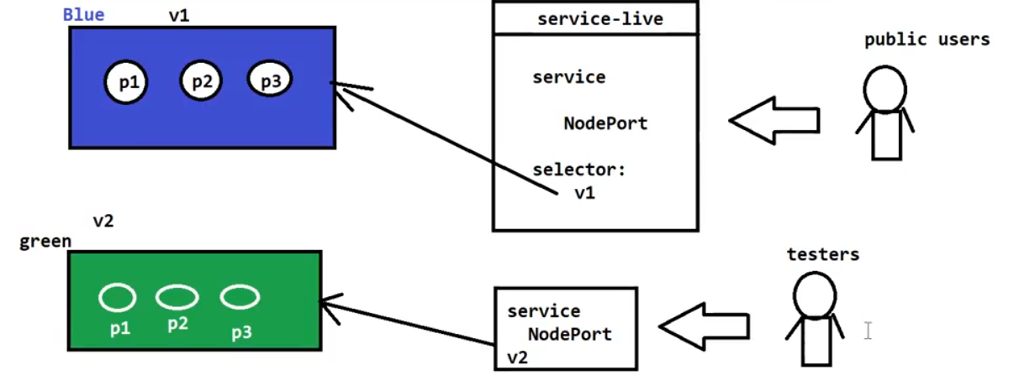

Already NodePort service is created, now verify the service: #kubectl get svc

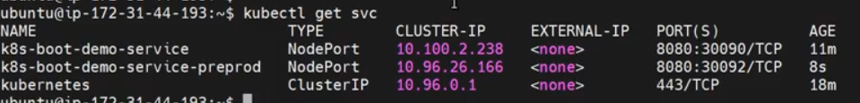

NOTE: Pre-prod is executing in to the V2 selected pods (green) test pods.

Live service is pointing to 🡪 v1

New code is pointing to 🡪 v2

Now we will give time to test the new code in Green v2 pods.

**After complete the testing, how to divert the traffic v1 to v2 (old code to new code), what I need to change?**

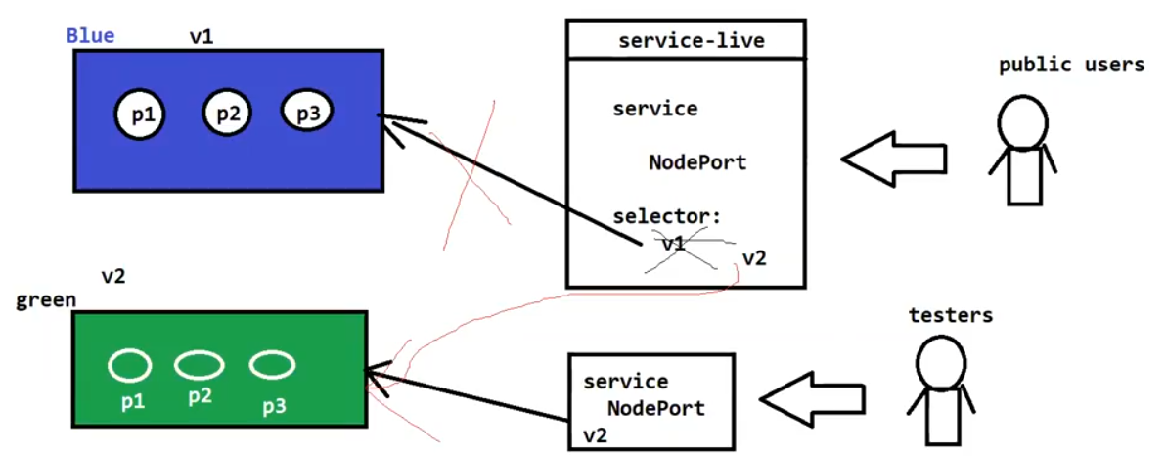

Here I will change the traffic diversion v1 to v2 , we will update the live service (NodePort)manifest file v1 to v2.

Just change the selector.

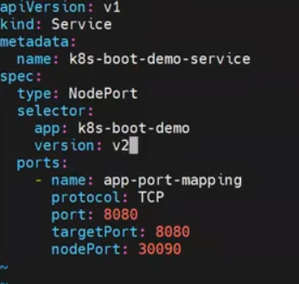

Then Apply: $kubectl apply –f bluedeploymentservice.yml

SO that traffic will divert v1 to v2. Within seconds will change the route traffic. So no down time.

**Interview qns: How you will deploy you’re code in to production with zero downtime?**

**After change done getting some calls from clients application not accessing properly, so what can we do?**

**Have some problem with new code, testers not tested properly. So that we can Roll-back to previous code.**

**How to roll back to previous code?**

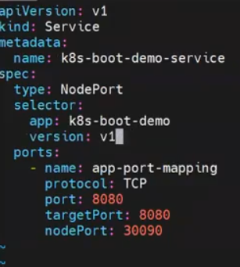

Just will update the selector v2 🡪 v1, so the live services will pointing to old pods (old code)

Then execute the apply command: #kubectl apply –f blue.yml

**Conclusion:**

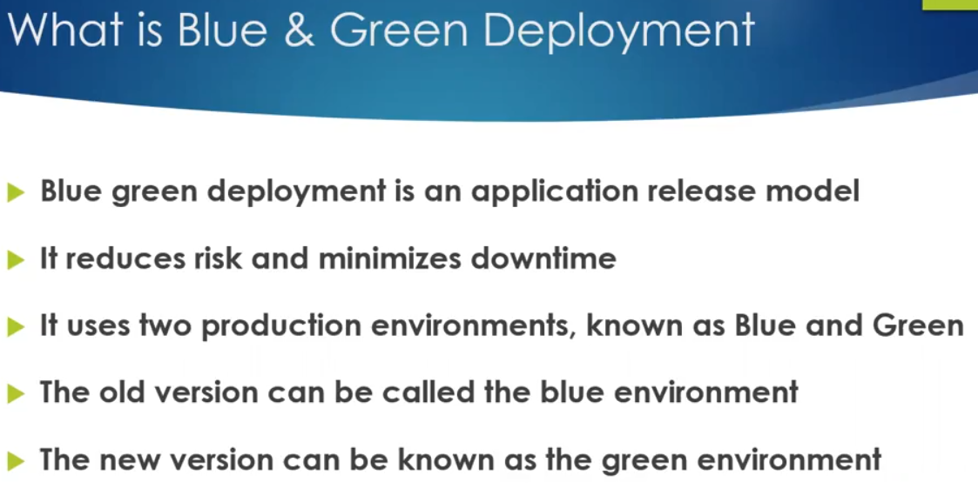

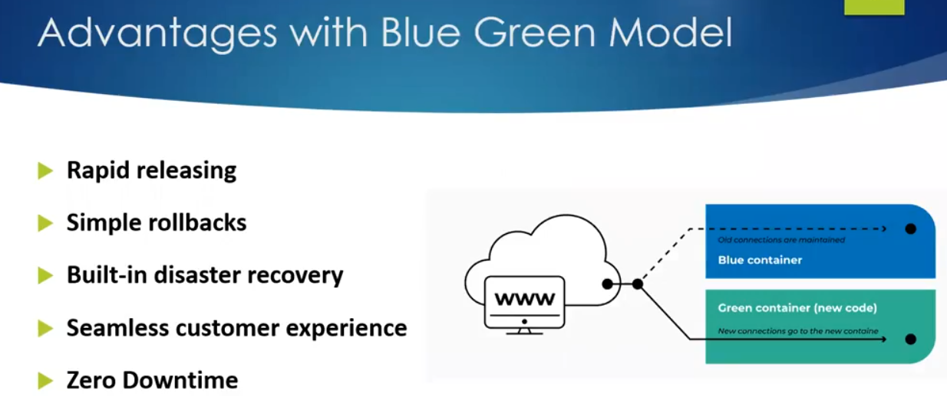

How many environments available in production now? Two below Image.

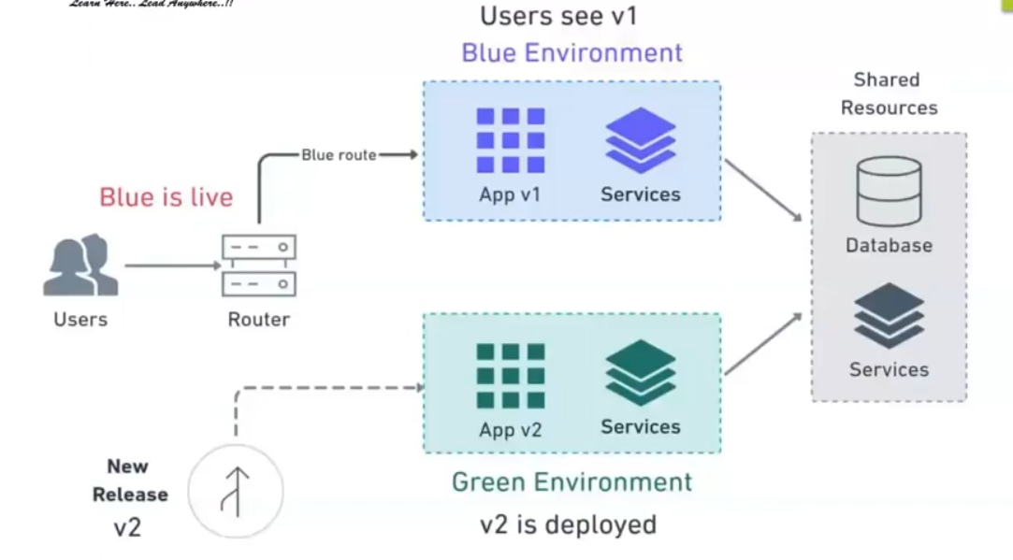

After complete blue Green go to official doc🡪 Deployment status🡪Progressing Deployment🡪Complete Deployment🡪 Failed Deployment

**What are the differences between rolling updates, recreate and blue green deployments:**

Rolling updates, Recreate deployments, and Blue-Green deployments are different strategies for updating and managing applications in a Kubernetes (K8s) cluster. Each approach has its own characteristics and use cases:

1.**Rolling Updates:**

**Characteristics:**

* In a rolling update, you gradually replace old pods with new ones, one at a time, until all pods are updated. This approach is designed to minimize downtime and ensure high availability during the update process.

**How it works:**

* New pods are created with the updated version of your application, and they are gradually scaled up while old pods are scaled down. This process continues until all old pods are replaced.

**Use Cases:**

* Rolling updates are suitable for applications where you want to minimize disruption and can tolerate some temporary coexistence of old and new versions. It's the default update strategy for Deployments in Kubernetes.

**2.Recreate Deployments:**

**Characteristics**:

* In a recreate deployment, all existing pods are terminated simultaneously, and new pods are then created with the updated application version. This approach can result in a brief period of downtime during the update.

**How it works:**

* All old pods are deleted, and new pods are created to replace them. This means that there is a momentary interruption in service while the old pods are terminated and new pods are started.

**Use Cases:**

* Recreate deployments are suitable for applications where a brief downtime is acceptable, or you want to ensure that all instances of the application are consistently updated at the same time.

**3.Blue-Green Deployments:**

**Characteristics:**

* Blue-Green deployments involve maintaining two separate environments or sets of resources, one for the current production version (blue) and one for the new version (green). The switch between environments is made once the new version is tested and ready.

**How it works:**

* The new version of the application is deployed in the "green" environment, while the existing version continues to run in the "blue" environment. After thorough testing and validation, a switch or traffic redirection is performed to make the "green" environment the new production environment.

**Use Cases:**

* Blue-Green deployments are ideal for scenarios where you want to thoroughly test the new version of your application before making it live. They provide a way to switch back to the previous version quickly if issues are detected.

**In summary:**

* Rolling Updates are used to update applications gradually, minimizing downtime and ensuring high availability during the update process.
* Recreate Deployments involve updating all pods simultaneously, resulting in a brief downtime but ensuring consistency.
* Blue-Green Deployments provide a way to switch between two separate environments, allowing thorough testing of the new version before it becomes the production version.

The choice of deployment strategy depends on your application's requirements, your tolerance for downtime, and your testing and rollback needs. Each strategy has its advantages and trade-offs.

**Auto Scalling in K8S:**

Replication controller and replication set have any auto-scaling or manually scaling?

I am specifying desired number of replicas.

It’s a self-healing capacity.

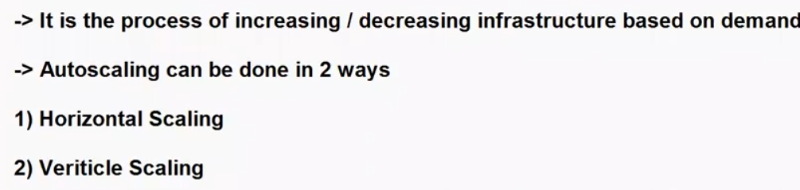

Horizontal scaling and vertical scaling are two different approaches to increasing the capacity and performance of a system, such as a server, application, or database. They involve different strategies for handling increased workload or resource demands:

**1.Vertical Autoscaling:**

Use Case:

* Vertical autoscaling, also known as scaling up or scaling down vertically, involves increasing the capacity of an individual server or instance by adding more resources, such as CPU, memory, or storage.

How It Works:

* When resource utilization exceeds predefined thresholds, additional resources are allocated to the server, allowing it to handle increased workload or traffic.

Example:

* Increasing the CPU and RAM of a virtual machine in response to high application load.

**2.Horizontal Autoscaling:**

Use Case:

* Horizontal autoscaling, also known as scaling out or scaling horizontally, involves adding more server instances to distribute the workload and improve performance.

How It Works:

* When resource utilization or demand increases, new server instances are created and added to a server cluster or pool. Load balancers distribute traffic across these instances.

Example:

* Adding more web server instances to handle increased web traffic during a sales promotion.

**We have another Load Balancing is also availabele.**

**3.Load-Based Autoscaling:**

Use Case:

* Load-based autoscaling adjusts server resources based on real-time metrics, such as CPU load, network traffic, or request latency.

How It Works:

* Autoscaling policies are defined to monitor specific metrics, and when thresholds are reached or exceeded, additional servers or resources are provisioned or de-provisioned as needed.

Example:

* Automatically adding more application servers when CPU load surpasses a predefined threshold.

**4.Scheduled Autoscaling:**

Use Case:

* Scheduled autoscaling allows for planned increases or decreases in server capacity based on predetermined schedules or events, such as daily or weekly patterns.

How It Works:

* Autoscaling actions are triggered at predefined times or in response to scheduled events, such as recurring backups or data processing tasks.

Example:

* Scaling up the number of database instances during nightly data processing and scaling them down afterward.

**5.Container Autoscaling:**

Horizontal Scalling: Ex: If you suffering with fever, met doctor he suggested tablets for one week daily one tablet this is horizontal.

Vertical: You have taken all the tablets one day (fever will gone or you will gone)

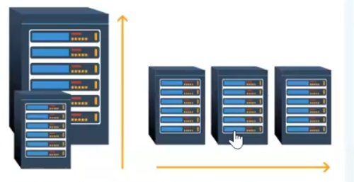

**What is the K8S auto scaling:**

* Autoscaling in Kubernetes (K8s) is a feature that allows you to automatically adjust the number of pod replicas in a Deployment, ReplicaSet, or StatefulSet(StatefulSets are used to deploy and manage stateful workloads, such as databases, message queues, and key-value stores, where each pod in the set requires a unique identifier and stable network identity.) based on resource utilization or custom metrics. This ensures that your application can handle varying workloads without manual intervention. There are two main types of autoscaling in K8s:

**1.Horizontal Pod Autoscaling (HPA):**

* HPA is the most common form of autoscaling in K8s and is used to scale the number of pod replicas horizontally (i.e., add or remove pods).
* HPA is based on CPU and memory metrics or custom metrics that you define.
* To set up HPA, you need to create an HPA resource and specify the desired metric(s), target values, and the minimum and maximum number of replicas.



Install Metric Server in K8S cluster for monitoring.

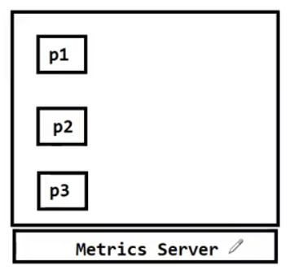

**What is the Metrics Server:**

* The Metric Server in Kubernetes is a component that collects and provides resource utilization metrics from your cluster's nodes and pods.

**Here's a simplified example of how the Metric Server and HPA work together**:

* You create an HPA resource that specifies the target metric (e.g., average CPU utilization should be below 50%).
* The HPA queries the Metric Server for CPU utilization metrics.
* The Metric Server provides the HPA with the current CPU utilization across pods.
* Based on the metrics data, the HPA calculates whether to scale the number of pod replicas up or down to meet the desired metric target.
* To set up the Metric Server in your Kubernetes cluster, you typically deploy it using a manifest file

**How to set-up Metrics server:**

**How to verify Metric Server is configured or not?**



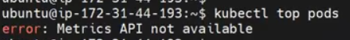

NOTE: By default Metrics Server not available.

Need manifest files for create a Metrics Service.

We can download from Git Hub Public repository.

**URL: git clone** [**https://github.com/ashokitschool/k8s_metrics_server**](https://github.com/ashokitschool/k8s_metrics_server)

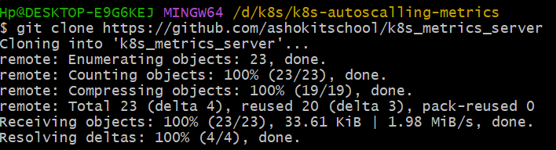

**Inside repo you will see some directories:**

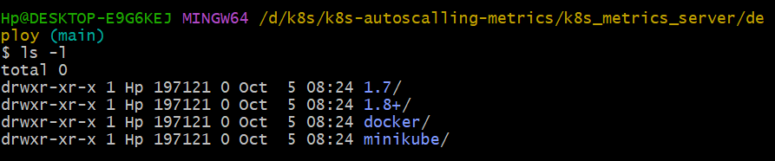

Change directory into 1.8+/ => cd 1.8+/

There will find the all manifest files for Metrics Service install.

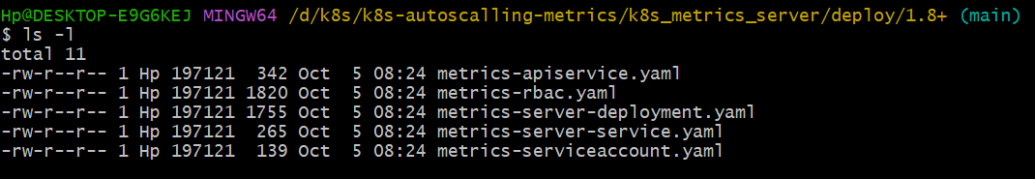

**Go to master server and apply the kubectl command.**

**#kubectl apply –f deploy1.8+/**

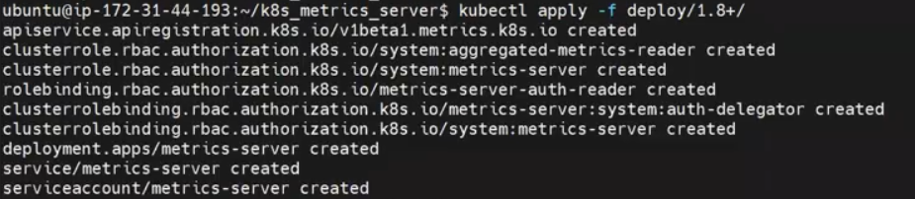

**All the resources are created.**

**Recall all steps for create Metrics Server:**

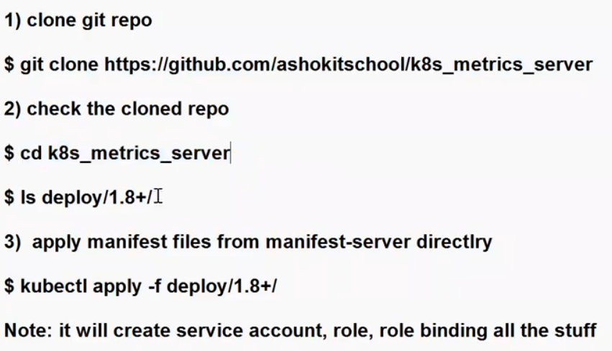

**We can verify Metrics Service running or not?**

#kubectl get all –n kube-system

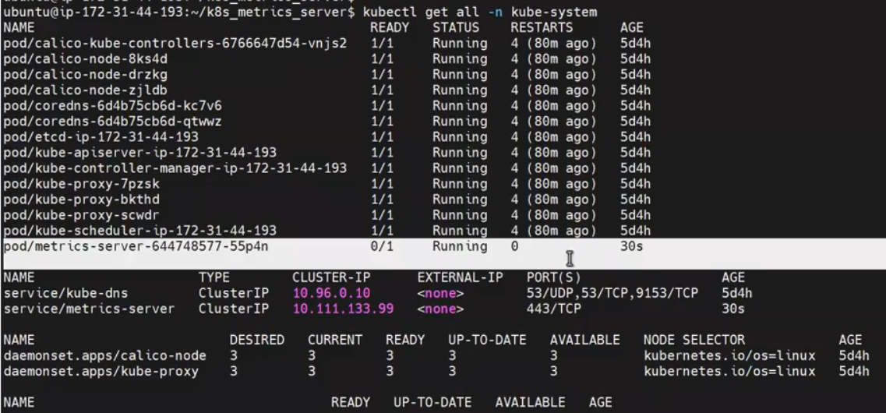

How to delete metric server?

#kubectl delete deployment metrics-server -n kube-system

#kubectl delete service metrics-server -n kube-system

# kubectl delete serviceaccount metrics-server -n kube-system

#kubectl delete role metrics-server -n kube-system

#kubectl delete clusterrolebinding metrics-server -n kube-system

#kubectl delete clusterrole metrics-server -n kube-system

#kubectl delete customresourcedefinitions.metrics.k8s.io metricservers.metrics.k8s.io

#kubectl delete rolebinding metrics-server-auth-reader -n kube-system

**NOTE: Metrics Service is running in Default namespace kube-system name space.**

**Check the top nodes using metric server:**

**#kubectl top nodes**

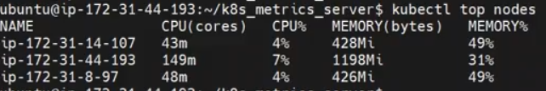

**In above observe the CPU Utilizations:**

**Clear the server pods and svc, rc, rs and deploynets.**

**#kubectl delete all –all**

**Then apply HPA manifest file: #kubectl apply –f <hpa-manifest file>**

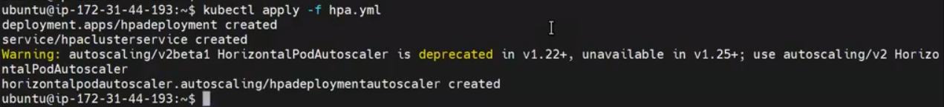

**apiVersion: autoscaling/v2beta2**

**kind: HorizontalPodAutoscaler**

**metadata:**

**name: my-hpa**

**spec:**

**scaleTargetRef:**

**apiVersion: apps/v1**

**kind: Deployment**

**name: my-deployment**

**minReplicas: 2**

**maxReplicas: 5**

**metrics:**

**- type: Resource**

**resource:**

**name: cpu**

**targetAverageUtilization: 10**

Verify the pods: #kubectl get pods

Verify the Nodes cpu utilizations: #kubectl top nodes

What is our target cpu utilizations I given: 20

Note: How to increase load on my nodes? ( as of now no any load in my server, without load we cannot verify autos

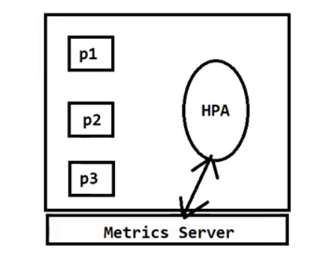

calling, we have to keep the load manually)

Now we need simulate the load using bus-ybox.(Busy-box is the image to increase the load on the server)

#kubectl run -it --rm loadgenerator --image=busybox

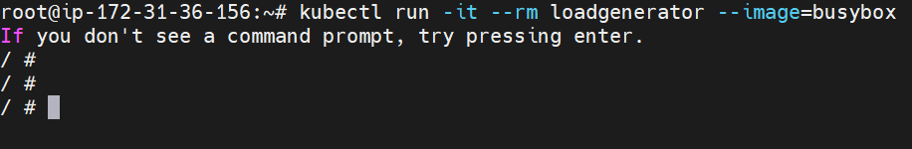

After execute this above command, we’ll switched into busy-box container.

Then will execute the below command inside the container for stress the load.

# wget –q -0- <http://hpaclusterservice>

-q: Quiet mode. Suppresses output, so it doesn't display progress or other information.

-O -: Specifies the output file. In this case, it directs the output to the standard output (stdout) using the hyphen (-).

http://hpaclusterservice: The URL or address from which you want to download content.

Will get response from pod “ok”

Keep on give requiste , then it will increase the load.

Once verify the nodes cpu usages.

#kubectl top nodes

If need to increase the load on the server, go to loop concept for continuous increase the load on the server.

#while true; do wget –q -0- <http://hpaclusterservice>

NOTE: If load in not reach up to 20%, increase more load open new tab and do same above for increase the load.

#kubectl run –it –rm loadgenerator –image=busybox

# while true; do wget –q -0- <http://hpaclusterservice>

Then verify top nodes: #kubectl top nodes

Then verify pods: #kubectl get pods

Qns: When the load is decreased, what is the pods auto-scaling status?

NOTE: After completed the verification, stop the load on the nodes.

**2.Vertical Pod Autoscaling (VPA):**

* VPA focuses on adjusting the resource requests and limits of individual pods, rather than the number of replicas.
* It helps to optimize resource allocation for your pods.
* VPA takes into account historical resource utilization data to adjust the resource requests and limits.
* To use VPA, you need to create a VPA resource and specify which pods it should target.

07-10 EKS

**Managed Cluster:**

**What is Manages Cluster:**

A managed cluster in Kubernetes (K8s) refers to a Kubernetes cluster that is set up, operated, and maintained by a third-party service provider, such as a cloud provider or a Kubernetes platform-as-a-service (PaaS) offering. In a managed cluster, the responsibility for managing the control plane components and underlying infrastructure is shifted from the end user to the service provider.

Here are the key characteristics and benefits of a managed cluster:

**1.Control Plane Management:**

* The service provider is responsible for setting up, scaling, and maintaining the Kubernetes control plane components, including the API server, etcd, controller manager, and scheduler.
* This includes tasks like updates, security patches, and high availability configuration.

**2.Infrastructure Management:**

* The service provider manages the underlying infrastructure required for the cluster, which may involve provisioning and configuring virtual machines (VMs), networking, and storage resources.
* Users do not need to worry about these operational aspects.

**3.Ease of Use:**

* Managed clusters are designed to be user-friendly and are often easier to set up and operate, making it simpler for users to get started with Kubernetes without deep expertise in infrastructure management.

**4.Scalability and Automation:**

* Many managed clusters offer features such as auto-scaling, monitoring, logging, and integrated backup solutions. These features make it easier to scale applications and automate operational tasks.

**5.Security and Compliance:**

* Service providers often implement security best practices and help users meet compliance requirements, reducing the burden of securing the cluster.

**6.High Availability:**

* Managed clusters are typically designed for high availability and fault tolerance, ensuring that the control plane is resilient to failures.

The choice between a managed cluster and a self-managed cluster depends on factors like your organization's resources, expertise, and specific requirements. Managed clusters can be a convenient choice for teams that prioritize ease of use and want to offload many of the operational tasks associated with running Kubernetes.

**What is the difference between self-managed and Managed(provider):**

The terms "self-managed cluster" and "managed cluster" in the context of Kubernetes (K8s) refer to how the Kubernetes infrastructure and control plane are set up and maintained. Here's the key difference between the two

**1. Self-Managed Cluster:**

**Ownership and Control:** In a self-managed cluster, you have complete ownership and control over the Kubernetes cluster. You are responsible for provisioning the infrastructure, setting up the control plane, and managing all components of the cluster.

**Setup and Maintenance:** You are responsible for installing, configuring, and maintaining the Kubernetes control plane components, such as the API server, etcd, controller manager, and scheduler. You also need to manage the worker nodes, container runtimes, and networking.

**Customization:** With a self-managed cluster, you have the flexibility to customize and configure every aspect of the cluster, allowing you to tailor it to your specific requirements and infrastructure.

**Infrastructure Costs:** You need to manage the underlying infrastructure, which may involve setting up virtual machines, configuring networking, and ensuring hardware or cloud resources are available. This can be more complex but provides greater control.

**2.Managed Cluster:**

**Third-Party Service:** In a managed cluster, you rely on a third-party service, such as a cloud provider's Kubernetes service (e.g., Amazon EKS, Google Kubernetes Engine, or Azure Kubernetes Service). These services take care of many operational tasks for you.

**Setup and Maintenance:** The provider manages the setup, scaling, and maintenance of the control plane components, including upgrades and security patches. You only need to manage your application workloads and worker nodes.

**Ease of Use:** Managed clusters abstract much of the complexity of operating the control plane and infrastructure, making it easier to get started and focus on deploying and managing your applications.

**Scalability and Automation:** Managed clusters often offer features like auto-scaling, monitoring, and logging integration, making it easier to scale your applications and automate common operational tasks.

**Infrastructure Costs:** While managed clusters simplify many operational tasks, you'll typically incur costs for the managed service itself, which may be based on the number of nodes or other usage metrics.

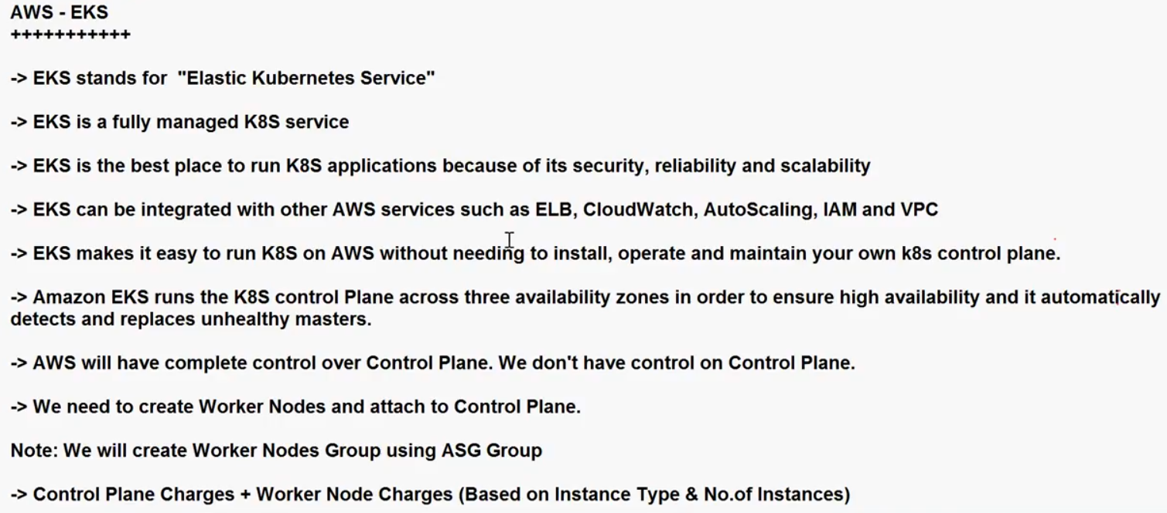

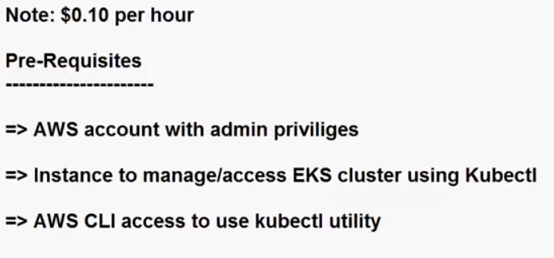

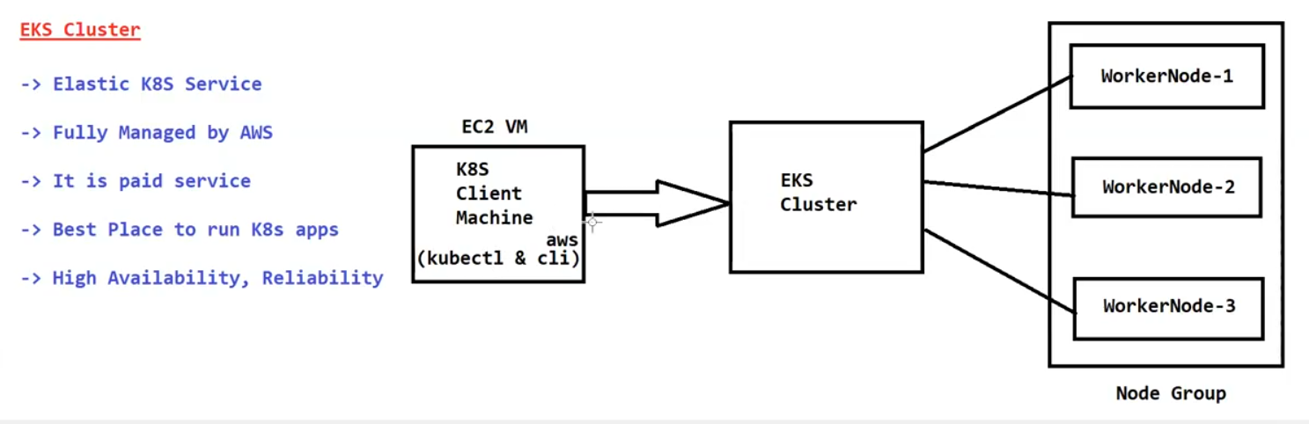

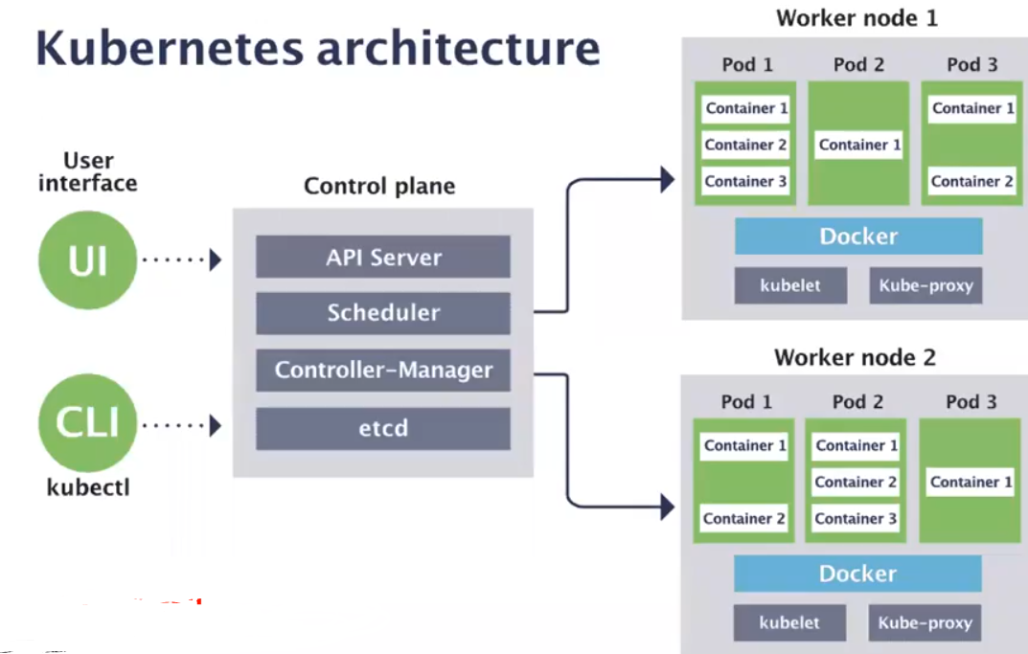

**EKS cluster setup:**

**Step 1: Create an IAM Role for EKS**

This role is used, when we set-up eks cluseter

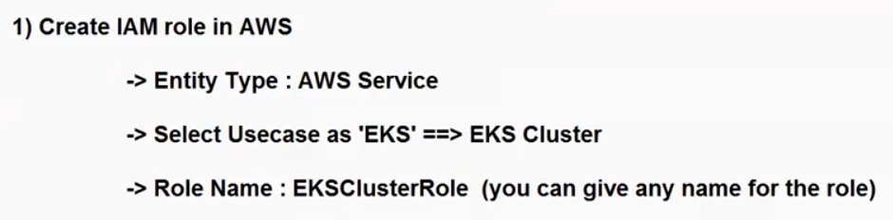

**Step 2: Create Custom VPC using Cloud Formation. Using below url for download yaml file to create VPC.**

<https://s3.us-west-2.amazonaws.com/amazon-eks/cloudformation/2020-10-29/amazon-eks-vpc-private-subnets.yaml>

Go to 🡪 cloud formation🡪 create stack🡪

**Step 3: Create EKS cluster using custom VPC**

Go to EKS service🡪

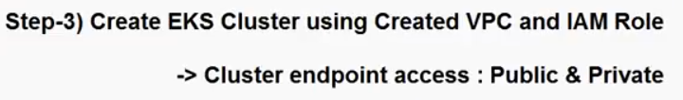

NOTE: Creating cluster it will take some time (be patient)

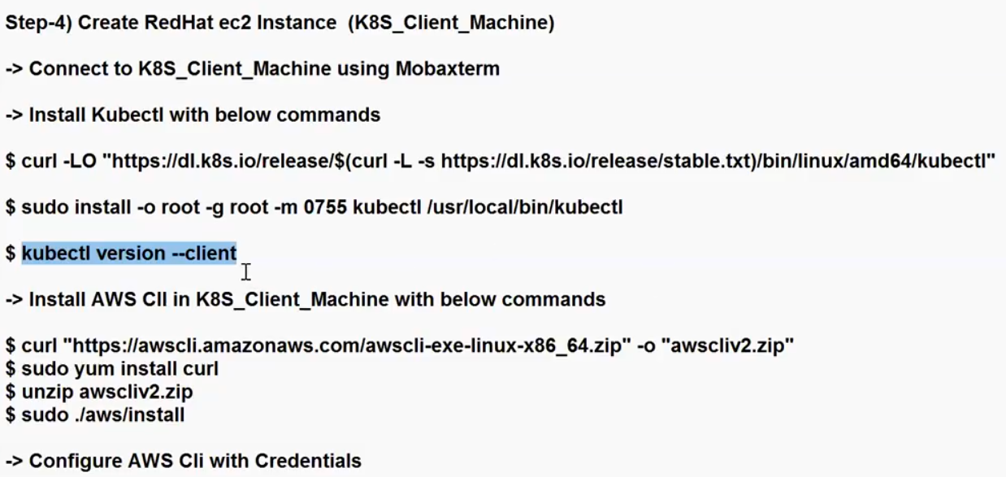

1. After launch the server need to update.

Sudo apt-get update –y

1. Download the kubectl binary:
2. sudo curl -LO https://dl.k8s.io/release/$(curl -L -s <https://dl.k8s.io/release/stable.txt)/bin/linux/amd64/kubectl>
3. Install Kubectl

sudo install -o root -g root -m 0755 kubectl /usr/local/bin/kubectl

Here: -o root specifies the owner of the file as the root user.

-g root specifies the group of the file as the root group.

-m 0755 sets the permissions of the file to be read, write, and execute for the owner (root) and read and execute for others.

kubectl is the source file you want to install.

/usr/local/bin/kubectl is the destination path where you want to install the kubectl binary.

1. Then verify kubectl version;

#kubectl version –client

1. Install AWS Cli in k8s client machine with below commands

#sudo apt-get install curl

#sudo apt-get install unzip

#curl "https://awscli.amazonaws.com/awscli-exe-linux-x86_64.zip" -o "awscliv2.zip"

Verify zip file is downloaded or not? => #ls –lf ( here will see the zip file)

NOTEL: here awscli zip file is downloaded, now unzip that file.

#unzip awscliv2.zip

then install awscli

#sudo ./aws/install

then verify aws cli:

#aws –version

1. configure AWS cli with credentials , root user/ crate one IAM user

Go to aws🡪 security 🡪 Access Keys 🡪 create access keys

OR go to AWS IAM 🡪 create one new user.

#aws configure

Here give your accesskey and secreat key.

default output format: table

1. Everything is success, lets verify the k8s cluster.

#aws eks list-clusters

#ls ~/.

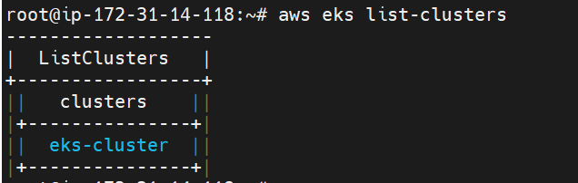

1. Then configure eks cluster for access the cluster through remote server.

#aws eks update-kubeconfig --name <clustername> --region ap-south –1

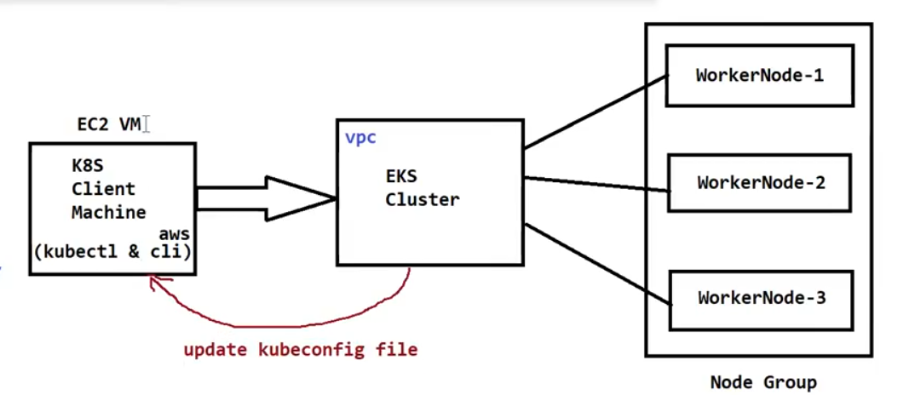



1. Verify the pods: #kubectl get pods (Go to EKS and verify status active or not)
2. #kubectl get pods –all-namespaces

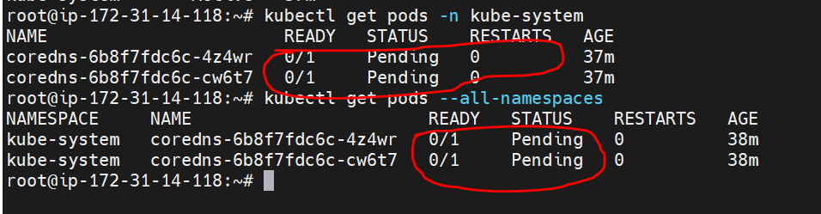

QNS: why it’s showing pod’s status pending?

As of now just we created cluster, worker nodes are not available for execute the pods.

1. Need to create IAM roles for Worker nodes.

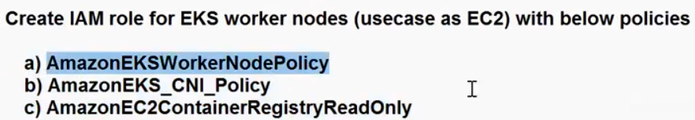

Go to roles & policies crate role using with above 3 policies.

AmazonEKSWorkerNodePlolicy

AmazonEKS_CNI_Policy

AmazonEC2ContainerRegisteryReadOnly

1. Create Worker Node Group

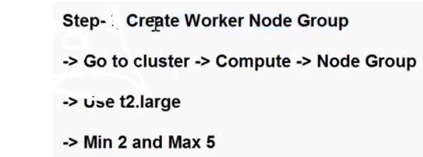

Go to EKS 🡪 open cluster setup🡪 compute🡪 Node groups🡪 Add node group🡪 name🡪 select IAM role(already created for ec2)🡪 choose server AMI type🡪

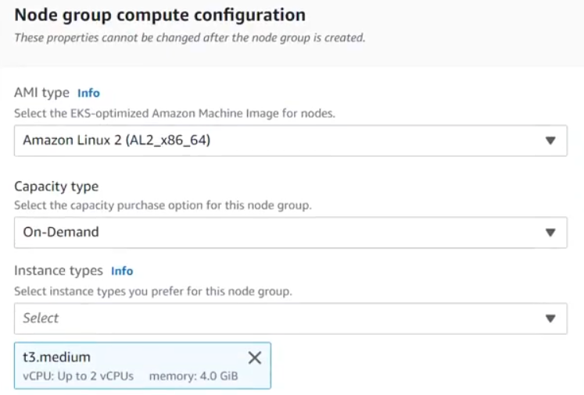

**NOTE: In security group choose your SG, otherwise Public IP will not display (if you choose script SG)**

Choose node group auto scaling:

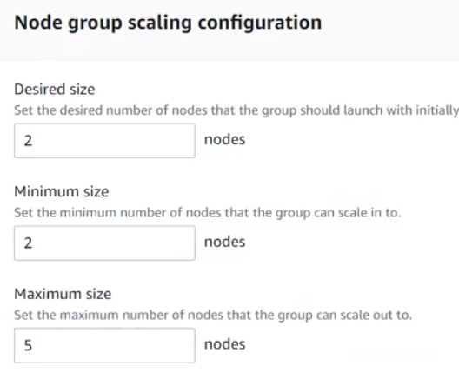

SSH enable (if you want to connect using key pair)

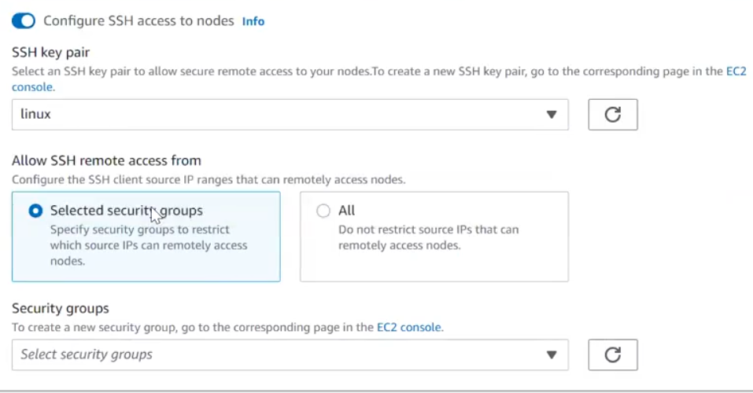

Then create, it will take couple of minitus.

Verify: go to eks🡪 cluster group(all the things will take care by aws join worker all the things)

Then verify in remote machine for nodes.

#kubectl get nodes

Verify the ec2 servers in the ec2 dash board.

Verify running pods : #kubectl get pods –all-namespaces

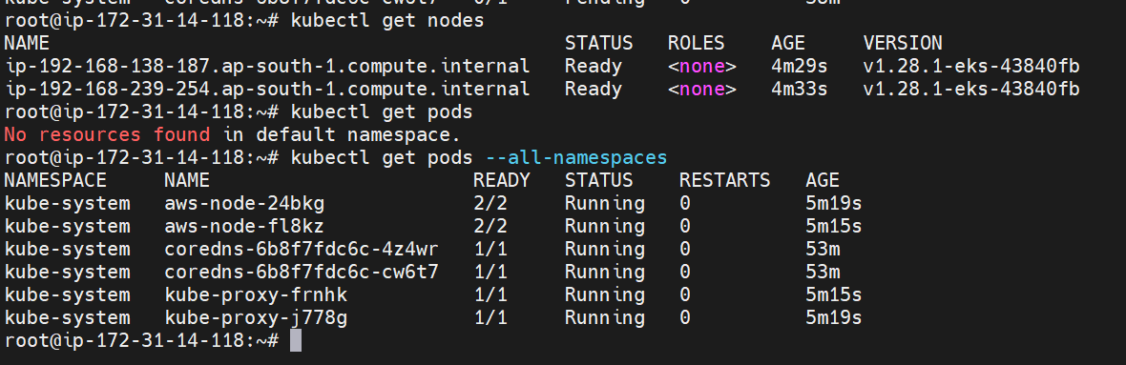

Create one pod through pod manifest file.

Vi podmanifest.yml

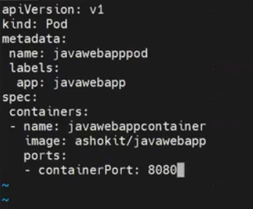

Then apply the manifest file through kubectl command: #kubectl apply –f <filename>

Then verify the pods: #kubectl get pods

NOTE: here if will run the pods , required docker, who installed docker in all the workers?

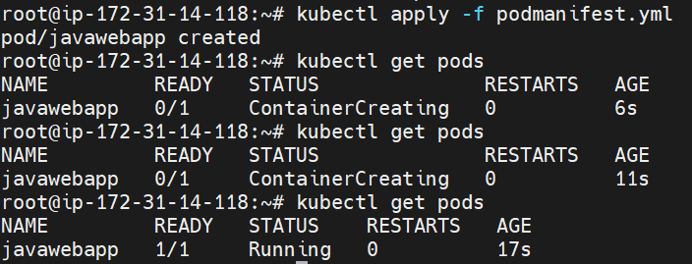

Verify where the pod is created in which node?

#kubectl get pods –o wide



How can I access the application outside of the cluster? Need to create a service.

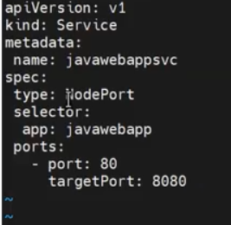

#kubectl apply –f <mainifest file>



Enable the Port in SG.

Then access outside the cluster using IP and port.

NOTE: How to delete set-up, first will delete node group then delete cluster setup.

**Conclusion: All the steps re-call**

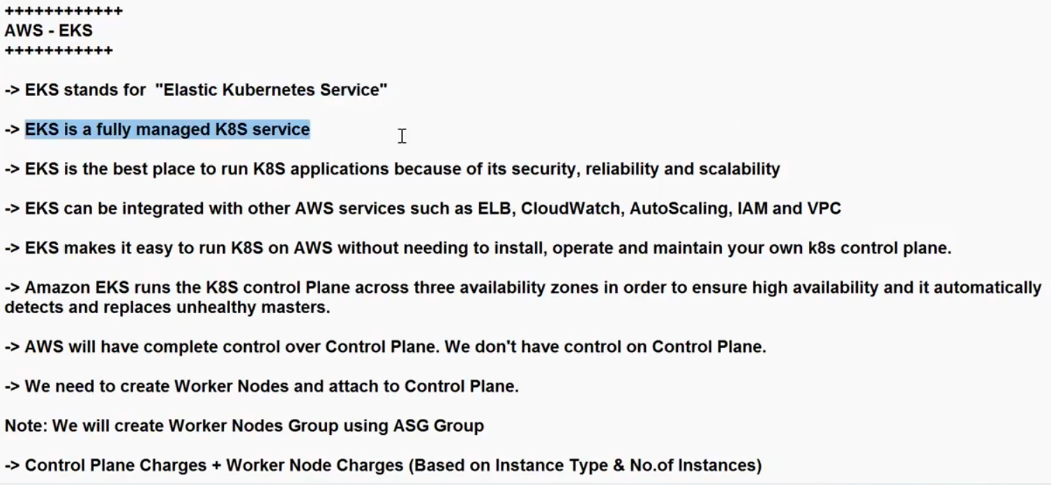

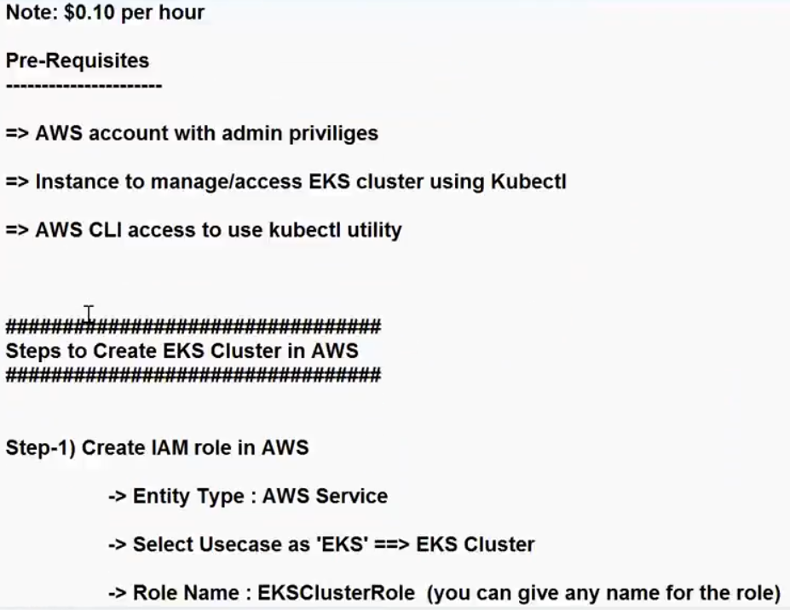

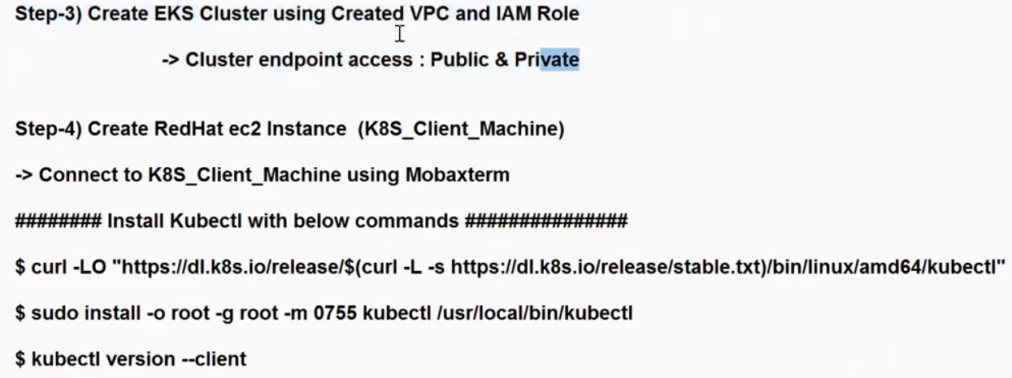

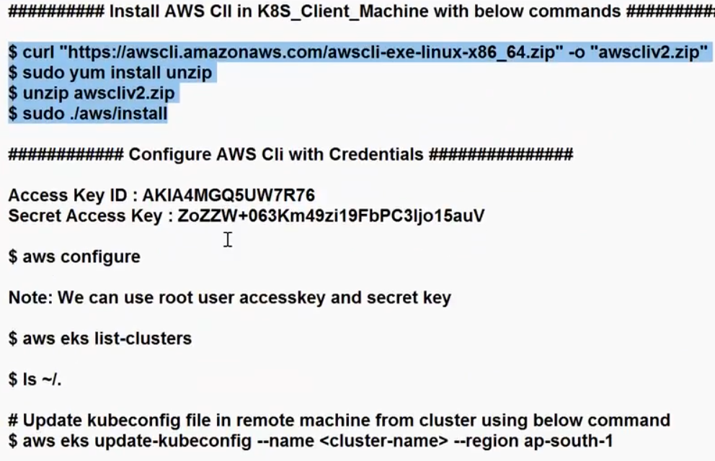

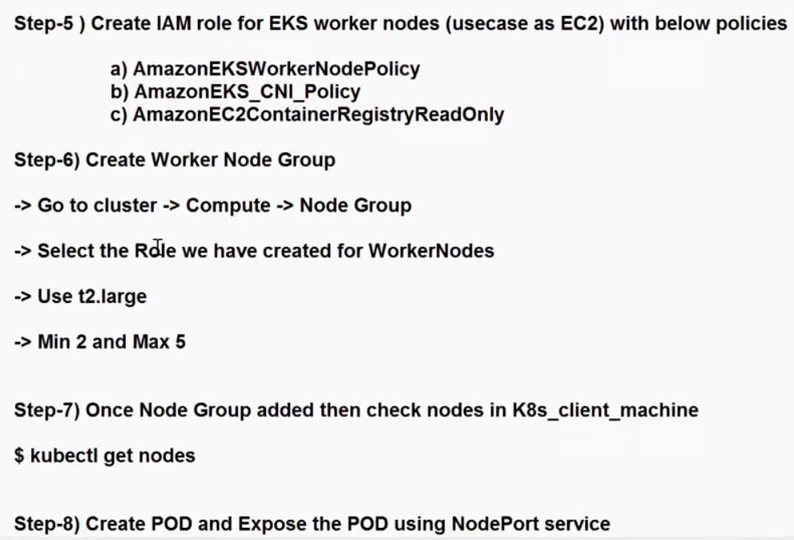

**18-10**

**Once look in LoadBalancer service:**

1. **Cluster IP 2. NodePort 3. LBR**

* In Kubernetes (K8s), a load balancer service is a way to expose your application to external network traffic.
* It's a service type that automatically provisions a cloud provider's load balancer and configures it to distribute incoming traffic among a set of pods (backend endpoints) that belong to the service.
* Load balancer services are particularly useful for applications that need to be highly available, scalable, and accessible from the internet.

Define a Service:

You need to create a Kubernetes service YAML file

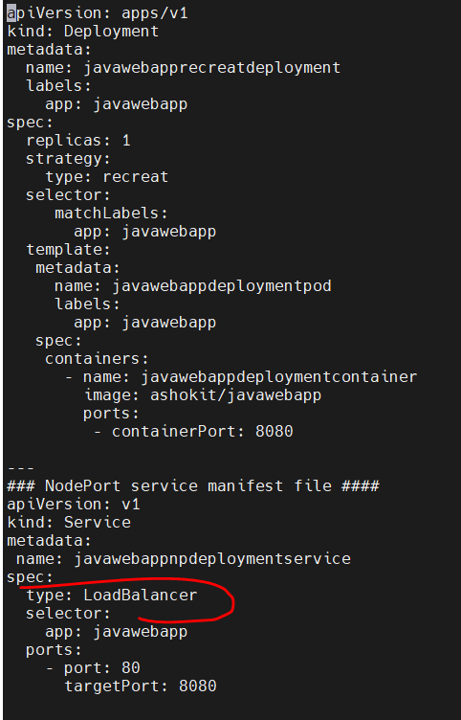

Once verify have any LBR is existed or not. Then apply the manifest file.

Apply the Configuration:

Use the kubectl apply command to create the service:

#kubectl apply –f <file> (now verify the LBR)

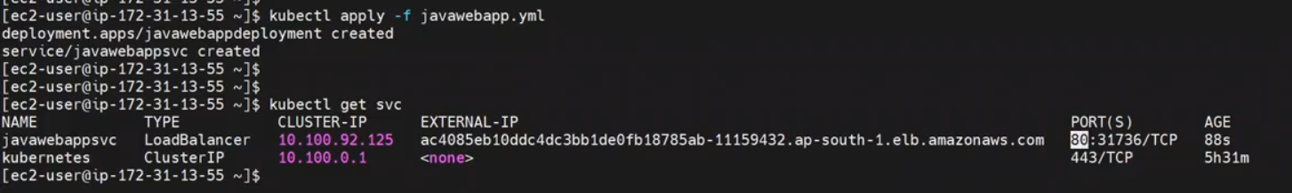

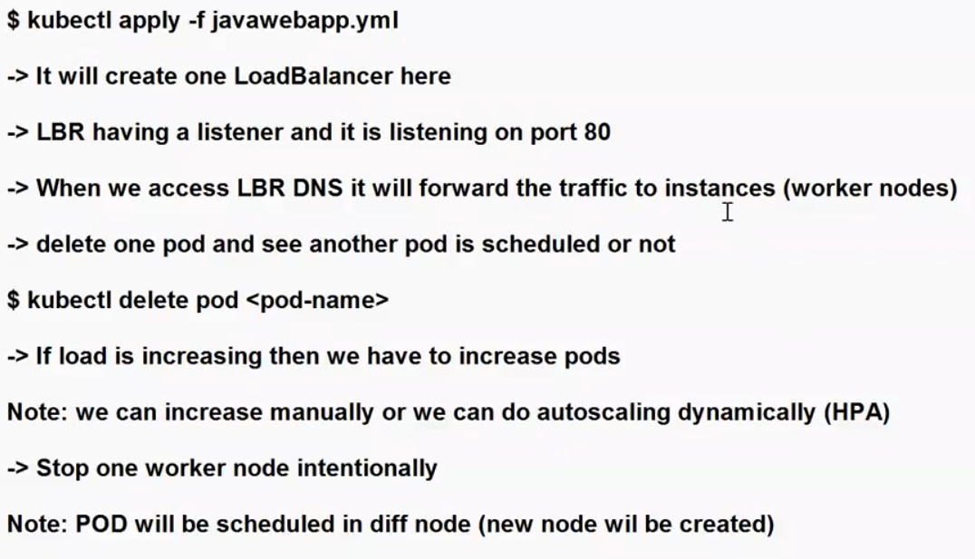

**It’s generated one external url and port. Expose the url and access the application.**

NOTE: For testing purpose will terminate one node manually from the cluster. Control plane will recreate one more new node for the desired node count.

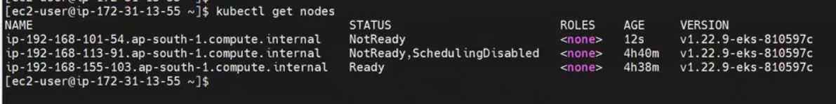

If any node is down/failure control plane will recreate new node (it’s self-healing capability)

**Ingress Architecture:**

* In Kubernetes (K8s), "Ingress" is an API object that manages external access to services within a cluster. It provides a way to configure and manage rules for routing HTTP and HTTPS traffic from external sources to services running within the cluster.
* Ingress controllers are responsible for implementing the rules defined in Ingress resources and managing the actual network traffic routing.

Here are some key points about Ingress in Kubernetes:

1.Routing Rules:

* Ingress allows you to define rules that specify how incoming requests to specific hostnames or paths should be directed to the appropriate backend services within the cluster.

2.HTTP and HTTPS:

* Ingress can be used for both HTTP and HTTPS traffic. For HTTPS, it often involves configuring SSL/TLS termination and managing certificates.

3.Load Balancing:

* Ingress controllers often work in conjunction with load balancers (such as cloud load balancers or on-premises load balancers) to distribute traffic to the appropriate services.

4.Host-Based Routing:

* You can set up different rules based on the hostnames requested in the HTTP headers. For example, you can route traffic for app.example.com to one service and traffic for api.example.com to another.

5.Path-Based Routing:

* You can route traffic based on the path requested in the URL. For example, you can send requests to /api to one service and requests to /web to another.

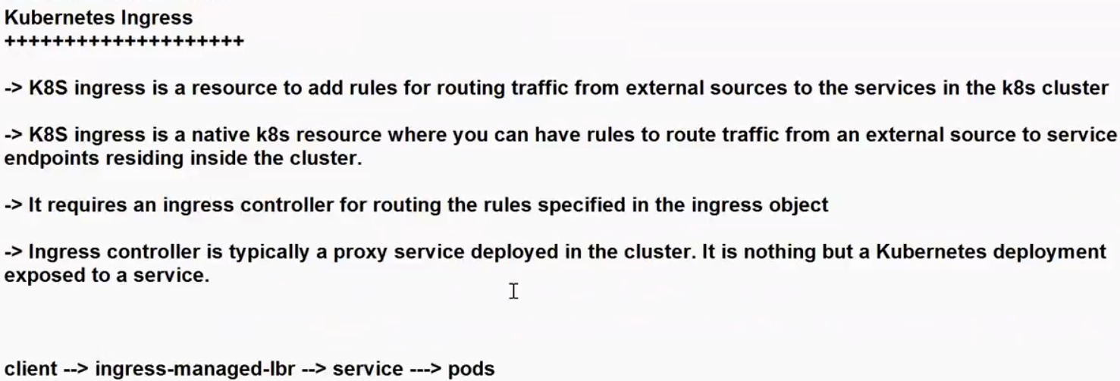

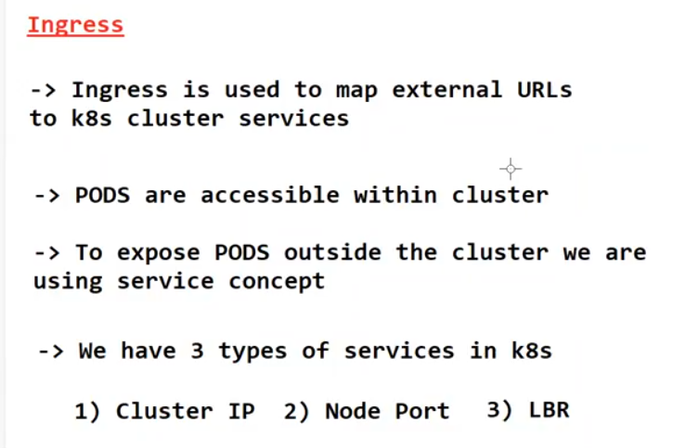

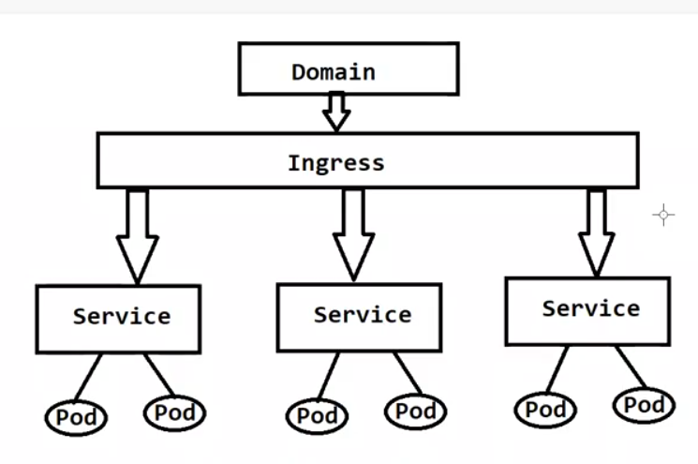

**What is Ingress?**

Ingress exposes HTTP and HTTPS routes from outside the cluster to services within the cluster. Traffic routing is controlled by rules defined on the Ingress resource.

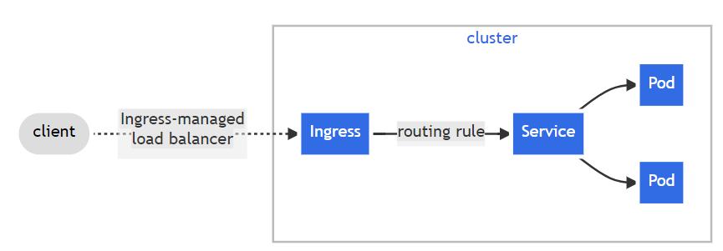

#kubectl get all (it will get all the existing services)

For Ingress Lab:

Delete all the existing services for you are better understand.

Crate two web application one is java and second one is maven project.

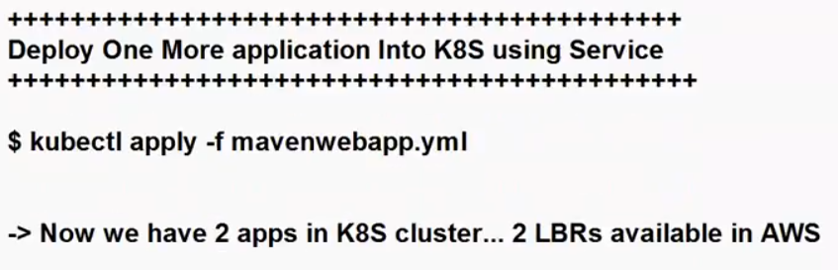

Javawebapp.yaml

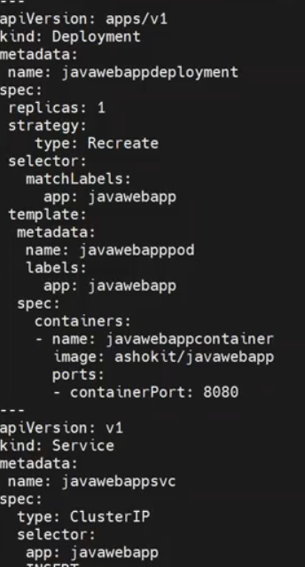

Mavenwebapp.yml

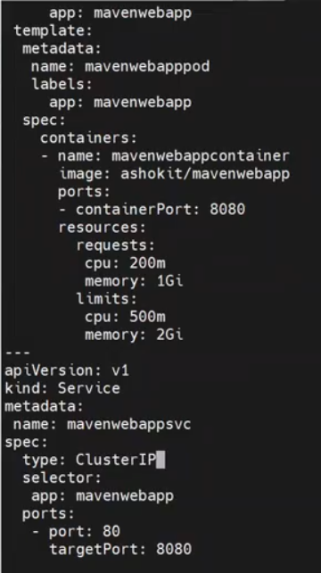

Run kubectl apply for two manifest files.

Verify with #kubectl get svc

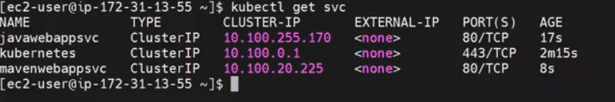

Now we will create the Ingress-controller for route the traffic.



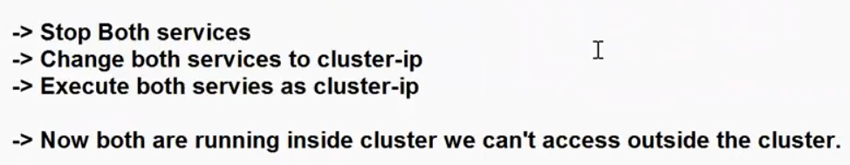

Now need to create the Ingress for access the both the applications.

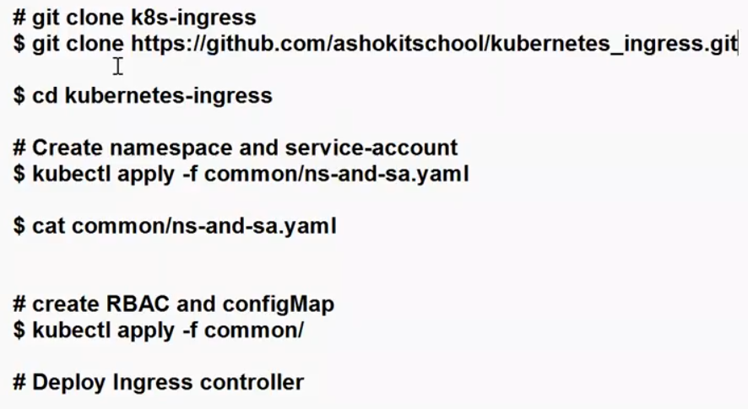

Github URL: git clone <https://github.com/ashokitschool/kubernetes_ingress.git>

Clone this repo in your node , all the ingress set-up files are existed in this repo.

Two ways we will create the ingress set-up.

1. Daemon-set
2. Deployment

Step 1: Create the name space using yaml file

Go to downloaded directory kubernertes-ingress 🡪 common🡪 ns-and-sa.yml

Execute this yaml file using apply command.

Step 2: Create RBAC

* RBAC, which stands for Role-Based Access Control, is a security mechanism in Kubernetes (K8s) that allows you to control access to resources in your K8s cluster based on roles and permissions.
* It provides fine-grained control over who can perform specific actions within the cluster, helping you enforce the principle of least privilege.

RBAC in a Kubernetes cluster involves the following key components:

1.Roles:

* A Role is a set of rules that define what actions (verbs) are allowed on which resources (nouns) within a specific namespace.
* For example, you can define a Role that permits read and write access to ConfigMaps within a particular namespace.

2.RoleBindings:

* A RoleBinding associates a Role with one or more users, groups, or service accounts. It specifies which users or entities are granted the permissions defined in the Role.
* RoleBindings are usually created within the same namespace as the Role.

3.ClusterRoles:

* A ClusterRole is similar to a Role but applies cluster-wide, rather than being limited to a single namespace. It defines permissions for cluster-level resources.

4.ClusterRoleBindings:

* A ClusterRoleBinding associates a ClusterRole with users, groups, or service accounts, granting permissions on a cluster-wide basis.

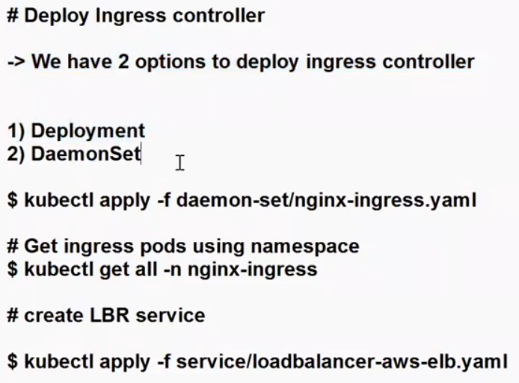

Step 3: Now we are going with daemon-set to create ingress-controller.

Go to deamon-set directory🡪 nginx-ingress.yml

Execute nginx-ingress.yml file using apply command.

# kubectl apply –f daemon-set/nginx-ingress.yml



Verify : after execute the apply command verify the service with name space.

#kubectl get all –n nginx-ingress

Step 4: Now create LB service for the Ingress-controller.

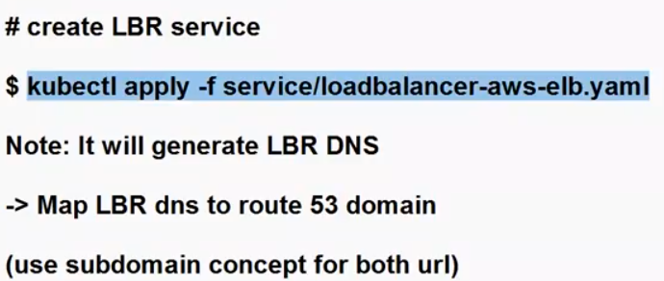



NOTE: when you created the LBR delete in cluster only , do not delete manually, if you delete manually it will not recreate again with the same name.

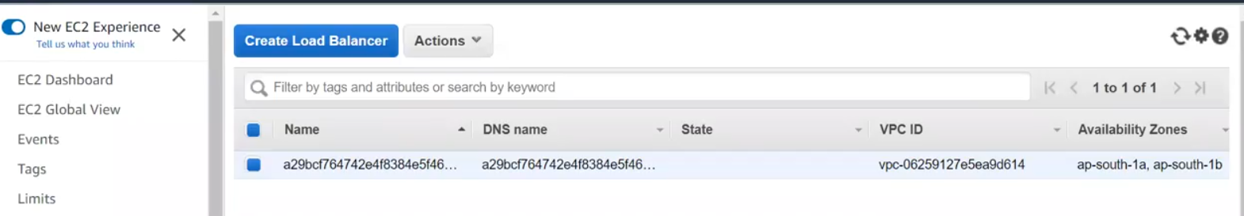

This Load balancer is for ingress-controller, not for application LBR.

Will see the all the details in my custom name-space:

#kubectl get all –n nginx-ingress

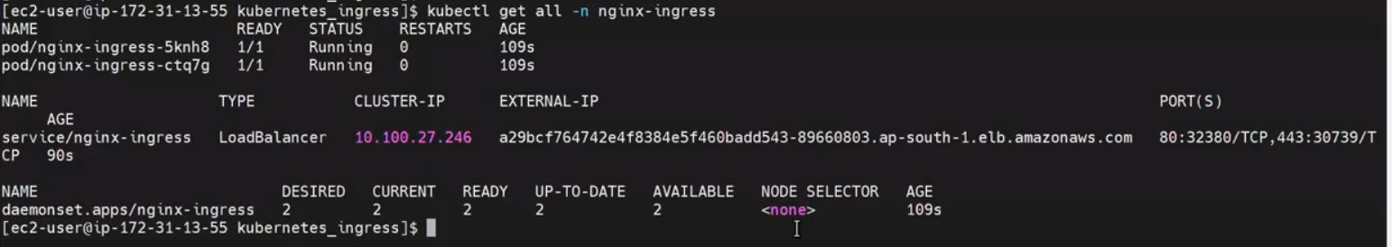

**Now need to MAP application details to this ingress controller.**

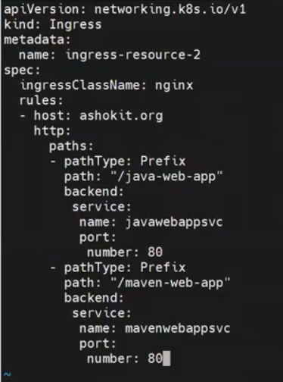

Now MAP LBR DNS (Ingress URL)with R53

Go to R53🡪 select you’re existing domain🡪 create record🡪

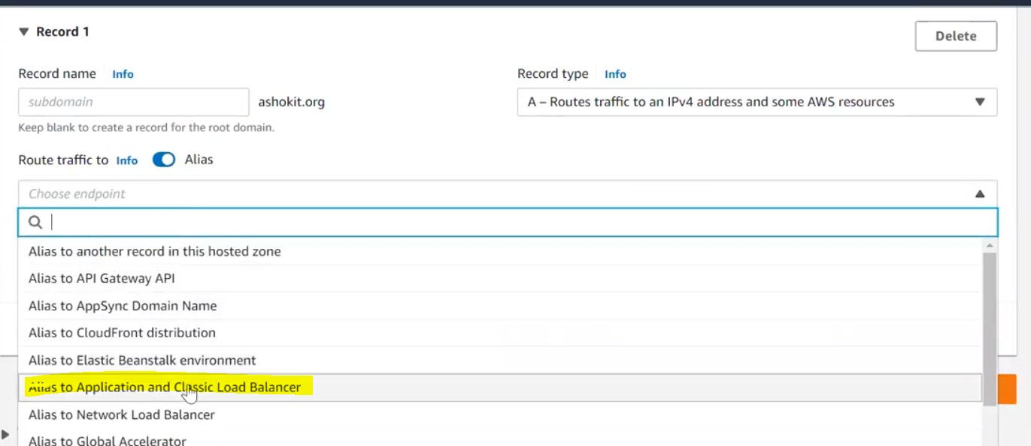

Choose Route traffic , Region and URL

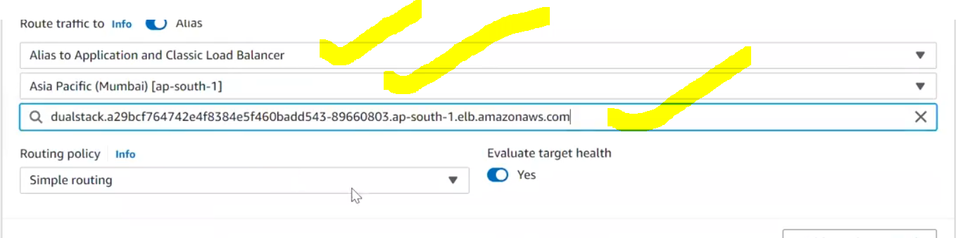

Then create Record. Domain name is mapped with ingress load balancer.

NOTE: Ingress is used for route the traffic.

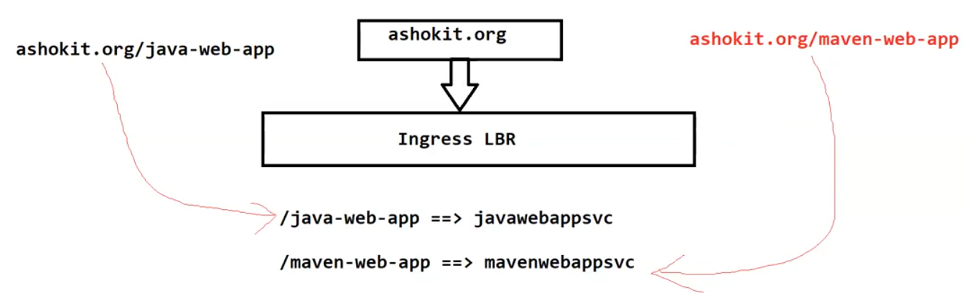

Finally users will access the application through domain name only.

Once verify all the services.

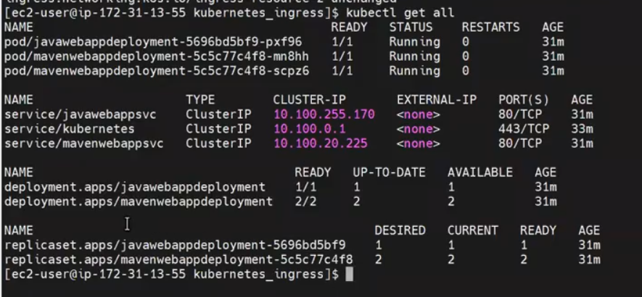

NOTE: will access the application through R53.

23-10 SH

Install Docker:

$curl <https://get.docker.com/> | bash

$lsns –t pid

$watch –n 1 lsns –t pid

For verify: open new terminal🡪 $docker run –d –p 8080:80 nginx:latest && docker ps

Observe first terminal it will run one new process. It will create the NS and will run the process.

Note: container is nothing but a processer.

#ps –ef | 8080

$netstat –tunlp

Docker will run the docker container.

K8s is container orchestration(maintainer)

Developer + ops team (both are sister-in-law and aunty always fighting)application working in developer side,but not working in ops team, dependencies problem. Ie introduced container.

Diff b/w VM & container?

3.What is dockwer swarm(diff k8s & swarm), why con’t user swarm in you are project?

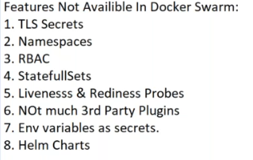

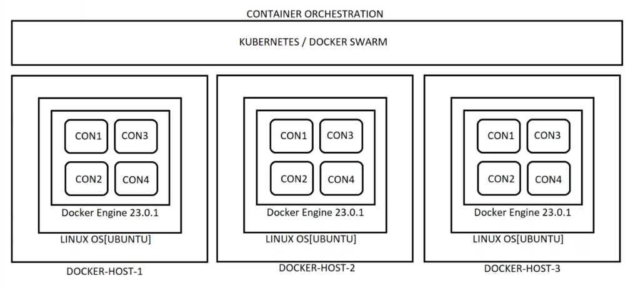

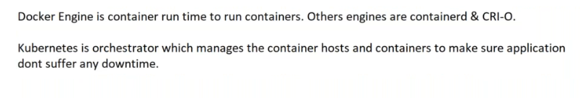



DOcke r all the services install not mandatory, will install container “D” in enough for k8s.

1. In containers are not stored data, data it will store in another place, so node delted no data loss.

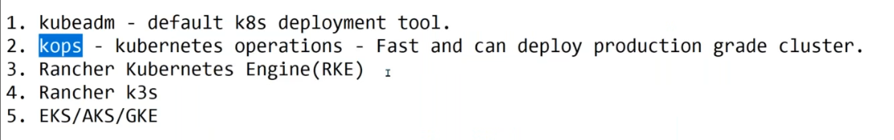

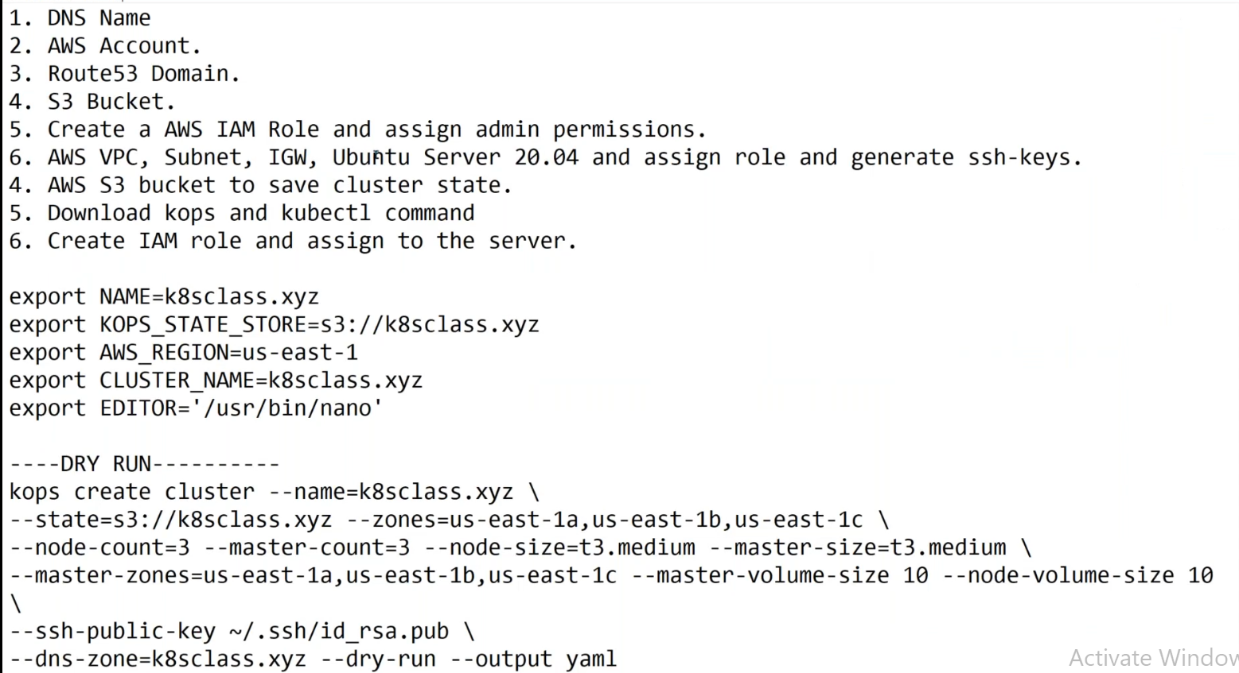

Kops installation:

Google: kops github🡪

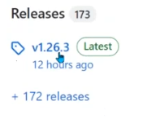

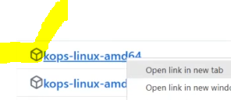 copy the Link

Login in to server🡪 cd /usr/local/bin

#wget <link>



#ls

Don’t have permissions, so give permissions.

#chmod 700<file-name>

Then download kubectl:

Google🡪 kubectl download

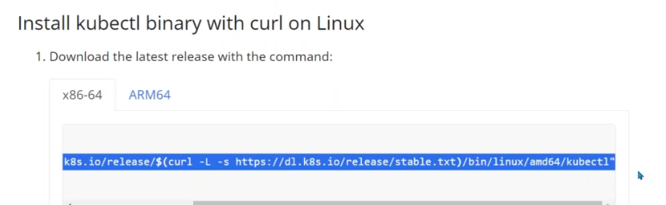



Chmod 700 kubectl

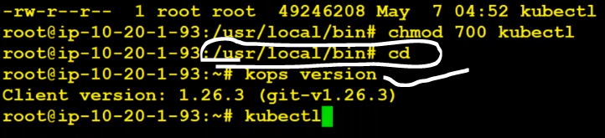

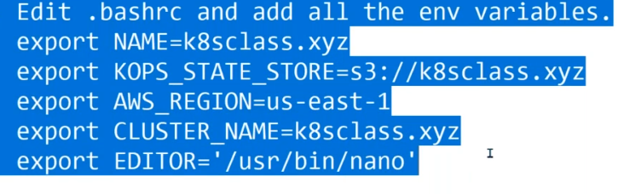

Edit .bashrc file and add all the env variables.

export NAME = k8stech.xyz (domain)

export KOPS_STATE_STORE=S3:// k8stech.xyz

export AWS_REGION=ap-south-1

export CLUSTER_NAME=k8stech.xyz

export EDITOR=’/usr/bin/nano’

alias ku=kubectl

1. Create cluster using kops and generate a cluster file.

DRY RUN:

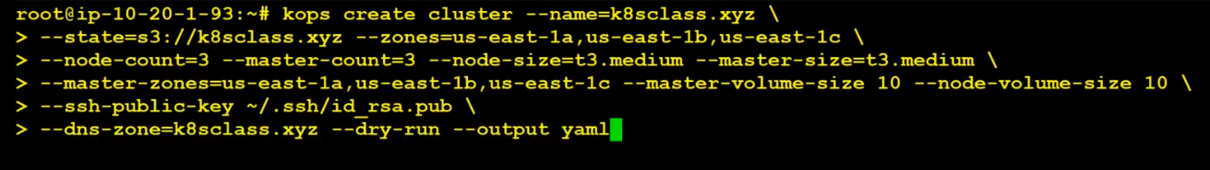

#kops create cluster –name=k8stech.xyz \ --state=s3://k8stech.xyz –zones=ap-south-1a,ap-south-1b,ap-south-1c \--node-count=2 –master-count=1 –node-size=t2.small –master-size=t2.medium \ --ssh-public-key ~/ .ssh/id_rsa.pub \ --dns-zone=k8stech.xyz --dry-run --output yaml

What is Dry RUN:

A "dry run" is a term used in various contexts to refer to a practice or simulation of a process or procedure without actually executing it in a live or production environment. The purpose of a dry run is to test, validate, or practice a particular operation, often to identify potential issues or errors before committing to the actual execution. Here are a few common scenarios where dry runs are used: